**What exactly a Biosphere Reserve consists of?**

**The Edu-BioMed project’s course**

**Module 5**

**Conceptual and methodological tools relevant in the field of conservation management**

**[ENGLISH]**

**About Edu-BioMed**

The project aims to strengthen, ameliorate and upgrade academic activity at four Moroccan and Lebanese Higher Education Institutions (HEIs) in the context of Mediterranean Biosphere Reserves (BRs), in collaboration and through networking with BRs’ stakeholders (citizens, visitors, managers and technicians), public administrations and EU Partners.

**Partners:**

* [Universitat Autònoma de Barcelona](https://www.uab.cat), Spain (coordinator)
* [Université d’Aix Marseille,](http://www.univ-amu.fr) France
* [American University of Beirut](https://www.aub.edu.lb), Lebanon
* [Université Saint-Joseph](http://www.usj.edu.lb), Lebanon
* [Université Cadi Ayyad](http://www.uca.ma), Morocco
* [Université Mohammed V de Rabat](http://www.um5.ac.ma), Morocco
* [MAB France](http://www.mab-france.org/fr), France
* [Association for the Protection of Jabal Moussa (APJM)](http://www.jabalmoussa.org), Lebanon
* [UNIMED – Mediterranean Universities Union](http://www.uni-med.net), Italy

**More at**

[www.edubiomed.eu](http://www.edubiomed.eu)

The online version of the course is at:

https://www.edubiomed.eu/mooc/open-web-version-of-the-course/

|  |  |
| --- | --- |
|  | The Edu-BioMed project has been funded with support from the European Union. This document reflects the view only of the author, and the Commission cannot be held responsible for any use which may be made of the information contained therein. |
|  |  |
| [Creative Commons License](http://creativecommons.org/licenses/by/4.0/) | This work is licensed under a [Creative Commons Attribution 4.0 International License](http://creativecommons.org/licenses/by/4.0/) |

# Table of Contents

Table of Contents 3

Welcome 4

Whom is the course for? 5

How to use the course 6

Module 5 – Conceptual and methodological tools relevant in the field of conservation management 7

M5 – Lesson #1 Biodiversity knowledge, monitoring and representation 8

M5 – Lesson #2 Citizens science in Med BRs 12

M5 – Lesson #3 Stakeholder engagement 14

M5 – Lesson #4 Tools for decision making 16

M5 – Lesson #5 European Project Design and Mangement – Introduction to EU Programmes 19

M5 – Lesson #6 European Project Design and Management – Proposal preparation 22

# Welcome

What exactly a Biosphere Reserve consists of?

The objective of the Edu-BioMed course is to answer to this key question from a Mediterranean perspective. The course is developed under the framework of the project, whose main objective is to promote education and applied research in Mediterranean Biosphere Reserves.

Throughout the course, participants will learn about the case of Biosphere Reserves, special protected areas promoted under the auspices of the Man and Biosphere Program of UNESCO. Teachers are professionals in the field of environmental protection and education: university professors and researchers, NGOs representatives and Biosphere Reserve managers.

The Edu-BioMed course in numbers:

* 5 modules
* 1 Inspiring Talk
* 28 lectures
* 14 organizations involved
* 22 trainers
* 1 MOOC

# Whom is the course for?

The online course ***“What exactly a Biosphere Reserve consists of? from a Mediterranean perspective”*** produced within the Edu-BioMed project with the support of the Erasmus+ Capacity Building Programme of the European Union, aims to promote education and applied research in Mediterranean Biosphere Reserves and raise awareness on the management and relevance of the reserves.

The course content is composed of five modules, which explore different aspects related to Mediterranean Biosphere Reserves, exploring the role of the biosphere in an era of global change, and how Biosphere Reserves can serve to the understanding and managing of changes and interactions between social and ecological systems. Managers of the Reserves present case studies from the Med region as well as conceptual and methodological tools that are relevant in the field of conservation management.

Target Audience

The course is addressed to many different targets:

* Students developing skills on biodiversity, nature conservation, biosphere reserves and protected areas, territorial governance and more
* University educators (professors, lecturers) from several discipline, from environmental studies to Mediterranean geography, from sustainable tourism to natural sciences, etc.
* Researchers and professionals in the field of environmental protection
* Representatives and Biosphere Reserve managers, staff and practitioners
* Citizens, associations and the wider public with an interest in biodiversity and natural heritage protection
* Local communities living and working in the Biosphere Reserves
* Decision-makers at national and regional levels

# How to use the course

The course is designed as a learning journey for students and adult learners, who can navigate through the 5 modules and the many lectures and resources available. Videos, readings and activities are proposed by the 22 trainers involved in the production and delivery of the contents.

The course can be accessed in both English and French.

The online course **“*What exactly a Biosphere Reserve consists of?* from a Mediterranean perspective”** produced within the Edu-BioMed project Course is one of the main outputs of the project. The content and online activities are available under an open license that enables anyone to reuse, adapt, store and share those resources.

The entire course and each one of the modules are available as standalone units of content, so anyone anywhere can repurpose them according to their own needs. To facilitate the use of the course contents, and to support the sustainability of the Edu-BioMed course over time, it has been developed in different formats.

Course Formats

PDF / WORD

The content of the course has been released as both PDF and Word files. The current document is the English version of the Edu-BioMed course.

HTML / Open Web

The open version is accessible through the Edu-BioMed project website: [Open Web Version of the Course](https://www.edubiomed.eu/?page_id=1620)[1].

Terms of Use

The Edu-BioMed course contents are licensed under Creative Commons Attribution 4.0 International License.

This means that everyone is free to:

* Share: copy and redistribute the material in any medium or format
* Adapt: remix, transform, and build upon the material for any purpose, even commercially

You may do so for any purpose. However, you must give appropriate credit to the Edu-BioMed project, provide a link to the license, and indicate if changes were made. You may do so in any reasonable manner, but not in any way that suggests the licensor endorses you or your use. Moreover:

* You do not have to comply with the license for elements of the material in the public domain
* The licensor cannot revoke these freedoms as long as you follow the license terms

No warranties are given. The license may not give you all of the permissions necessary for your intended use. For example, other rights such as publicity, privacy, or moral rights may limit how you use the material.

Please contact us at info@edubiomed.eu if you have any questions about citation and attribution.

# Module 5 – Conceptual and methodological tools relevant in the field of conservation management

* LESSON #1 Biodiversity knowledge, monitoring and representation

Magda Bou Dagher Kharrat, University Saint-Joseph

* LESSON #2 Citizens science in Med BRs

Salma Talhouk, American University of Beirut

* LESSON #3 Stakeholder engagement

Catherine Cibien, MAB France

* LESSON #4 Tools for decision making

Gonzalo Gamboa, Universitat Autònoma de Barcelona

* LESSON #5 European Project Design and Mangement, Introduction to EU Programmes

Raniero Chelli, UNIMED

* LESSON #6 European Project Design and Mangement Proposal preparation

Raniero Chelli, UNIMED

## M5 – Lesson #1 Biodiversity knowledge, monitoring and representation

Magda Bou Dagher Kharrat, University of Saint Joseph

Magda Bou Dagher Kharrat is a Professor at the University of Saint Joseph in Beirut (USJ) and Director of the Biodiversity and Functional Genomics Laboratory at the Faculty of Sciences of USJ. She holds an HDR from the University of Paris-Sud and a PhD on cedar genetics from the University Pierre et Marie Curie. She is President and co-founder of the NGO Jouzour Loubnan. She is a member of several international learned societies and research consortia and is the author of about 50 scientific papers. Her research work focuses on the genetic characterisation of the biodiversity of Lebanon and the Mediterranean region. The application of her research helps to define concrete and sustainable conservation policies.

Description

How to map, monitor and represent biodiversity? Prof Magda Bou Dagher introduces some tools to better know the diversity of life around us!

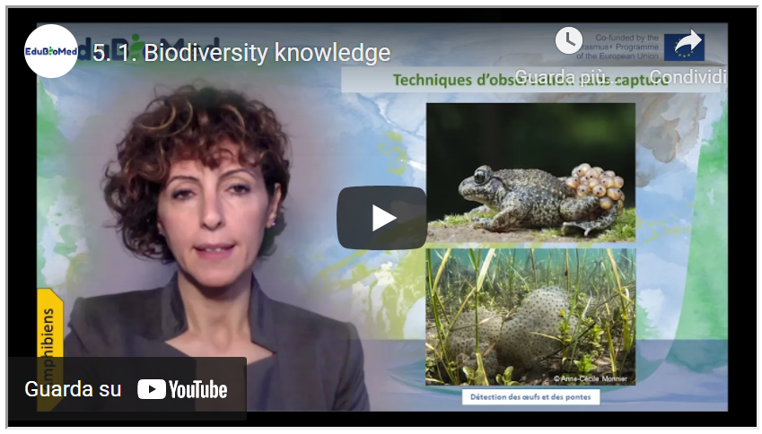

Link to video: <https://youtu.be/XDQfLJsLio8>

Activities

Additional resources to go further:

* Watch the video “Big Cats Wild for Calvin Klein Cologne?“[2]
* Catalog of entomological sampling methods (Chap. 2, part. II), P. Bonneil, L.M. Nageleisen, Christophe Bouget[3]
* Evaluation of the microfauna biodiversity of a watercourse, Biodiversity in Lebanon[4]
* Watch the video on stream invertebrates “A visual guide to Riverfly monitoring”[5]

Transcript of the video

To study biodiversity, we must consider its different levels:

* Species-level = species diversity
* Ecosystem level = landscape diversity
* Intraspecific level = genetic diversity

When asked to characterize biodiversity, we generally limit ourselves to species diversity. However, it is recommended to consider the other two levels. In this MOOC, we will address only the species level. For species diversity, it is necessary to consider animal, plant, and fungal species and microorganisms and other forms of life called “protists.” These inventories are not just a list of species but rather contribute to an understanding of the functioning of the ecosystem. Thus, these studies will clarify the potentialities of the site to be studied, its weaknesses, the issues, and the constraints to be tackled.

Ideally, the entire ecosystem should be systematically inventoried. As part of the "One cubic foot" project, a photographer systematically photographed every living organism he found in this volume; he carried out this exercise on land and in the sea. The results would not be precisely the same if he had examined the integrality of the site. This approach is not feasible on a large scale since it is time and resources consuming.

For this reason, we carry out a sampling in a representative area of our site, and we will then extrapolate the results to a larger area.

This representative area can be a “Quadrat,” which is a rectangular surface whose size depends on the nature of the ecosystem:

• 1x1 in a bog

• 5 x5 in a meadow

• 100 x 100 m in a forest.

Several quadrats are defined when the site is heterogeneous. The location of the quadrats must be studied scrupulously to represent all types of habitats. One could also draw transects and assess the biodiversity along these transects. The choice of the transect location must also cover the maximum number of habitats in the site to be studied. The quadrat technique is used in terrestrial, aquatic, or underwater environments. It is adopted for fixed or low-mobility species.

To inventory species and draw up an inventory of biodiversity, it is necessary to tackle all groups of organisms and find the optimal means of effort and resources to be spent to list the site’s biodiversity. Naturalists competed in imagination and creativity to adapt sampling techniques appropriate to their group of interest.

Mammals inventory: they should be observed with the naked eye or binoculars. There are other means of observation for fearful or stealthy animals. It will be necessary to install camera traps. Alongside these traps, researchers tend to set traps or decoys. For example, to attract big cats, perfumes like Chanel Number 5 or Obsession by CK have proven their effectiveness in attracting big cats. Other means also exist, such as non-invasive traps, which allow animals to be trapped temporarily to study them before releasing them.

I cite other techniques such as ultrasonic detection for bats.

Traces left by animals can also constitute indirect evidence of their passage: droppings, hair, paw prints, etc.

Animal droppings, for example, have proven to be a great source of information; sometimes, scat shape could be sufficient to identify the animal that dropped it: rabbit droppings are ball-shaped, while wombats ones are cubic ….

Apart from the shape that can tell us about the animal’s identity, droppings contain much more information. Animals' diets can be revealed through the analysis of their scats. The technique of DNA metabarcoding, which simultaneously sequences several DNA fragments and compares them to a database, allows us to know what the animal has consumed, such as leaves or roots or other parts of plants that are not detectable like seeds visual analysis.

For birds, ornithologists have their tools. There is, of course, observation using binoculars, but the most popular technique today relies on the bird-song recording. And in this regard, today's technologies have revolutionized this field since they allow uninitiated amateurs to identify the birds encountered from their song. Indeed, it is possible to record the sound of a bird and use specific applications available on smartphones, for example, compare the soundtrack to the database and identify the bird. Techniques for tracking traces such as feathers or nests or eggs… Examination of droppings is also possible. This is especially interesting in owls, where whole rodent skeletons can be found in the scats. Japanese mist net for catching birds is used when seeing the bird is necessary for studies and for ringing them. Ringing makes it possible to monitor a large number of birds individually and to collect a lot of information (sex, age, biometrics, etc.). This collected data improves the bird’s life, behavior, and survival rates. GPS tags are used for migrating birds. This allows you to know the dates and routes of migration and the location of rest areas.

To study reptiles, herpetologists have techniques and tools specific to them: long cuffs, thick gloves... because the bites of some reptiles can be dangerous. Since reptiles are cold-blooded animals, they often seek warmth. Traps such as tunnels or artificial shelters that trap heat catch reptiles and identify them. Identifying reptile exuviae can also reveal the identity of the reptile. Examination of the DNA extracted from it allows precise identification of the species. Observation of amphibians can be done with or without capture. This observation can be done during the day or night, a privileged time for certain species to move. Singing detection: Singing (croaking) can reveal the identity of frogs.

We choose listening points to cover potential areas of species presence. The songs are diurnal and nocturnal. Visual detection in water or on the ground: The use of a high-power lamp makes it possible to detect amphibians present in the breeding sites at night. We gently walk around the perimeter of the aquatic sites, observing the borders and water areas. Searching for eggs and clutches (some species have very typical egg-laying techniques) can also reveal the species present.

To capture amphibians, the use of artificial caches is employed. This propensity to use shelters can be taken advantage of by placing plates (wood, sheets, squares of carpet) near the egg-laying sites. These techniques make it possible to assess the biodiversity of aquatic environments, but what has revolutionized the field of study of aquatic biodiversity is the discovery of eDNA or environmental DNA. The DNA can be recovered after water filtration extracted from an aquatic environment. The analysis of this DNA reveals the identity of the lake inhabitants who, by their mere presence, leave cells, excretions, etc. Arthropods: This group forms more than 52% of our planet's biodiversity. There is enormous variability in the life forms of this group. The techniques for studying insects are just as diverse. Active methods require dislodging insects from their environment using threshing, mowing, or debarking techniques. Then a visual identification specimen by specimen is carried out. In the aquatic environment, cloudy-water nets are used, such as the Suber net, to recover animals dislodged from their habitats. Some of these animals are indicators of water quality.

As for the passive techniques, they are also very numerous:

Light traps consist of placing a light source rich in UV or a lighted white sheet in the middle of the biotope whose insects you are trying to study. This phenomenon of attracting insects to lights is well known to entomologists worldwide. We can even observe it with our insects in town around public lighting or a lamp on our terraces in summer evenings.

The Barber Trap, invented in 1931 by the American entomologist Herbert Spencer Barber, makes it possible to capture organisms moving on the surface of the ground. It consists of the insertion in the ground of a container filled with a liquid (vinegar or alcohol) in which the insects drown by falling into it.

René Malaise a Swedish entomologist invented the device that bears his name. It is a tent with a white roof which makes it possible to converge the insects which enter it, in particular Diptera and Hymenoptera, towards a bottle filled with alcohol which will keep them for later studies.

To study the arthropods of the soil, it is the Berlèse device that will have to be used. A fraction of the soil (litter plus the height of a shovel) is taken and then placed in a device lit brightly from above (wide-mesh sieve above a funnel), causing the arthropods to escape from below into the pot collector containing a preservative liquid (alcohol). “Splatometer” is an unusual technique that relies on the evaluation of the diversity and abundance of insects killed on the windshields and license plates of cars during their movement at high speed. To study the diversity of plants, the procedure is relatively simple since the plants are generally fixed to the ground. On the other hand, to assess all the plant diversity of a place, it will be necessary to pass several times and in different seasons to observe the different parts of the perennial plants and to be able to observe the seasonal plants. Plant pollen can also be a plant identification tool. Placing a device such as the Cyclone sampler in an environment that sucks up airborne particles reveals the presence of plant or fungal species that have released these spore or pollen particles. It is by analyzing the DNA of these particles that we will identify the species. Mushrooms are present all year round but visible above ground only at certain times of the year when humidity and heat conditions are adequate. The study of the carpophore (visible part of the mushroom) allows their identification. Note that the genetic study from soil extracts is possible all year round.

The LIFEPLAN project aims to establish the current state of biodiversity across the globe, and to use our insights for generating accurate predictions of its future state under future scenarios. Biological diversity will be explored through a worldwide sampling program, and develop the bioinformatic and statistical approaches needed to make the most out of these data. LIFEPLAN is led by the University of Helsinki, it brings together more than 100 study points around the world

## M5 – Lesson #2 Citizens science in Med BRs

Salma Talhouk, American University of Beirut

**Salma Talhouk** is Professor of Landscape Horticulture, at the Faculty of Agricultural and Food Sciences (FAFS), Department of Landscape Design and Ecosystem Management (LDEM) of the American University of Beirut.

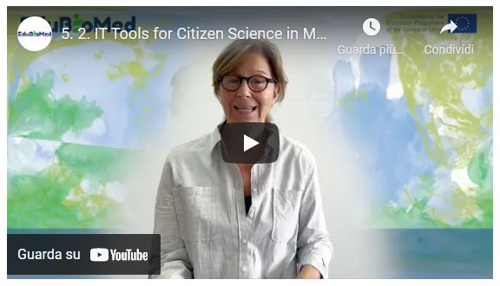

Link to video: <https://www.youtube.com/watch?v=6t7hJSlRfxA>

Transcript of the video

*So how often do you spend time in nature, maybe once or twice a year, or maybe you go regularly? Either way, you go to nature, probably because it makes you feel better. But how do you know if nature is feeling better every time you visit them? How would you know if nature is healthy? This is what Biosphere Reserve managers and scientists do. They are in charge of nature's health. They monitor biodiversity. They monitor organisms on a regular basis because they need to gauge how people impact nature. Biosphere reserves managers, they work with scientists to learn how organisms and ecosystems are changing in response to people's visits and their activities. This monitoring is crucial to help them detect early warning signs of any damage that we may be causing to nature. But to do this, both managers and scientists need to collect a lot of data through our very large fields and many organisms and over very long periods of time. You can hide them and be involved in the scientific research that takes place in biosphere reserves without being a scientist as a citizen. You can actually participate in scientific research that takes place in biosphere reserves. You can, as a non-expert, become a citizen scientists. By doing this, you can help scientists and managers uncover changing partners in nature.*

*So, what do citizen scientists do in biosphere reserves? Citizen scientists, they learn from researchers and managers, they engage in data collection, and they are involved in scientific research only when many citizens work together with scientists and managers. Then it becomes possible to collect big data across time and over large areas. The data collected by citizen scientists will drive change because it is useful and it is impactful. So, the citizen scientist who engages with scientists and managers will help them acquire knowledge through research and will help transform this knowledge into action, and it will guide management and planning. When you want to be a citizen scientist, you can choose the research that interests you that you find important. Some people may be curious about scientific research. Others may be interested in a specific organism, even if you don't have specific preferences. The key is that when you are a citizen scientist, you will also advance your scientific literacy and you will contribute to research and have a direct impact on nature. In short, as a citizen scientists, you get to make a difference in nature and the communities living in biosphere reserves, while also you are growing, learning and acquiring knowledge from the scientific perspective. Your contribution as a citizen scientists will help the scientists plan larger projects and more impactful research projects because they know that there are many people working with them, and so they can plan a collection of a large number of samples over a long period of time. If you don't contribute, if you don't have them, they will not be able to do this because large projects are very costly.*

*There are many success stories of citizen science around the world. One of them is citizen engagement in bird watching. On October 9th. Citizen scientists around the world do bird watching. Specifically, they collect, identify, locate and upload as many bird species as possible using the eBird phone application, which has been developed specifically to allow citizen scientists to contribute bird watching data. In 2020, despite the COVID 19 outbreak, more than 32000 participants submitted 18400 checklists, with 7128 species. There are many phone applications that have been developed to engage citizens and citizen scientists in monitoring and data collection of organisms and natural elements. Our team has developed a phone application that allows citizen scientists to participate in research conducted and Mediterranean by its users. The application, called Edu-BioMed, allows scientists and managers to share projects conducted in biosphere reserves, and it is a useful tool that facilitates the participation of citizens in the search. As a citizen scientist, you can browse and choose a project that interests you and list the skill that you have, or that you would like to learn. The Edu-BioMed phone application will link you with ongoing projects that match your choices. Your contribution can range from uploading your photo or contributing to other data collection apps. Now, as you visit biosphere reserves, you can help scientists and managers conserve nature and promote sustainable development in the biosphere reserves. Sign up on Edu-BioMed phone application, visit the Mediterranean biosphere around you and see how you can make a change. Your contribution is necessary. In summary, the Edu-BioMed phone application targets citizens who are interested in participating in biosphere reserves related research projects. Through this app, you can familiarize yourself with Mediterranean biospheres and encourage friends and families to engage in citizen science, becoming citizen science today and help scientists and managers conserve nature!*

## M5 – Lesson #3 Stakeholder engagement

Catherine Cibien, MAB France

Catherine Cibien is the Director of MAB France. MAB France animates and strengthens the national network of 14 Biosphere Reserves, puts it in touch with the French and international communities interested in this program: scientific community, educational and academic world, organizations for the management and conservation of biodiversity, sustainable development and of the ecological transition. She co-hosts the Master MAB (Man and Biosphere) at the University of Toulouse.

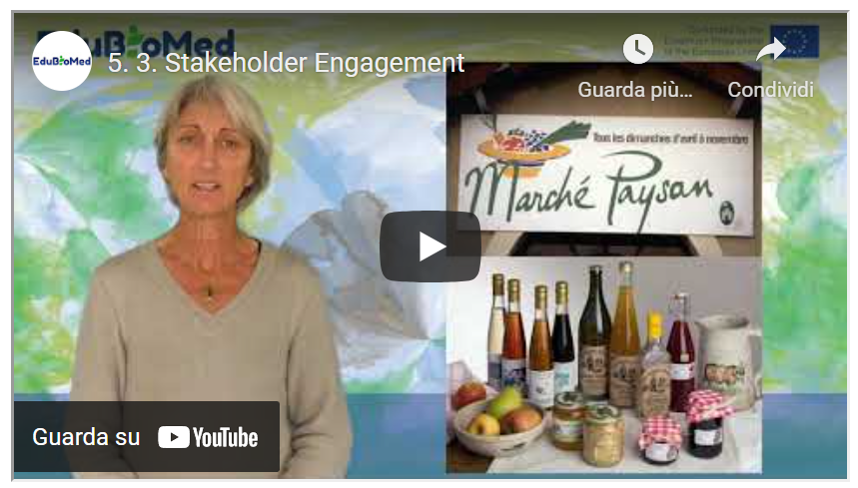

Link to video: <https://youtu.be/ZR22YSq45bY>

PPT presentation

Link to slides: <https://www.edubiomed.eu/wp-content/uploads/2021/09/PPT-5.3.pdf>

Transcript of the video

*In Biosphere Reserves (BRs), the involvement of "stakeholders" is fundamental, and concerns different types of stakeholders, for whom the stakes of participation differ. It takes place in a particular way at certain key moments in the life of the BR.*

*A key moment for participation, creation, periodic review and implementation of the biosphere reserve's management policy. At these stages, the inhabitants, their representatives, the private and associative sectors and institutions will have to analyze the issues facing the biosphere reserve and agree on the policy and projects to be carried out in the coming years, in the fields of conservation, support for the development of human activities, research and studies, and education - training - awareness raising.*

*It is therefore necessary to plan cycles of meetings that will first inform, identify and understand in a transparent manner the challenges of the moment. Then, there will come a phase of co-construction of the BR project that the official bodies will have to validate and carry out.*

*Various participatory facilitation techniques can be mobilized: public meetings, various participatory workshops (world café, forum theatre, or the famous THM that Obama used on a large scale for his health reform), the reports of which should be put online, made public and relayed in the local media. Outside of these highlights, local participation is also encouraged on a daily basis, through the working methods and governance of the Biosphere Reserve, which includes representatives from the public and private sectors.*

*They are based on the reflections of committees or working groups and projects, which involve stakeholders, on agriculture for example, or forestry, or education. Representatives of professions, associations are invited to participate. The social and ecological transition of a territory can only take place if the inhabitants and actors take ownership of it and make it, are themselves bearers of transformation.*

*Some Biosphere Reserves have established mechanisms to recognize their commitments. Depending on the country, they call themselves ambassadors or eco-stakeholders of BR. In France, eco-actors sign a charter with BR, committing themselves to a process of environmental and social progress for their own activity. Some BR have established brands for products and services that meet high environmental and social standards. Those who benefit from these brands have their quality efforts recognized by the BR.*

*In France, trophies are awarded every year for original initiatives by local players. All these schemes are complementary and it is not uncommon for companies with branded products to also be eco-actors or ambassadors of their BR. They enable the creation of networks and partnerships at the service of the region.*

*Participation efforts can also be aimed at a specific social group.*

*Thus the mobilization of young people aged 18 - 35 is on the agenda in the BRs. Youth forums, or youth councils, are organized, in participatory formats, to train them in territorial dialogue, in the management issues raised by the territory where they live or study, and to invite them to take part in discussions concerning its future, in an informed and constructive way.*

*Helping the younger generation to be more proactive, to initiate the reforms necessary to achieve the SDGs before 2030 is an important issue for many countries.*

## M5 – Lesson #4 Tools for decision making

Gonzalo Gamboa, Universitat Autònoma de Barcelona

Gonzalo Gamboa is a social ecological economist. He holds a PhD in Environmental Sciences (UAB, 2008) and has extensive experience in combining participatory methods with quantitative analytical tools, such as multicriteria evaluation and multi-scale integrated assessment of societal metabolism. Gonzalo has applied this approach to a wide range of fields: windfarms location, coastal management, water management and territorial planning. Also, he has focused his research in how to define adequate indicators to characterize and assess the performance of socio-metabolic systems across scales, making explicit the contrasting visions and values in society.

Description

Biosphere Reserves as complex socio-ecological systems are difficult to understand and manage. When it comes to make public decisions, the social multi-criteria evaluation is an adequate tool to employ.

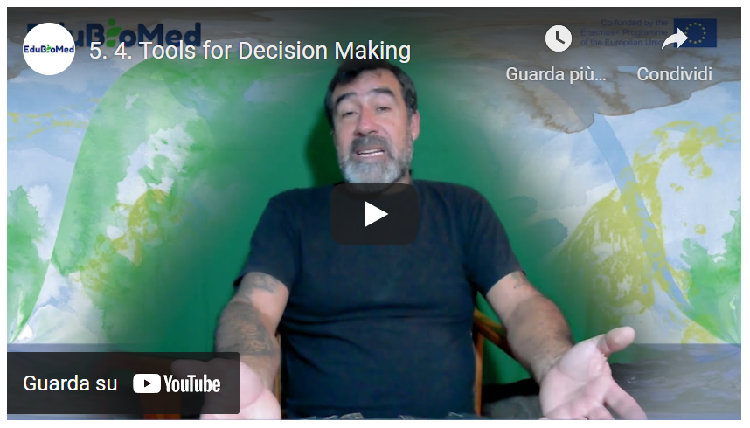

Link to video: <https://youtu.be/Gb0mkN4ns00>

PPT presentation

Link to the slides: <https://www.edubiomed.eu/wp-content/uploads/2021/09/5.4-slides.pdf>

Activity

Have a look at the Handbook on Participatory Action Research, Planning, and Evaluation[6]​ (2021), and read “Social multi-criteria evaluation: Methodological foundations and operational consequences” by Giuseppe Munda (2004)[7], from the European Journal of Operational Research.

Transcript of the video

Hello! In the following, I will present some tools for public decision making. In this case, we will focus on the social multi-criteria evaluation. In the real life, we face many situations where conflicts and conflicts of interests converge. In these situations, where different knowledges and values encounter, the social multi-criteria evaluation is an adequate tool for public decision making. We face complex socio-ecological systems, and we could differentiate between two types of complexities.

The ontological complexity, that has as consequence the social incommensurability, that is, that in society a set of contradictory and legitimate values exists, and based in different perceptions of the situation we have. And this ontological complexity calls for public participation. Then we have the epistemological complexity, that relates with technical incommensurability, that is, it is impossible to put express all the (e)valuations under the same measuring unit. So we can say that these two types of complexity are participative and multidisciplinary. The social multi-criteria evaluation frames into three phases: approaching, representing and evaluating. In the first part, the approaching, we have the first step, which is the identification of social actors. Then, we would define the problem we have in front of us, for which we must decide. As methods, we have different ones: historical-institutional analysis, interviews, focus group, that we will review later. Then representation would come: that implies to generate a multi-criteria structure with alternatives to tackle the problem we are facing, and different valuation criteria to evaluate these alternatives. Again, in this step we could make use of participative tools such as in-depth interviews, focus groups, workshops

Finally, we evaluate the different alternatives, basing in different criteria; which requires a multi/inter-disciplinary work; we compare the different alternatives and analyse and discuss results. Once again participation comes into play. This is a non-linear, cyclical process since we go back to the beginning in the sense that we go back reinterpreting the problem and re-define them, if necessary, and go back into the various steps until when someone must decide. Some tools? To identify social actors, we have the historical-institutional analysis that is basically based in document review so to generate a timeline so to identify in which moments which actors are present in the situation we are analysing.

To define the problems, we have dynamics like the participatory mapping or the problem tree, that generate a vision of what are the roots and consequences of what problem. Then we represent. We need to create a multi-criteria structure... Again, the problem tree is a good tool because in identifying the causes of the problems we can define some alternatives to solve it. And then we have for instance the narrative analysis, that is a methodology where we conduct a text analysis of interviews, newspapers, opinion articles, so to identify narratives and from that to define evaluation criteria for the evaluation, we must evaluate the criteria, compare the alternatives and dynamize the discussion.

In this case, we use the multicriteria evaluation where –in this case, for example- it is presented an impact matrix with different alternatives that are evaluated under different criteria. The interesting part is that each of the criteria maintains its measuring units and not everything should be reduced to a single measuring unit. Here we can see, for example, as only by colouring with different colours the different cells of the impact matrix we can have an idea of what is the best alternative – or the less bad- in order to solve a determined problem. We can also use algorithms, that tells us the order of alternatives according to the input parameters. Always keeping in mind that these algorithms should be a tool that help us in making a decision, and they are not the ones who take the decision. We should made responsible for the decision on the basis of the information we collected. Then, these impact matrix with a lot of information should serve as basis to go back discussing the problem and, if it’s the case – take a decision, or go back defining the problem and seek for alternatives. Here I present you a manual with many participatory dynamics for identifying actors, determining the problems, and a series of participatory dynamics that allow us to face these situation of high complexity.

As conclusion, in general, the social-multi-criteria evaluation is a framework for the public decision making, mainly – I would say - at a project level, that allows us to include different visions of the problem that we are dealing with. It combines public participation with multi/inter-disciplinarity work. When we invite to participate social actors in these kinds of processes, we need to take into consideration and be very cautious with the fact that the expectative of participants and of whom dynamize the process can be very different. Transparency is required, and be very clear on what are the premises, the time span, and all the factors that are taken into account for both the development of alternatives and the definition of evaluation criteria. We need to comply with the acquired compromises, for example with giving back information to participants. And there are key issues as: who decides who participate, how they participate, and what is the knowledge that is relevant in the process? For the same reason, ethics and transparency are very important in the participative processes. We need to have clear who and why someone participate.

Another thing: the participation is necessary, but not always sufficient...

...for this reason... It is promoted the shift from the quality of the product to the quality of the social process, in which everyone has the right in participating, and in which we can facilitate the participation of all sort of actors, with more or less resources or more or less possibilities for expressing their opinion in these processes.

The quality of the process requires engagement, multidisciplinary work, and transparency. The software we are utilizing should provide results that are consistent with the information at hand. And more important: the ethics and responsibility of the process... how do we incorporate the vision of who cannot participate, or of whom do not have the tools to participate. And, to assume the responsibility in the moment in which we make a decision based on the information at hand.

That it’s. Thank you very much.

## M5 – Lesson #5 European Project Design and Mangement – Introduction to EU Programmes

Raniero Chelli, UNIMED

Raniero Chelli. Active since 1985 in European projects (mainly in RTD, training and international cooperation), as a Commission Official (ESPRIT Programme 85-88), Project Manager, Project Design specialist, Evaluator and reviewer, Quality assurance manager, National Delegate in IST management Committees and as a trainer on EU programmes and funding. He is currently the Coordinator of EU projects at UNIMED, to facilitate access to EU funding by identifying appropriate calls for proposals, helping them in setting up successful proposals and consortia, and where applicable, supporting the management of selected projects with a particular emphasis on Quality Assurance. Over the years, he has managed more than 10 significant projects funded by the European Commission through R&D Framework Programmes, TEMPUS, Erasmus+ and Euromed Heritage and he has consequently acquired an outstanding experience in managing large and complex international publicly funded projects, especially as regards the planning the activities of a highly diversified consortia, conflicts resolution and administrative matters.

Description

The title of this lecture is the introduction to European Union programs. But actually, what we’re going to look at is the European programs providing funding for countries which do not belong to the European Union.

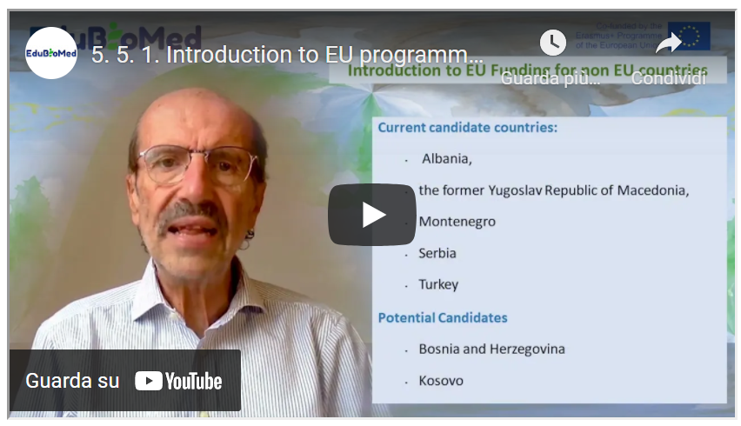

Link to video: <https://youtu.be/tM2Hwtjp6ao>

PPT presentation

Link to the slides: <https://www.edubiomed.eu/wp-content/uploads/2022/01/Lecture-5.5.1-Introduction-to-EU-programmes-.pdf>

Transcript of the video

The title of this lecture is the introduction to European Union programs. But actually, what we're going to look at is those European programs which provide funding for countries which do not belong to the European Union. As you probably know, the European Union is constituted by today 27 member states, which you have the list here. And the United Kingdom used to be a member, but they decided to leave this year. It is important to know which countries belong to the European Union because most programs are reserved for European Union countries. However, there are other countries which are in the in the status of candidate countries, and you have the list here. These countries have a special treatment because they are following a process of joining the European Union so they can be part of some programs. And then for each program, you can have some exceptions. For instance, Horizon 2020 is the largest European research and development and innovation program provides funding for projects which are in the area of research, development and innovation. It will finish this year, but they are already preparing the next generation, which is called Horizon Europe. You can have here the link to the Horizon 2020 website. And the easiest thing, however, is to google H2020 and you will find the website. The interesting thing about Horizon 2020 is that there are some countries which I called associated countries.

For instance, Tunisia, which is the only African country which is an associate of Country. What does it mean? It means that Tunisian organisations, whatever type research companies, universities, they can participate in the program as though they were at European Union countries. But in addition to that, many eligible countries do not belong to the European Union. In many cases, proposals of Horizon 2020 allow non European Union organizations to participate. There are some specific goals which explicitly call for the participation of non European Union countries. But the general rule is that whatever, wherever you are in principle, if there is a good reason for participating in the program, then you are allowed to do so. The program is very, very articulated, very complicated. It has a number of different programs, but by and large, in virtually, let's say, the greatest part of the program. Organizations from countries like yours can participate in the project. Get funding from the project, of course, in partnership with European Union organizations. There are some exceptions like China, Brazil, India, but this is not the theme of this course. No. The other big program is Erasmus Plus, as you probably know, is a program which addresses basically the word of education, training and in particular of higher education. It also addresses of basically concerned youth and sports. It is structure within the Central Agency, which is in Brussels and national agencies. Here again, I advise you to visit the website of the Erasmus plus. But the most important strand sub program of Erasmus plus is the one which is called cooperation for HEIs in all EU countries.

This is the program, for instance, where the Edu-BioMed project has been funded, and it is explicitly meant for cooperation between universities in countries which do not belong to the European Union and countries which belong to the European Union, as it is in partnership with some European countries and some non-European countries. You have another, a similar program, which is called capacity building in field of youth, as the name says, does not address as university addresses associations organization to deal with young people. And through this link, you can get a list of the eligible countries for the capacity building for higher education. The third big strand, which is explicitly meant for non-European Union countries, is the central cooperation: Europe Aid. It is the Directorate-General for External Cooperation, also called the cooperation for development and the extent of cooperation is strengthened into three areas. The Pre-Accession Countries IPA, this is the countries which was shown before Albania, Kosovo, etc. the nine country, ENI, European Neighbors initiative. And these are the countries that we should belong to those countries which are neighbors to the European Union, through land or even through sea. So, all countries which belong to the southern Mediterranean area belong to the ENI. And then the third one is the DCI, the Developing Countries Initiatives. You have many calls for proposals. I recommended that you go and look through this link to some External Cooperation call for proposal to see what they are about. So as a quick recap of what we have seen up to now, you have the H2020, which allows the participation of European countries, you have the Erasmus+, which has one stranded capacity building for higher education, which is explicitly meant for non-European Union countries. And you have Europe Aid, which is everything concerning extending cooperation. Thank you very much.

## M5 – Lesson #6 European Project Design and Management – Proposal preparation

Raniero Chelli, UNIMED

Raniero Chelli. Active since 1985 in European projects (mainly in RTD, training and international cooperation), as a Commission Official (ESPRIT Programme 85-88), Project Manager, Project Design specialist, Evaluator and reviewer, Quality assurance manager, National Delegate in IST management Committees and as a trainer on EU programmes and funding. He is currently the Coordinator of EU projects at UNIMED, to facilitate access to EU funding by identifying appropriate calls for proposals, helping them in setting up successful proposals and consortia, and where applicable, supporting the management of selected projects with a particular emphasis on Quality Assurance. Over the years, he has managed more than 10 significant projects funded by the European Commission through R&D Framework Programmes, TEMPUS, Erasmus+ and Euromed Heritage and he has consequently acquired an outstanding experience in managing large and complex international publicly funded projects, especially as regards the planning the activities of a highly diversified consortia, conflicts resolution and administrative matters.

Description

In this lecture, we’re going to look at the main steps that they need to take in proposal preparation. Once you have identified the suitable call for proposals and you want to submit your proposal in order to get your project funded, you have to write the proposal. So basically, what I’m going to give you is the process that you have to follow in order to prepare a good proposal.

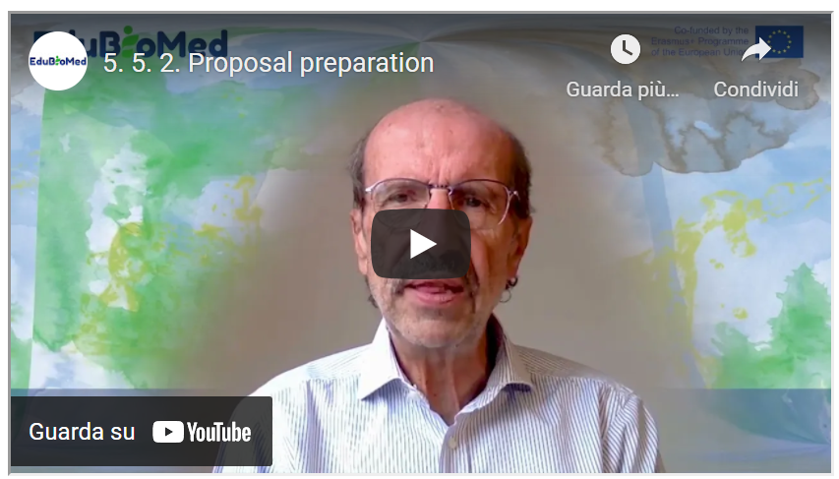

Link to video: <https://youtu.be/AdXGGWqh_Tk>

Transcript of the video

In this lecture, we're going to look at the main steps that they need to take in proposal preparation. Once you have identified the suitable call for proposals and you want to submit your proposal in order to get your project funded, you have to write the proposal. So basically, what I'm going to give you is the process that you have to follow in order to prepare a good proposal. Of course, you have to start by identifying a project idea. Why am I saying that? Because many times you find a call for proposals and you want to submit the project so you react to the call for proposal, this is not a good idea.

You should start by a strong project idea around which you are going to build a partnership and write the proposal. Then the second important thing is that you have to download the documents related to the call and analyzing that. We have a terms of reference, we have an application form, you sometimes have another document, which is the logical framework, you have another document, which is the budget. You have to download the documents and analyze them to understand in the first place what are the rules for that particular course for proposals. If you are eligible, and things like that. So, you had to analyze on the basis of what you have read, if it is a good idea to take part in that particular call for proposals.

As I said before, you should check whether you are an eligible organization, in an eligible country, whether what you want to do fits into the requirements of the call for proposals. If the budget which is allowed by the call is coherent with what you want to do. You normally have, for instance, in the Horizon2020, you have an indication like this project should cost three million euros. if you had in mind a project for five hundred thousand euros, this is not for you. You should look for some something else and things like that. Once you have decided that you have a good idea to participate in the call for proposals, then you have to prepare a proposal summary: a short document which carries the basic concept, the basic project idea, which you would need to start the Partner search. Partner research is an articulated activity. It is very, very fundamental for the success of your application process.

Having a good partnership or strong partnership allows you to have a good hope that your proposal will be selected. There are many, many channels for partner search. Many programs provide you with facilities for partner search, and then you have networks, like UNIMED, which are there to support you in finding good partners. Once you have put together a suitable partnership, what do you want to do is to share with your partners the work of writing the proposal. So, you should allocate the responsibilities in the writing of the proposal issued a sign writing tasks to all of your partner. Of course, you need that agreement, and once you have done that, you can start working in parallel and waiting for the partners to send a contribution. In some cases - this is very, very critical - You need formal documents, documents signed by, for instance, the legal representatives of the parties.

So, because this procedure is a bureaucratic one, it can take a long time. You should if in the contract proposal, you find out that these documents are needed, you should start as soon as possible. Collecting this document, send in these documents to the parties and asking them to return the document signed in time for submitting the proposal.

Now, the biggest part, of course, is the writing of the proposal, and we will see in the next lecture some parts of this in collaboration with the partners. You have to finalize the full documentation set, which means you put together all the bits and pieces and then you give them a final check, sometimes in some cases you still need to do the packaging if the donor requires that you submit also paper copies. In most of the cases, now the submission happens via the internet to be on the web, so you don't need to do the packaging, but in some cases, this is needed. The submission, as I said, in 95 percent of cases is electronic, but this means that you must check the procedure well in advance. Sometimes you need a particular identification code for the organization. For instance, Horizon 2020 is called the PIC to be obtained from the European Commission. In the case of Europe Aid, that you need what is called the PADOR. And then again, you have to ask for the PADOR, you have to submit so you must start in advance and so that you make sure that when you do the final submission, all what is needed, everything is in place.

1. https://www.edubiomed.eu/?page_id=1620
2. <https://www.nationalgeographic.com/animals/article/100624-big-cats-cologne-vin-video>
3. <https://www.edubiomed.eu/wp-content/uploads/2022/02/pub00030221.pdf>
4. <http://biodiversite-liban.blogs.usj.edu.lb/2012/03/03/la-biodiversite-du-liban-nahr-ibrahim/>
5. https://www.youtube.com/watch?v=2lSh9UfwdZM
6. <https://www.participatoryactionresearch.net/>
7. <https://www.edubiomed.eu/wp-content/uploads/2021/09/munda_2004.pdf>