**What exactly a Biosphere Reserve consists of?**

**The Edu-BioMed project’s course**

**Module 4**

**Case studies from the ground presented by Biosphere Reserve managers**

**[ENGLISH]**

**About Edu-BioMed**

The project aims to strengthen, ameliorate and upgrade academic activity at four Moroccan and Lebanese Higher Education Institutions (HEIs) in the context of Mediterranean Biosphere Reserves (BRs), in collaboration and through networking with BRs’ stakeholders (citizens, visitors, managers and technicians), public administrations and EU Partners.

**Partners:**

* [Universitat Autònoma de Barcelona](https://www.uab.cat), Spain (coordinator)
* [Université d’Aix Marseille,](http://www.univ-amu.fr) France
* [American University of Beirut](https://www.aub.edu.lb), Lebanon
* [Université Saint-Joseph](http://www.usj.edu.lb), Lebanon
* [Université Cadi Ayyad](http://www.uca.ma), Morocco
* [Université Mohammed V de Rabat](http://www.um5.ac.ma), Morocco
* [MAB France](http://www.mab-france.org/fr), France
* [Association for the Protection of Jabal Moussa (APJM)](http://www.jabalmoussa.org), Lebanon
* [UNIMED – Mediterranean Universities Union](http://www.uni-med.net), Italy

**More at**

[www.edubiomed.eu](http://www.edubiomed.eu)

The online version of the course is at:

https://www.edubiomed.eu/mooc/open-web-version-of-the-course/

|  |  |
| --- | --- |
|  | The Edu-BioMed project has been funded with support from the European Union. This document reflects the view only of the author, and the Commission cannot be held responsible for any use which may be made of the information contained therein. |
|  |  |
| [Creative Commons License](http://creativecommons.org/licenses/by/4.0/) | This work is licensed under a [Creative Commons Attribution 4.0 International License](http://creativecommons.org/licenses/by/4.0/) |

# Table of Contents

Table of Contents 3

Welcome 4

Whom is the course for? 5

How to use the course 6

Module 4 – Case studies from the ground presented by Biosphere Reserve managers 7

M4 – Lesson #1 The role of women in Montseny Biosphere Reserve 8

M4 – Lesson #2 The Arganaraie Biosphere Reserve: a delicate balance between man and the Biosphere in Morocco 11

M4 – Lesson #3 Cevennes Case Study 14

M4 – Lesson #4 Jabal Moussa case study 16

M4 – Lesson #5 Thinking outside the borders: the Mediterranean Intercontinental Biosphere Reserve 19

# Welcome

What exactly a Biosphere Reserve consists of?

The objective of the Edu-BioMed course is to answer to this key question from a Mediterranean perspective. The course is developed under the framework of the project, whose main objective is to promote education and applied research in Mediterranean Biosphere Reserves.

Throughout the course, participants will learn about the case of Biosphere Reserves, special protected areas promoted under the auspices of the Man and Biosphere Program of UNESCO. Teachers are professionals in the field of environmental protection and education: university professors and researchers, NGOs representatives and Biosphere Reserve managers.

The Edu-BioMed course in numbers:

* 5 modules
* 1 Inspiring Talk
* 28 lectures
* 14 organizations involved
* 22 trainers
* 1 MOOC

# Whom is the course for?

The online course ***“What exactly a Biosphere Reserve consists of? from a Mediterranean perspective”*** produced within the Edu-BioMed project with the support of the Erasmus+ Capacity Building Programme of the European Union, aims to promote education and applied research in Mediterranean Biosphere Reserves and raise awareness on the management and relevance of the reserves.

The course content is composed of five modules, which explore different aspects related to Mediterranean Biosphere Reserves, exploring the role of the biosphere in an era of global change, and how Biosphere Reserves can serve to the understanding and managing of changes and interactions between social and ecological systems. Managers of the Reserves present case studies from the Med region as well as conceptual and methodological tools that are relevant in the field of conservation management.

Target Audience

The course is addressed to many different targets:

* Students developing skills on biodiversity, nature conservation, biosphere reserves and protected areas, territorial governance and more
* University educators (professors, lecturers) from several discipline, from environmental studies to Mediterranean geography, from sustainable tourism to natural sciences, etc.
* Researchers and professionals in the field of environmental protection
* Representatives and Biosphere Reserve managers, staff and practitioners
* Citizens, associations and the wider public with an interest in biodiversity and natural heritage protection
* Local communities living and working in the Biosphere Reserves
* Decision-makers at national and regional levels

# How to use the course

The course is designed as a learning journey for students and adult learners, who can navigate through the 5 modules and the many lectures and resources available. Videos, readings and activities are proposed by the 22 trainers involved in the production and delivery of the contents.

The course can be accessed in both English and French.

The online course **“*What exactly a Biosphere Reserve consists of?* from a Mediterranean perspective”** produced within the Edu-BioMed project Course is one of the main outputs of the project. The content and online activities are available under an open license that enables anyone to reuse, adapt, store and share those resources.

The entire course and each one of the modules are available as standalone units of content, so anyone anywhere can repurpose them according to their own needs. To facilitate the use of the course contents, and to support the sustainability of the Edu-BioMed course over time, it has been developed in different formats.

Course Formats

PDF / WORD

The content of the course has been released as both PDF and Word files. The current document is the English version of the Edu-BioMed course.

HTML / Open Web

The open version is accessible through the Edu-BioMed project website: [Open Web Version of the Course](https://www.edubiomed.eu/?page_id=1620)[1].

Terms of Use

The Edu-BioMed course contents are licensed under Creative Commons Attribution 4.0 International License.

This means that everyone is free to:

* Share: copy and redistribute the material in any medium or format
* Adapt: remix, transform, and build upon the material for any purpose, even commercially

You may do so for any purpose. However, you must give appropriate credit to the Edu-BioMed project, provide a link to the license, and indicate if changes were made. You may do so in any reasonable manner, but not in any way that suggests the licensor endorses you or your use. Moreover:

* You do not have to comply with the license for elements of the material in the public domain
* The licensor cannot revoke these freedoms as long as you follow the license terms

No warranties are given. The license may not give you all of the permissions necessary for your intended use. For example, other rights such as publicity, privacy, or moral rights may limit how you use the material.

Please contact us at info@edubiomed.eu if you have any questions about citation and attribution.

# Module 4 – Case studies from the ground presented by Biosphere Reserve managers

* **LESSON #1 The role of women in Montseny Biosphere Reserve**

Juana Barber Rosado, Montseny Biosphere Reserve

* **LESSON #2 The Arganaraie Biosphere Reserve: a delicate balance between man and the biosphere in Morocco**

Abdelaziz Afker, RBA

* **LESSON #3 Cevennes Case Study**

Stéphane Garnier, MAB France

* **LESSON #4 Jabal Moussa case study**

Pierre Doumet, Association Protection Jabal Moussa (APJM)

* **LESSON #5 Thinking outside the borders: the Mediterranean Intercontinental Biosphere Reserve**

Mchich Derrak and Águeda Villa Díaz, RBIM

## M4 – Lesson #1 The role of women in Montseny Biosphere Reserve

Juana Barber Rosado, Universidad Politécnica de Madrid

Juana Barber Rosado is a forestry engineer from the Universidad Politécnica de Madrid and works in the administration of the Barcelona Provincial Government as Head of the Natural Parks Technical Office. Since 1992 she has been working for the Natural Park Service of Barcelona Provincial Council, first as an engineer in charge of building projects at the Central Services and, from the end of 1995, as head of the Building Unit at the Montseny Natural Park and Biosphere Reserve. From mid-2004 to early 2018 she was the director of the Montseny Natural Park and Biosphere Reserve and since 2018 she has been the head of the Parks Office but she still manages the Biosphere Reserve.

Description

A case study from Montseny Biosphere Reserve[2] (Spain). Its manager Juana Barber Rosado tells about the story of how the women of Montseny got to develop a Gender Equality Plan and a women assembly after a series of workshops.

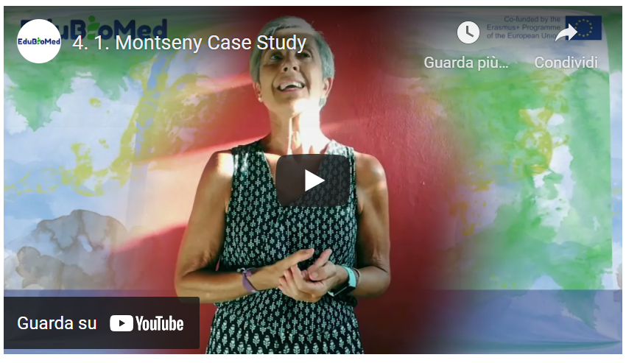

Link to video: <https://youtu.be/xMSJLvEAHIU>

Activity

Explore the web of Montseny Biosphere Reserve and read about its Gender Equality Plan[3]. You can use DeepL translator[4] since the web is in Spanish.

Transcript of the video

*The management of a territory that is called Biosphere Reserve relies on an Action Plan that the same territory presents to UNESCO during the application process. This very Action Plan should base on the Seville Strategy, in the Lima Action Plan, in the UN’s Sustainable Development Goals and in the 2030 Agenda.*

*In this regard, in the case of Montseny Biosphere Reserve, these days [September 2020] we are between the end of an Action Plan and the adoption of the following one.*

*Until now, the way we implemented the Plan was through working groups, specifically four groups that would lead the daily management of the Reserve. The first working group is for the issue of ecolabeling and the related patrimonialization of the rural heritage. Another working group of mobility and public transport, which is a very relevant topic in Montseny BR, since it is close to the place [Barcelona] where approximately 70% of Catalonia’s population lives and therefore receives many visitors. Another working group works on energy efficiency. In the case of Montseny, given the abundance of forests, biomass is a central topic. And another working group that is dealing with water management. As we like to say in Montseny BR, water is the element on which we orbit. The conservation of natural heritage passes by a good water management.*

*Besides these four basic working groups, opportunities come up. In this sense, and looking at the 5th Sustainable Development Goal - gender equality - in 2017 we organized some meetings to discuss the role of women in the rural world. These meetings were held in Montseny BR and people from other Biosphere Reserves came to share their experiences.*

*The idea that we managers had at that time was to discuss a topic that we believed important, without expectations. And the meetings were successful, mainly thanks to the engagement of attendants, who put emotions and feelings in what was happening and it created in Montseny -as I like to say- a small revolution.*

*And when the meetings concluded, many people, both men and women came to me saying that it had to continue, that we had to keep working the topic of gender equality, so we kept working, and last year [2019] we approved the Gender Equality Plan of Montseny Biosphere Reserve.*

*A plan that deals with equal gender opportunities, in a world -the rural- where inequality is even larger than in the urban world, it counts of a series of objectives (available in our website), and what is important to say is that it has been a Plan born from the same citizens of Montseny Biosphere Reserve that enabled the organization of a series of workshops on women empowerment, the creation of a women assembly, and above all... That people got to meet. Rural and mountain areas - as it’s the case of Montseny BR- they are isolated areas. So people were not knowing each other’s’ before. They did not have a relationship. Thanks to all these workshops, all the meetings and the Gender Equality Plan, a small revolution happened, as we like to say. Small business and enterprises led by women are starting, especially in the agricultural and forestry sectors.*

*I believe it is very important also because that it is not accomplishing just the 5th SDG, but also other ones, especially the #17, the one on Partnership. Well, this is the small experience of Montseny BR, and do not hesitate in contacting us for anything.*

## M4 – Lesson #2 The Arganaraie Biosphere Reserve: a delicate balance between man and the Biosphere in Morocco

Abdelaziz Afker, Arganaraie Biosphere Reserve

Abdelaziz Afker is the focal point of the Arganaraie Biosphere Reserve at the Regional Directorate of Water and Forests (Agency of the Ministry of Agriculture, Maritime Fisheries, Rural Development and Water and Forests of the Kingdom of Morocco) in Agadir. Diploma in Water and Forestry Engineering (1988 Salé Morocco) Master’s Degree in Human Resources Management and Organizations (Nancy 2009) and Professional Coaching Certificate (Casablanca 2013). Involved in all initiatives supporting sustainable management of biodiversity (projects and programs) and also in the animation and support of local groups in the process of revitalization of territories.

Description

Mr Afker tells us about the complexities of the Arganeraie Biosphere Reserve (RBA) socio-ecological landscape, in Morocco, a territory covering 2,5 millions hectares. What are the main factors hindering rather than supporting a sustainable coexistence between human development and nature conservation practices?

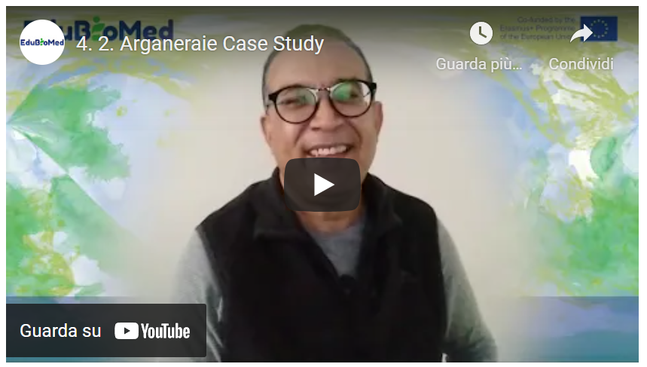

Link to video: <https://youtu.be/DzEr-5y4T2o>

Transcript of the video

*Good morning, it is a great pleasure for me to talk about the Arganeraie Biosphere Reserve (RBA). It is a reserve that was created in 1998. It is the first one in Morocco. It covers a territory that extends over 2.5 million hectares and is home to about 3 million inhabitants and which is experiencing a dynamic that is very, very complex and contrasted as well. Why is it so? Because if we take the Reserve, it is a set of territories. We will find each territory has its own characteristics, its dominant functions, we will also find characteristics related to culture, linked to the most dominant production system. If we take the mountain, it's not like the plain, the High Atlas is not like the Anti-Atlas. The coastal part is not like the continental part, even the mountain, the piedmont is where we see more presence of the population, uses and pressure on the resource.*

*And also, it is a territory rich by its culture, where we will find the identity culture characterizing the Anti-Atlas, but also that of the High Atlas. It is a crossroads from the climatic point of view of oceanic influences, Saharan influences, but also the dominance of influences characterizing the Mediterranean ecosystems found in northern Morocco. A part of these Mediterranean ecosystems is present at altitude and follows the stages constituted by the Arganaraie. The Arganaraie extends from the ocean to an altitude of 1500 . Beyond 1500, we will find the Red Juniper, Oak-Green, the Oxycedra and all the accompanying species of the ecosystems based on Oak-Green and Juniper. But the Arganeraie also consists of many, many associations, it offers many biotopes with Mediterranean species, then with species that we will find in the Canary Islands, especially the three species of euphorbia most known here, but we will find the presence of Saharan species like the acacia. And this is what gives a little more richness in terms of biodiversity to the territories, the Arganeraie and the biotope offer a lot of habitat for a remarkable and interesting fauna, I would say with an important status, very important in terms of numbers. But in terms of the importance of status, I'm going to talk here about the Cuvier gazelle, which has made a significant return, but also the mouflon and a number of species of raptors that have made a comeback.*

*We are going to talk about the relationship of these biotopes with the dynamics of the territory in terms of use, in terms of population mobility. Over time, we have points of attraction, that is, metropolises, cities that offer more jobs, if not where we have encouraged the development of good agriculture, which needs manpower, especially on the plain, and this has created mobility over time. We have a strong exodus from mountain areas to the plain or to the cities. And all this creates a lot of disturbances in relation to the biotopes. There are areas that receive this mobility, but also, on the other side, we are going to see a return of biotope balances, ecosystems in the mountains that have been more or less overexploited. And all of this is known by everyone in the world.*

*But overall, we must always keep an eye on these balances or between conservation and development. And that was the initial objective among others in the creation of the RBA: to maintain practices, to maintain production systems that operate on the same space throughout the year, but in such a good balance and a balance where the population ensures the sustainability of this resource and does not go beyond the possibilities of productivity.*

*And here, over time, we see changes, whether at the level of society or community organization. Well, we've given way to individualistic action, if I dare say so. But also, it is everywhere in the world. Also because we are part of it and we are impacted by the influences that let us go towards a consumer society. So now is the time to change scale. We want to look for return quickly and seek a profit quickly, whereas in these territories where the central point we have to manage is to look at the resilience of these territories. We are in territories with low resilience, ecosystems that need to be made resilient. Why? Because in a territory that is mostly arid and semi-arid, this means that degradation is occurring more rapidly than the return to equilibrium in terms of ecosystem composition and development. And that degradation occurs rapidly if the uses are not adapted to the resource and the loss in relation to the long-term gains is considerable.*

*Today, the challenge is to bring all actors and users, from afar, to understand that resilience is important to take into consideration in planning whose action or even in the completely normal or simple behaviour, but also to take the RBA as a way of doing, to look at the territory with the presence of all its facets. Whether natural or physical, biotic, abiotic in a general way, but also to review all the gearing of actions that are done on this territory and federate them, put them on a mechanism that ensures a certain balance between the conservation of the natural heritage in general, but also of these ecosystems, these biotopes that the argan tree offers and also be part of a sustainable development where we can not only seek the maximum, the maximum profit, but to ensure a threshold, sustainably.*

*Why? Because the loss in relation to natural capital is not something that can be easily recovered. And there, the role of the youth of young people, but also of research for me, are considerable. In this sense, it's because tomorrow is for the youth. They must be aware of their way of doing things and their relationship with the territory, but also with scientific research. It is there to bring scientific solutions and technical solutions to help managers, actors and users to better appreciate first of all the territory, but also to better adapt the action to what this territory can give. Because the will is there, everyone is aware, everyone is committed to the principle in the concept of the Biosphere Reserve. But the translation of the practice of this concept and its scale, it is still a big construction site.*

*Will the conciliation be able to be conceived in relation to the whole extent of the reserve? Or, in my opinion, we must move towards a territorial unit that is as small as possible, as I said, as small as possible in relation to the scale of the RBA, which is 2.5 million hectares, where we are going to say good, that is where the territorial unit is, where we will really seek conciliation between conservation and development, but also to put in a very precise, very clear manner the role and contribution of scientific research.*

## M4 – Lesson #3 Cevennes Case Study

Stéphane Garnier, MAB France

Stéphan Garnier, local development officer at the Cévennes National Park, is the coordinator of the Cévennes Biosphere Reserve.

Description

Stéphan will tell us about Cevennes Biosphere Reserves.

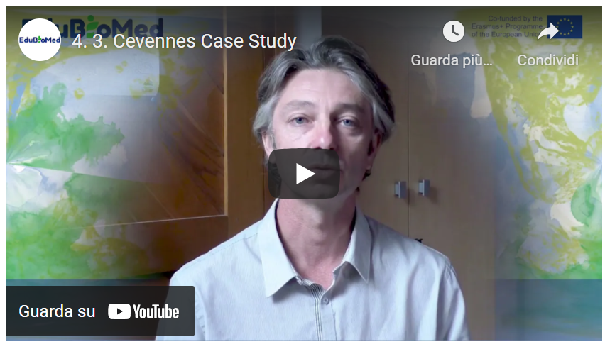

Link to video: <https://youtu.be/PTiiWVFLWd0>

Additional Resources

Animer une Réserve de biosphère… d’une génération à l’autre[5].

Park national des Cévennes[6].

Transcript of the video

*The Cévennes Biosphere Reserve has the particularity of being supported by the Cévennes National Park and has existed since 1985.*

*And indeed, the local authorities have an essential role in the implementation of the management plan which makes the Cévennes a real territorial project that has been co-constructed with all the stakeholders and where the national park is the manager, in which it has an important mission of implementation, but where the majority of the actions that are planned in this real territorial project are made by the public authority. And that's why. Moreover, it is on the basis of this project that the communities decided to join the biosphere reserve by adopting the territory project, and our role as manager of the biosphere reserve is to help the communities implement this project of territory. So, it's really a matter of providing support and advice, of agreeing contracts on very specific subjects, since the member communities have committed themselves to ten very, very specific points which correspond to the different axes of the territorial project. And then, beyond that, we count every three years or so. Other actions more specific to the municipality, which we want to carry out together and which contribute to the territorial project. Concretely, we could talk about the commitment, the modernisation of public lighting. For example, we have decided to apply for the label of international dark-sky reserve so that it will be the driving force for the territory. It engages more players than it is motivating and our action consisted in showing elected officials all the dimensions related to public lighting, i.e. both the energy side, but also the light pollution side and the impact on biodiversity. And for that, we set up training courses for elected officials, training courses for municipal agents and we released funds, notably European, throughout the Occitan region to encourage the modernisation of public lighting around very precise technical specifications that had been shared with the main technical operators of public lighting on our territory.*

*Another theme that we are working on with the local authorities is the management of public spaces, what we call the differentiated management of public spaces, that is to say bringing more biodiversity into public spaces, that is to say avoiding always chopping down. Also choose species that are resistant and do not require a lot of water.*

*It also means thinking differently about the management of cemeteries. It also means thinking differently about tree pruning. Put more plants back in the city, especially in relation to the living environment and the effects of global warming, and find and equip communities and train them, especially agents in alternative techniques to all the pesticides that are no longer used at all on our territory. And then, another action as well, which is very mobilizing for the communities. But beyond the inhabitants, it is what we call the class of communal biodiversity. It is a methodology and a national policy in France that is widely relayed in the Cévennes Biosphere Reserve by supporting the municipalities that are project owners and that, for two to three years, will mobilise all the stakeholders in their area to significantly increase their knowledge of communal biodiversity. Moreover, everything that is a field inventory is associated with moments of awareness raising and protocol learning. It is very participative and it is really a work on the sensitivity and sharing of this taste for nature and the discovery of new species. But it is also very concrete since it allows precise mapping of biodiversity to be drawn up, debates or technical committees to be held on the issues specific to the commune and on the actions that can be carried out to make it more attractive for this more welcoming biodiversity, to be more exact, and since there is a real action plan that is implemented, it can be implemented by the community in its management, but also by the citizens. Of course, schools are highly mobilised to contribute to knowledge, awareness and sharing.*

## M4 – Lesson #4 Jabal Moussa case study

Pierre Doumet, Association Protection Jabal Moussa

Pierre Doumet is the Director of the Association Protection Jabal Moussa (APJM) – MBA and a Chemical Engineering degree. He is a founding member and currently the president of APJM. Although a volunteer position, Pierre dedicates more time and effort in managing APJM than he does on managing three other companies which he directs. Renowned for his pioneer work in the private sector, Pierre brought the professionalism and focus of the private sector to the not-for-profit domain of APJM. Under his management, Jabal Moussa, designated a Biosphere Reserve in 2009, became one of the most important ecotourism destinations in Lebanon, receiving an exponentially growing number of visitors every year.

Description

Pierre will tell us about Jabal Moussa Biosphere Reserve.

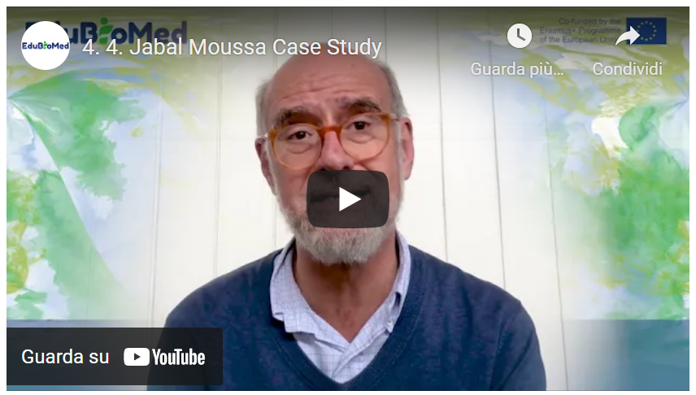

Link to video: <https://youtu.be/7CYzZzeAXh0>

Activity

Watch The Epic of Gilgamesh, Lecture by Andrew George[7]. Surf the websites of the Jabal Moussa Reserve (https://www.jabalmoussa.org/) and the Shouf Biosphere Reserve (<http://www.shoufcedar.org/>).

Transcript of the video

*In a previous video we discussed the world network of Biosphere Reserves, as well as the Mediterranean Network of Biosphere Reserves, of which Jabal Moussa is a very proud co-founder. And today we will discuss the Lebanese biosphere reserves of which one is currently inactive. It's called Jabal Rehaan and two are very active: Shouf Biosphere Reserve, four hundred and forty square kilometers , 22 villages, over 100’000 visitors a year; and Jabal Moussa Biosphere Reserve: sixty-five square kilometers , seven villages and over thirty-five thousand visitors a year. What is particularly interesting to note and emphasize is the mythological dimension of both these Lebanese Reserves, not just historical or cultural, but mythological. So Shouf is associated with the Epic of Gilgamesh out of Mesopotamia. It is said that King Gilgamesh and his alter ego Enkidu, came to Mount Lebanon from Mesopotamia to fell the large cedars there and bring them home. But there was a giant, the fierce giant called Humbaba who was there watching the forest. Unfortunately, or fortunately, depends how you see it - Humbaba gets tricked by Gilgamesh and Enkidu, and they are able to fell the large cedars and just before they take them home Enkidu talks Gilgamesh into killing the giant Humbaba. Now, that was an unnecessary act because they could they took the cedars and they could have gone home, but unfortunately, they do slay giant Humbaba.*

*So, what you have here is the mother of all protection, since this is a four-thousand-year-old story, presumably, and you also have the mother of all non-sustainable behavior since they go out and kill the giant, whatever you do remember, do not slay Hubaba. So that's the Shouf story... Now I will discuss Jabal Moussa. Jabal Moussa is bordering Adonis valley is associated with the myth of God Adonis out of Phoenician and Greek mythology, itself related with the ancient Egyptian myth of Isis and Osiris. Adonis is an exceptionally handsome young man, loved by many goddesses in the Olympus, in particular by Astarte, goddess of love and fertility, and Persephone, the goddess of the underworld. These two are fighting for his favours, but basically, he's favoring both a little bit equally. Part here, part there, until he decides that he's madly in love with Astarte and he starts being with her more than Persephone. So, she gets mad. And one day as he's hunting in the Adonis valley bearing his name by the river, he gets attacked and mauled by a mysterious wild boar, presumably sent by Persephone. And his blood flows in the river and he dies right there.*

*Well, Astarte is able to convince Zeus to let him come back to life three days every year. That's the legend and the mythology. And so, from Byblos, there was a yearly procession of the king and princes going up the river to the Astarte Temple. And they used to have there in Afaka or Afka three days of revelry and feasting for the return of Adonis. This is all, of course, mythology. But the places continue to exist today. And one of the great joys of a biosphere reserve such as ours is to contribute to the protection and knowledge of such extraordinary sites. There are three pillars in any Man and Biosphere program, and we have the same. These three are, number one, conservation of nature and culture.*

*We have seven hundred and twenty-six species of plants of which six are endemic to the sole Jabal Moussa.*

*A wonderful deciduous forest that is presumably a remnant from the Ice Age, a global important bird area. Many wonderful things that are worth conserving. What does research do? That's the second pillar. One is conservation. Two is research. Research allows us to find out about more and more things that are worth conserving. For example, local universities have found that we have all kinds of interesting mammals like hyenas and wolves that can be seen in plain daylight. And that is quite extraordinary. 50 kilometers from the capital, Beirut. Foreign University, for example, in the case of Helsinki University, they found insects, new insects or insects new to science that they actually called Jabal Mussa. Archaeology. There is a recent documentary that explains this, that we can that you can watch, that we'd like you to watch. Basically, what we have is remnants, archaeological remnants from the Kananae and Bronze Age, which is 2500 years before Christ, going all through Roman and Bizantine up to the Ottoman period. So, this is through research. We unearth these extraordinary things that we can then conserve and show people. Third pillar is the social economic aspect of sustainable development to encourage local people to protect their heritage. This is really very important because that's the philosophy of the man and biosphere concept, human beings at the heart of conservation. So here again, we have three pillars, important pillars of our socio-economic action. One is ecotourism. We have local guards and guides, all of them local. We have guest houses where people have lunch when they come. The 35000 people that came so far, a large number wants to take something to stay at guesthouses or bed and breakfast. And then we have also the traditional food products and handicrafts. So, these ecotourists, they want to take something home. And so, we have a central kitchen where the local ladies are able to make some wonderful products that people then at the entrances can take home. In particular, we have honey and oregano that are the most cherished products at this stage. A third activity we have that's been quite successful is our native tree nurseries, where we plant up to 40000 seedlings every year coming from our wonderful seeds in our forest and we propagate those. So, we are replanting large parts of Lebanon with these local native seedlings as opposed to importing stuff from outside. So, these activities are bringing something socioeconomically to the homes of the mountain of the biosphere reserve, and that makes the whole difference. Now, you can imagine that there are many constituents in the Man and Biosphere Reserve. We have the landscapes that are part of it. We have the forest, the birds, the bees, the mammals and of course, the people, as we just discussed with their invariably rich culture and traditions, how to balance the often-conflicting interests of all these constituents. That is a difficult balancing act. What we try is to respond to grassroots concerns by all constituents, of course, particularly the people, by giving them work, tested universal answers with support from international knowledge providers and donors. We call this the helicopter approach to biosphere reserve management hovering between intensely local grassroots issues and internationally tried and tested responses.*

*Does it work? So far, so good. Thank you for your attention.*

## M4 – Lesson #5 Thinking outside the borders: the Mediterranean Intercontinental Biosphere Reserve

Mchich Derrak, RBIM

Mchich Derrak is a Moroccan forestry engineer who has been working since 2003 at the Regional Directorate of Water and Forests and the Fight Against Desertification of the Rif (Agency of the Ministry of Agriculture, Maritime Fisheries, Rural Development and Water and Forests of the Kingdom of Morocco) in Tetouan. In 2011, he obtained his Master’s degree in Science in Integrated Planning for Rural Development and Environmental Management from the Mediterranean Agronomic Institute of Zaragoza, Spain. In 2017, he obtained his PhD in Ecology jointly from the University of Tetouan and the University of Alicante in Spain. He has participated in several projects on natural resource management in general and on participatory forest restoration in particular.

Águeda Villa Díaz, RBIM

Águeda Villa Díaz has a degree in Geography and History (University of Seville) and a PhD in History and Humanistic Studies: Europe, America, Arts and Languages (University Pablo de Olavide). She develops her professional activity in projects and technical studies of planning, natural heritage and culture, sustainable development and landscape. Since 2000 she has been working as an external technical advisor for the Committee of Biosphere Reserves of Andalusia. As a teacher, she is an associate professor at the Universidad Pablo de Olavide and participates in masters and courses on heritage, land management, sustainability and landscape.

Description

This capsule presents the case of the Mediterranean Intercontinental Biosphere Reserve (RBIM), a territory that goes beyond the national borders since it is ‘shared’ between Southern Spain and Northern Morocco. Two Biosphere Reserve managers, from the two different shores of the Western Mediterranean, will tell us how the RBIM is a virtuous case of international collaboration in the frame of the MaB program.

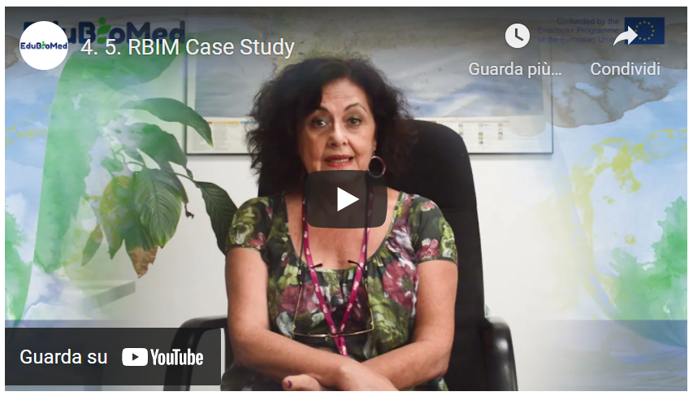

Link to video: <https://youtu.be/4GjGr7tuuqU>

Activity

Reading and analysis of the last part (pages 38-80) of the RBIM Activity Report 2006-2011. [SP[8]] [FR[9]]

Transcript of the video

**Part 1**

*The Mediterranean Intercontinental Biosphere Reserve (RBIM) is established on a double basis: first, on the recognition that there was a very much valuable socio-ecosystem that was shared between Andalusia (Spain) and Northern Morocco, that is between Europe and Africa and on the other side, the conviction that to establish a transboundary Reserve would have been a key instrument for the development of a cooperation.*

*How to do it? From one side, through two Memoranda. One that the Andalusian Regional Government (JA) holds since the year 2000 with the Reign of Morocco to do environmental cooperation; the other, more specific, ratified in 2003 between the Andalusian Environmental Office (CMA) and the Water and Forestry Office of the Moroccan Ministry of Environment (HCEF). Those are the two instruments that facilitate the establishment of the Reserve with a certain Institutional guarantee*

*From another side, an Interreg program that mobilized the funding for the drafting of the needed documents. This Reserve is presented, and it was approved in 2006. At that moment, the International Co-ordinating Council (of MAB) congratulated the initiative, finding it pretty ambitious. What stands out is that the initiative has many possibilities, despite its complexity, it has a very elaborated documentation already drafted, which achieved two very important things as to establish the main work strategies, the common values that have been worked together between Spain and Morocco; and to pave the way for future work when the proposal was accepted, the three bodies (JA, CMA, HCEF) started working together.*

*We can speak about the results of the 10-year evaluation (by UNESCO). They have been quite acceptable, and we received a particular remark on the level of maturity that the Reserve gained. Maturity that comes from the fact that the three institutions (JA, CMA, HCEF) have been willing to continue working together , not only voluntarily, but also generating an institutional instrument that allows it to be: the Memoranda. Since 2006 two more Memorandum has been ratified. One in 2011, and another in 2016. Those documents contemplate those instruments that are basic for the functioning of a Reserve: a mixed Committee, that is the transboundary management organism; the participatory organism, that is yet to be formed; and the Action Plan. An Action Plan that was conceived in a flexible way , so to make it adaptable and modifiable according to the circumstances and evaluations (from UNESCO), like projects or even the work strategies.*

**Part 2**

*The territory of the RBIM, both in its Moroccan and Spanish parts, is subject to soil erosion, forest fires, forest cover degradation, the advance of desertification or other effects related to climate change. In order to face these problems, several actions have been implemented within the framework of cooperation projects between the Moroccan and Spanish partners of the RBIM.*

*These actions focus on three main areas: conservation actions, development actions and logistical support actions. In terms of conservation actions and particularly the exchange of knowledge and experience in the field of forest fire prevention and control. The restoration of forests and some emblematic species such as cork oak, cedar and fir in Morocco or nif and fir in Spain. The strengthening of the urban waste sanitation network and the study of bird migration through Gibraltar.*

*As far as development actions are concerned, they have mainly focused on the promotion of sustainable tourism, revaluation of the products of the territory, such as meat, cheese, aromatic and medicinal plants.*

*The implementation of an integrated management in the rural environment and the strengthening of signage and supports in the protected area*

*Finally, in terms of logistical support actions, and particularly the carrying out of scientific studies developed in cooperation between the Spanish partners, the organisation of workshops on various topics such as integrated management of the RBIM, the fight against forest fires, ecotourism, management of the RBIM protected areas, etc.*

*Training for the benefit of academics, members, cooperatives, administrative technicians and engineers, nature guides.*

*The development of environmental education activities.*

*Other actions, such as the elaboration of information and communication media on the RBIM, such as leaflets, books, brochures, catalogues and finally the elaboration and strengthening of signage. Therefore, these actions have been implemented. But other projects are still open and deserve more work in order to progress in economic, environmental and social sustainability.*

*In this sense, a sustainable development strategy specific to the City is being drawn up. Another project is planned for the year 2021, which is the concretisation of governance within the RBIM. Concretely, through the operationalisation of a Participation Body that brings together different social actors involved and interested in the future, and finally the strengthening of shared management through institutional collaboration ensured and supervised by the RBIM Joint Committee.*

1. https://www.edubiomed.eu/?page_id=1620
2. <https://parcs.diba.cat/es/web/reserva-de-la-biosfera-del-montseny>
3. <https://parcs.diba.cat/es/web/reserva-de-la-biosfera-del-montseny/pla-igualtat-genere>
4. <https://www.deepl.com/translator>
5. <https://www.mab-france.org/en/new-and-publication/animer-une-reserve-de-biosphere-dune-generation-a-lautre/>
6. <http://www.cevennes-parcnational.fr/fr>
7. <https://www.youtube.com/watch?v=Rd7MrGy_tEg>
8. <https://www.edubiomed.eu/wp-content/uploads/2021/09/memoria-rbim-espa%C3%B1ol.pdf>
9. <https://www.edubiomed.eu/wp-content/uploads/2021/09/memoria-RBIM-franc%C3%A9s.pdf>