What exactly a Biosphere Reserve consists of?
The Edu-BioMed project’s course

Module 1
The role of the biosphere in an era of global change

[ENGLISH]

About Edu-BioMed
The project aims to strengthen, ameliorate and upgrade academic activity at four Moroccan and Lebanese Higher Education Institutions (HEIs) in the context of Mediterranean Biosphere Reserves (BRs), in collaboration and through networking with BRs’ stakeholders (citizens, visitors, managers and technicians), public administrations and EU Partners.

Partners:
- Universitat Autònoma de Barcelona, Spain (coordinator)
- Université d’Aix Marseille, France
- American University of Beirut, Lebanon
- Université Saint-Joseph, Lebanon
- Université Cadi Ayyad, Morocco
- Université Mohammed V de Rabat, Morocco
- MAB France, France
- Association for the Protection of Jabal Moussa (APJM), Lebanon
- UNIMED – Mediterranean Universities Union, Italy

More at
www.edubiomed.eu

The online version of the course is at:
https://www.edubiomed.eu/mooc/open-web-version-of-the-course/

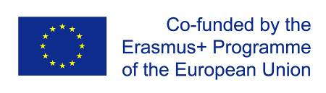 | The Edu-BioMed project has been funded with support from the European Union. This document reflects the view only of the author, and the Commission cannot be held responsible for any use which may be made of the information contained therein.
 | This work is licensed under a Creative Commons Attribution 4.0 International License

Table of Contents

Table of Contents 3
Welcome 4
Whom is the course for? 5
How to use the course 6
Module 1 - The role of the biosphere in an era of global change 7
M1 – Lesson #1 Global Change 8
M1 – Lesson #2 Climate Change 11
M1 – Lesson #3 The biosphere 14
M1 – Lesson #4 The biodiversity crisis 18
M1 – Lesson #5 Nature conservation and protected areas 22

Welcome
What exactly a Biosphere Reserve consists of?
The objective of the Edu-BioMed course is to answer to this key question from a Mediterranean perspective. The course is developed under the framework of the project, whose main objective is to promote education and applied research in Mediterranean Biosphere Reserves.
Throughout the course, participants will learn about the case of Biosphere Reserves, special protected areas promoted under the auspices of the Man and Biosphere Program of UNESCO. Teachers are professionals in the field of environmental protection and education: university professors and researchers, NGOs representatives and Biosphere Reserve managers.
The Edu-BioMed course in numbers:
- 5 modules
- 1 Inspiring Talk
- 28 lectures
- 14 organizations involved
- 22 trainers
- 1 MOOC

Whom is the course for?
The online course “What exactly a Biosphere Reserve consists of? from a Mediterranean perspective” produced within the Edu-BioMed project with the support of the Erasmus+ Capacity Building Programme of the European Union, aims to promote education and applied research in Mediterranean Biosphere Reserves and raise awareness on the management and relevance of the reserves.
The course content is composed of five modules, which explore different aspects related to Mediterranean Biosphere Reserves, exploring the role of the biosphere in an era of global change, and how Biosphere Reserves can serve to the understanding and managing of changes and interactions between social and ecological systems. Managers of the Reserves present case studies from the Med region as well as conceptual and methodological tools that are relevant in the field of conservation management.

Target Audience
The course is addressed to many different targets:
- Students developing skills on biodiversity, nature conservation, biosphere reserves and protected areas, territorial governance and more
- University educators (professors, lecturers) from several discipline, from environmental studies to Mediterranean geography, from sustainable tourism to natural sciences, etc.
- Researchers and professionals in the field of environmental protection
- Representatives and Biosphere Reserve managers, staff and practitioners
- Citizens, associations and the wider public with an interest in biodiversity and natural heritage protection
- Local communities living and working in the Biosphere Reserves
- Decision-makers at national and regional levels

How to use the course
The course is designed as a learning journey for students and adult learners, who can navigate through the 5 modules and the many lectures and resources available. Videos, readings and activities are proposed by the 22 trainers involved in the production and delivery of the contents.
The course can be accessed in both English and French.
The online course “What exactly a Biosphere Reserve consists of? from a Mediterranean perspective” produced within the Edu-BioMed project Course is one of the main outputs of the project. The content and online activities are available under an open license that enables anyone to reuse, adapt, store and share those resources.
The entire course and each one of the modules are available as standalone units of content, so anyone anywhere can repurpose them according to their own needs. To facilitate the use of the course contents, and to support the sustainability of the Edu-BioMed course over time, it has been developed in different formats.

Course Formats
PDF / WORD
The content of the course has been released as both PDF and Word files. The current document is the English version of the Edu-BioMed course.
HTML / Open Web
The open version is accessible through the Edu-BioMed project website: Open Web Version of the Course.

Terms of Use
The Edu-BioMed course contents are licensed under Creative Commons Attribution 4.0 International License.
This means that everyone is free to:
- Share: copy and redistribute the material in any medium or format
- Adapt: remix, transform, and build upon the material for any purpose, even commercially
You may do so for any purpose. However, you must give appropriate credit to the Edu-BioMed project, provide a link to the license, and indicate if changes were made. You may do so in any reasonable manner, but not in any way that suggests the licensor endorses you or your use. Moreover:
- You do not have to comply with the license for elements of the material in the public domain
- The licensor cannot revoke these freedoms as long as you follow the license terms
No warranties are given. The license may not give you all of the permissions necessary for your intended use. For example, other rights such as publicity, privacy, or moral rights may limit how you use the material.
Please contact us at info@edubiomed.eu if you have any questions about citation and attribution.

Module 1 - The role of the biosphere in an era of global change

- LESSON #1 Global Change
Roser Maneja, UAB

- LESSON #2 Climate Change
Graham Mortyn, UAB

- LESSON #3 The biosphere
Magda Bou Dagher Kharrat, USJ

- LESSON #4 The biodiversity crisis
Catherine Numa, IUCN

- LESSON #5 Nature conservation and protected areas
Maher Mahjoub, IUCN

M1 – Lesson #1 Global Change
Roser Maneja Zaragoza, Universitat Autònoma de Barcelona
Roser Maneja Zaragoza is the Project Coordinator of Edu-BioMed. PhD in Environmental Science (UAB, 2011), currently she is an Associated Professor in the Geography Department at the Autonomous University of Barcelona and Deputy Research Director at the Forest Science and Technology Centre of Catalonia. Her expertise ranges in the following fields: environmental education; communication and scientific dissemination; socioecological systems; urban biodiversity; forests; global change; health and environment and natural protected areas.

Description
We are living in an era of global change… What does this mean, or imply? Roser will introduce us to the topic from a socio-environmental perspective.

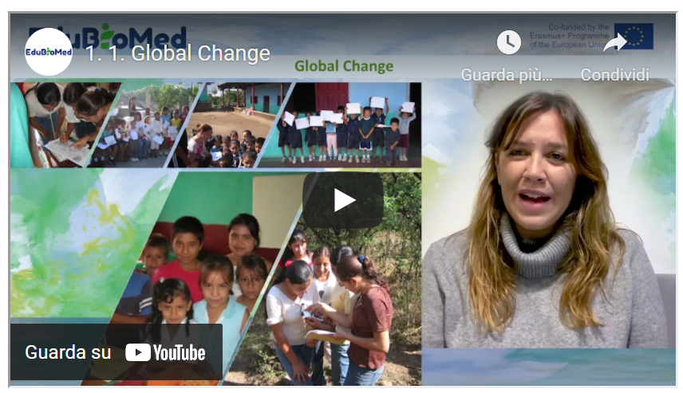
Link to the video: https://youtu.be/kJqA1Sal6bU

PPT presentation
Link to the slides:
https://www.edubiomed.eu/wp-content/uploads/2022/01/GLOBAL-CHANGE_MOOC_ROSER-MANEJA_FINAL-VERSION.pdf

Transcript of the video
Global change can be defined in a simple way as the set of socio-ecological alterations that take place in the Earth system. This set of alterations can be grouped into three main groups of impacts. The first, changes in land use and land cover. The second refers to the alteration of bio-geochemical cycles that take place in different parts and in different ecosystems of the planet. And finally, changes in biodiversity. This global change has a magnitude and speed of change hitherto unknown, so it refers to the history of mankind. It is also for the first time one of the planet's own species that is causing these changes, which although usually dry, although their expressions are at regional and local level, it is certain that their manifestations are on a global scale.
As can be seen in this slide, we can then define this global environmental change as the interaction between different socio-economic and biophysical driving forces. This global environmental change manifests itself at different times and on different spatial scales. That is why we speak of its local, regional and global dimensions. Moreover, all these changes are occurring on a temporal scale.
The history of the planet has had several cycles of change throughout the different historical stages, from the Neolithic revolution to the present day. We have suffered different oscillations of change, but it is from 1950 onwards that we can consider the year of inflection, from which all these changes are magnified and their rate of appearance is increasingly higher. Changes in landscapes, changes in the intensification of the nutrient cycle, changes in the introduction of invasive species, changes in the water cycle, in the atmospheric chemistry cycle, and also changes in the size of the world population. This year 1950 is known by the scientific community as the year B.P. before petroleum, before present, the year from which there is a massive introduction of fossil fuels that obviously change the behavior of our ecosystems.
They are different. The indicators and aspects that we can see are changing substantially on planet Earth. We talk about the ecological Footprint as an indicator that measures the number of hectares that each of the individuals living on the planet would need to satisfy our needs. As we can see, in this map, there are substantial differences between what we know as the global north and the global south, in which the differences in consumption to meet these needs is unfairly very different.
Also, as I have mentioned, changes in the world population, we can see that since this Neolithic transition, in which 3 million people were counted around the planet, we have increased to almost 8 billion people today and it is predicted that in the year 2100 this number will increase to 11 billion people in the world. There are three big drivers, the three big forces of change that we are facing today, that relate to population, to the increase of the world's population. Not only do we have a higher life expectancy, but also the per capita consumption of the inhabitants of the planet is increasing more and more.
We can then see in these graphs how this world population is increasing. And not only that, but more and more of the world's population is concentrating in urban areas.
Another of the indicators that we use to see these changes that have been occurring in a significant way since 1950 are the alterations of the cycles, in this case of the atmospheric cycles. And we can see in this graph how effectively the concentrations of carbon dioxide in the atmosphere are increasing more and more, even surpassing the limits that were already established as maximums. At that time, in addition to the increase in the average temperature of the planet, which is already almost at one point two degrees of increase in less than average.
As far as land use and land cover change is concerned, we can also see on this world map, how in certain areas of the planet, especially in these tropical and subtropical areas, deforestation rates are very latent, they are very important. Unlike what is happening in this global north, in which we can see that there is an increase of forest masses, especially in the Mediterranean area, where it can have very important effects on the water cycle, on biodiversity and also in the greater concurrence of large forest fires.
Here is a very illustrative image of what may be happening in different areas of the planet. This increase in forest mass in relation to the high rates of deforestation that are occurring in other areas of the planet.
Changes in biodiversity. Its main global causes are above all the destruction of habitats. Overexploitation of resources. Environmental pollution. Climate change and the introduction of invasive bio-invasive species may be deliberate or accidental in the face of this scenario of global change.
Faced with this scenario of ever more profound changes in our ecosystems, we firmly believe that we must change, that we must adopt a position of empowerment and not scare the population. But above all, we must be very aware of the panorama we have and be very aware that only through the empowerment of children's groups, of vulnerable groups, we can also change or try to change and reverse this situation. Also from knowledge, from training, from knowledge transfer. It is a good strategy to be able to know, to be able to appreciate the biodiversity and ecosystems that we have, to be able to face this ever-changing scenario, to be able to empower and not scare the population.
One of the proposals we have from the Edu-BioMed project is to integrate different forms of knowledge. On the one hand, tradition, empirical, traditional or popular knowledge, and on the other, scientific and academic knowledge. How to find these spaces of integration, of knowledge, of dialogue, of knowledge in relation to knowing our biodiversity? We have to consider a good tool. It is to consider our environment, our surroundings, as the best pedagogical tool.
And in this way, we can bring citizens closer, we can bring our students closer to the knowledge of their immediate environment in order to be able to value it, to be able to conserve it and to be able to understand much better what is happening on a more global scale.
In this sense, for example, young people and adolescents are a group that has traditionally been excluded from decision making, and a commitment is also to include these groups that have much to contribute.
And their knowledge is also important to also consider women and women from the global south and other areas of the planet with vulnerable situations. They are people that we must also include in this decision-making process and also in this process of including different forms of knowledge. From this traditional knowledge to more scientific knowledge.
These are some of the guidelines that we can contribute from this project, from Edu-BioMed, to make our ecosystems, to make our world a habitable world, a fairer world and a world where these changes that we are accelerating at an unprecedented rate, we can somehow incorporate them into the functioning of ecosystems. Thank you very much.

M1 – Lesson #2 Climate Change
Graham Mortyn, Universitat Autònoma de Barcelona
Graham Mortyn is researcher at the Institute of Environmental Science and Technology (ICTA) at the Autonomous University of Barcelona, where he is also affiliated to the Department of Geography. He earned BS and MS degrees in Earth Science and a PhD in Oceanography from Scripps Institution of Oceanography (University of California at San Diego, UCSD). Prior to academia he worked as a hydrogeologist. He was an Assistant Professor in California (California State University, Fresno, CSUF) before ICTA arrival in 2004.

Description
The capsule introduces to the topic of climate change. After a brief introduction to the most recent figures of global warming trends by the scientist Graham Mortyn, the learner will be invited to explore its causes and effects.

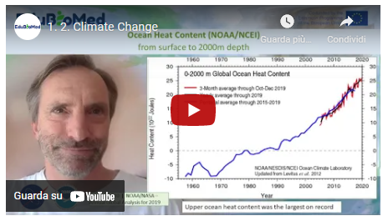
Link to the video: https://youtu.be/6DR33m1atPM

PPT Presentation
Link to the slides:
https://www.edubiomed.eu/wp-content/uploads/2021/07/PPT-Climate-Change.pdf

Activity
Learn about the causes and effects of climate change from NASA (https://climate.nasa.gov/) and IPCC (https://www.ipcc.ch/) websites.

Transcript of the video
Hello, my name is Graham Mortyn, professor at the Universitat Autònoma de Barcelona, at the Institute of Environmental Sciences and Technology, as well as at the Department of Geography.
So, I am going to try to describe global climate change in only 5-10 minutes. So, to do that, I'm going to rely on a few figures. And I understand that these my talk will be pasted into the PowerPoint where the figures exist later off line. So, I'm not actually showing you the figures right now.
So, to do this, I'm going to describe the NASA point of view of the global temperature at the end of the most recently completed year, which is the year 2019, of course. And this is something they do every year that we will in a few months to have that for the year 2020 present year. So basically, they show their annual mean for the year 2019 versus a global perspective of temperature difference and how that is different from place to place around the globe.
So, in other words, there are parts of the world that have warmed up more than other parts of the world. And so, in some sense, global warming is actually a bit of a misnomer because in some places it actually cooled. And in other places, it warmed by a lot. In other places it warmed by a little. In other places, it didn't warm or didn't cool, but it actually remained more or less the same.
And this is different from year to year based on dynamics and variability and so forth. But another thing they present, which I'll show in a later figure, is that how 2019 compared to other years and that decade versus other decades and so on. But the year 2019 was definitely accentuated in terms of warming in the high latitude northern hemisphere. And this is a process known as Arctic amplification, a part of the world highlighted in the northern hemisphere that has seen more warming than other parts of the world, not only for the year thousand and nineteen, but over several decades now really going back to the 1970s or so.
So overall in the year 2019 was zero point nine, eight degrees Celsius above the long-term average, which is taken from the year 1951 to 1980 as a form of baseline by which any year is sort of compared against as an example.
So not only the high latitude northern hemisphere, but in general, we see more warming over the landmasses and warming over the oceans, but not as much as on the landmasses. And in particular, Europe and Asia stood out with particular warming, although other continental landmasses as well.
And NASA reports that the year 2019 was the second warmest year of their long-term record. So, this second figure is showing how 2019 compared to other years, 2017-18 were relatively cool, although still very warm. Two thousand and 17 still stands out as the warmest year on record. And when you look at this graph showing a whole bunch of dots, you sort of get a sense not only of the multi decade sort of long-term increase in the global temperature, but also the entire annual variability in how, despite that long term trend of an increase, you do have a certain amount of noise in this record by virtue of things going on from one year to the next. And I'll highlight that in a subsequent figure. But another thing to point out from this figure, which I think is actually perhaps even more important, is taking the decade by decade comparison.
And so if you look at the year 2010 through ten thousand 2019 or prior decades, for example, 2000 and 2010 or 1990 to two thousand and so on, from that more collective time perspective, the annual global temperature increase and the amount of the warming is basically just going up from decade to decade, really going back to the 1970s or so.
And that is considered a time of sort of a regime shift when that global warming pattern in the media annual temperature record really started to go up and remain going up now for several decades, basically probably throughout the lifetimes of most people who are listening to this presentation. So that is a very significant observation about the global climate system.
Now to point out how inter annual variability can play a role. This third figure that I'm showing is the impact of El Nino Southern Oscillation on the NASA analysis. Now, I'm not going to take the precious time that I have and get into the details of what is El Nino Southern Oscillation, but take it at face value that it is a big temperature anomaly, among many other things, in the world's largest oceanic basin. And that is the Pacific. And because it's happening in the world's largest oceanic basin, it has impacts on the atmosphere. It has impacts on adjacent landmasses with tell a connection to other parts of the world. And so big El Nino events actually impact the global pattern.
And so, in the lower left of this diagram, you can see that the so contribution to specific years like 2015 and 16 were positive as it was for the year two thousand and nineteen. And those values are 0.03 for the year 2015, 0.11 degrees Celsius for the year 2016 and 0.07 degrees Celsius for the year 2019. So, by contrast, during La Nina conditions the opposite phase to El Nino. When you actually have a cooling anomaly in the Pacific Basin, that number becomes negative and 2017 and 18 were like that.
So, there are inter-annual changes that take place like El Nino, Southern Oscillation or El Nino and La Nina cycling that can give rise to one particular year’s variability. And another thing to point out on this record is volcanic eruptions as well, because sometimes from large emissions of volcanoes and their particles into the atmosphere and even as high up as the stratosphere, you can have short term cooling events. And so, Mount Pinatubo in the 1990s is probably the most recent large scale example of this on a global basis where that particular eruption is shown, as well as other volcanic eruptions, amount of going and LTE children in prior decades. But in the 1990s, for example, Mount Pinatubo had a very notable global cooling on a short-term basis of about a year or so after that eruption took place. So, despite the long-term warming trend, you do get inter-annual effects and features that can make any one year sort of stand out or be different on a short term basis.
So that's not to be taken lightly and not to be confused with the long-term trend. So now the last point, my fourth slide here is showing you the oceanic heat content from the National Oceanic and Atmospheric Administration. And last year at the end of 2019, it was the first year that they reported this, to my knowledge, down to a depth of two thousand meters. So, this is really significant because it implies that not only are the global oceans continuing to warm, as the graph suggests, but they are now reporting this warmth to deeper depths than prior times. So, this is implying that the warming is propagating from the top down in our global ocean system. And whether you look at the red curve here versus the black curve versus the blue curve, different ways of averaging time such that smaller amounts of time to larger amounts of time going from three months to five years, from red to blue to black with the black being annual record, you see a long term increase. And this increase in global ocean heat content is really disturbing in many respects because of things like hurricanes and storms and how the warming of the oceans is basically fuel for increasingly strong storms born from the oceans like hurricanes. As time goes on. So, this does not bode well for our planet. And it does not bode well for us as the human species that is increasingly inhabiting coastal cities, for example, that are prone to hurricanes and other such disasters. So that's a global climate change in a nutshell. And I hope that is useful and interesting for you. And I will now sign off. Thank you.

M1 – Lesson #3 The biosphere
Magda Bou Dagher Kharrat, University of Saint Joseph
Magda Bou Dagher Kharrat is a Professor at the University of Saint Joseph in Beirut (USJ) and Director of the Biodiversity and Functional Genomics Laboratory at the Faculty of Science of USJ. She holds an advanced degree from the University of Paris-Sud and a PhD on cedar genetics from the University Pierre et Marie Curie. She is President and co-founder of the NGO Jouzour Loubnan. She is a member of several international learned societies and research consortia and is the author of about 50 scientific papers. Her research work focuses on the genetic characterisation of the biodiversity of Lebanon and the Mediterranean region. The application of his research helps to define concrete and sustainable conservation policies.

Description
Prof. Magda Bou Dagher will explain what the biosphere consists of.

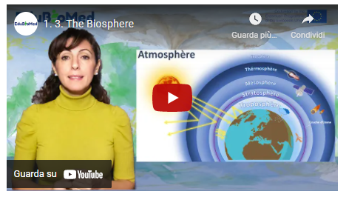
Link to video: https://youtu.be/muP3T_0oSbo

PPT Presentation
- Link to slides: https://www.edubiomed.eu/wp-content/uploads/2021/07/PPT-The-biosphere-1-9.pdf
- Link to slides: https://www.edubiomed.eu/wp-content/uploads/2021/07/PPT-The-biosphere-10-15.pdf
- Link to slides: https://www.edubiomed.eu/wp-content/uploads/2021/07/PPT-The-biosphere-16-19.pdf

Additional resources
- The Official Wizard Mind – Understanding the atmosphere.
- Journey to the centre of the Earth by Science Etonnante – The lithosphere.
- A Day on Earth, BBC.
- Interactions in an Ecosystem: How Wolves Change Rivers.
- Soil fauna: soil bioturbation.
- Calculate your ecological footprint - valid for Switzerland but will give you a rough idea of your ecological footprint.

Transcript of the video
The term biosphere is a contraction of the two Greek root words bios meaning "life" and sphaîra: sphere / or globe to refer to the earth globe.
It is therefore the set of living organisms on our planet and the space they occupy, in other words, any place on our planet Earth where there are living beings.
This biosphere consists of 3 parts:
- The atmosphere: the first 20 km of the atmosphere above our heads,
- The lithosphere: or the part of the earth's crust in and on which life exists.
- And the hydrosphere that encompasses all the waters of our planet whether fresh or salt, flowing or stagnant.
The atmosphere
The atmosphere is made up of several layers. We will focus here on the thin film of gas that surrounds the earth where the gases that form it are emanations from the earth itself. This layer is called TROPO-SPHERE, it is the seat of activity of living beings. It is thicker at the equator (13-16 km) than at the poles (7-8 km) and it is in this layer that meteorological phenomena, rain, thunder, lightning, storms and it is where airplanes travel.
The atmosphere is vital! No atmosphere, no greenhouse effect, no greenhouse effect, no life on earth. The term "greenhouse effect" has a negative connotation relative to the terrible global warming that our planet is currently experiencing. But be aware that if life is possible on Earth, it is thanks to this green-house effect that the temperature on its surface is neither too cold nor too hot. Without the atmosphere the temperature on earth would be -18°C. whereas thanks to this atmosphere the average temperature of the earth is around +15°C. The greenhouse effect is therefore vital but it is its accentuation that is harmful to us! To distinguish between these two notions, we will then speak of the "anthropogenic" greenhouse effect.

The lithosphere
The lithosphere is the rigid envelope of the Earth's surface that includes the crust and upper mantle, which make up the hard and rigid outer layer of the Earth.
The Earth's lithosphere is both continental and oceanic. The Earth's crust is divided into a number of tec-tonic plates, also called lithospheric plates.
Everything we know as living beings is on the lithosphere.
Not only on the surface but also IN the soil where millions of life forms evolve and make the soil fertile. Yes, the soil is alive.
The hydrosphere refers to all water on Earth, whether it is in liquid, solid or gaseous form; fresh, brackish or salty; flowing or stagnant.
Water provides shelter and food for a wide range of plant and animal organisms, enabling the establishment of complex and balanced food chains.
One should not conceive these 3 subdivisions The atmosphere, the lithosphere, and the hydrosphere as independent! Indeed, the biosphere is the seat of a constant interaction between the environment and the organisms that live there.
The biosphere's living conditions are maintained thanks to physico-chemical cycles (carbon, water, nitro-gen cycles, etc.) that allow elements to circulate between the environment and living beings.
The biosphere is the seat of a constant interaction between the physical environment and its abiotic (non-living) factors, whether climatic or non-climatic, and biotic factors (living beings) and their variability.
The environment influences living beings, their distribution, life cycle, reproduction, dormancy etc... and in turn these living beings shape the environment in which they live.
These interactions can be as basic as a food web. On this slide the food chain begins with primary producers such as the algae living in the pond which feeds the mosquitoes which in turn are eaten by the frogs .... The interdependence of several food chains forms a food web. The more complex the network, the more resilient the ecosystem is.
Food networks are not the only forms of interaction, here are some examples: competition, parasitism, predation, commensalism, mutualism or amensalism.... (TD related to these interactions)
The biosphere has been shaped by these interactions for MILLIONS of years! And the history of their presence on Earth and their evolution is very old. Dictated by all the geological and climatic events that our planet has known even before the appearance of mankind.
If you relate the history of life on earth to 1 hour of time, you will notice that the appearance of the hu-man species dates from the very last seconds compared to other forms of life whose presence is much older.
For more than 275,000 years since the appearance of our species, we were a species like any other we hunted and gathered for food. It is from the Neolithic period - around 12,000 - that human civilization be-came sedentary by domestication of plants and animals and since then our technology has not stopped evolving at times in such a dazzling way that for the first time in the history of the Earth a species is changing its face!

We have disturbed the biogeochemical cycles of our planet so much that we have decreed this new Anthropocene area!
It is a term of geological chronology proposed to characterize the time in Earth's history that began when human activities had a significant global impact on the Earth's ecosystem.
Biodiversity is weakened by human activities. It is declining almost everywhere in the world. Human population densities continue to increase. This translates into a continuous and rapid acceleration in the use of space and an increase in pressures on ecosystems and the species they contain. Pollution, the intro-duction of invasive species, overexploitation of natural resources, degradation, fragmentation and loss of habitats are all factors responsible for the erosion of biodiversity. Exacerbated by climate change, this anthropisation threatens to destroy the fragile balance of ecosystems and the biodiversity they contain.
The UNESCO program, Man and the Biosphere, launched in 1970, its objective is to preserve for present and future use, the diversity and integrity of animal and plant biotic communities within natural ecosystems, and to safeguard the genetic diversity of species on which their continued evolution depends.
Biosphere reserves are sites designated by national governments and recognized by UNESCO. They are learning sites for sustainable development.
Biosphere reserves allow ecological research and in particular basic studies in natural environments as well as in degraded environments. The purpose of these sites is to reconcile the conservation of natural and cultural diversity with economic and social development. They enable innovative approaches to sustainable development to be tested and developed from the local to the international level.
Biosphere reserves must fulfill three major functions:
1. Conservation function - contributing to the conservation of landscapes, ecosystems, species and genes.
2. Development function - to promote economic and human development that respects socio-cultural and environmental particularities.
3. Logistical function - to encourage research, monitoring, education and information exchange on local, national and global conservation and development issues.
Biosphere reserves are organized into three interconnected zones: the core area, buffer zone, and transition area, and only the core area must be protected by national legislation.

M1 – Lesson #4 The biodiversity crisis
Catherine Numa, IUCN Centre for Mediterranean Cooperation
Catherine Numa, PhD, is the coordinator of the Mediterranean Species Programme at the IUCN Centre for Mediterranean Cooperation. She coordinates two initiatives, the “Mediterranean Biodiversity Assessment” and the “Development of strategic conservation plans for threatened species”.

Description
In this capsule, Ms Catherine Numa (IUCN) explain us what biodiversity is, why it is important, how we are losing it, and what we can do for preserving it.

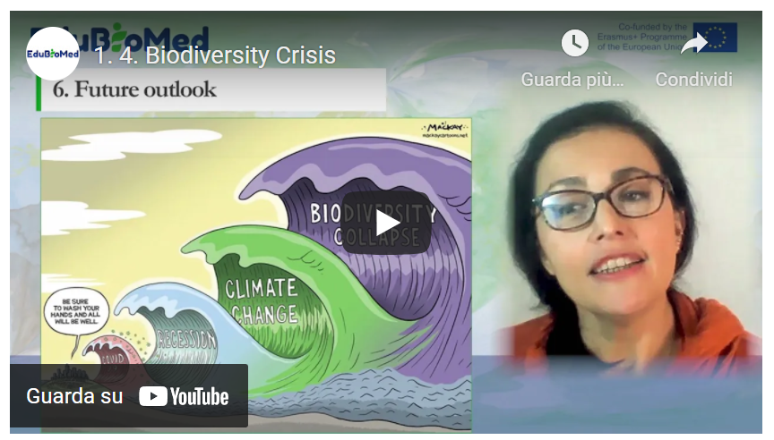
Link to video: https://youtu.be/15PrIy8etls

PPT presentation
Link to slides: https://www.edubiomed.eu/wp-content/uploads/2021/07/PPT_The-Status-of-Biodiversity.pdf

Further reading
In Defense of Biodiversity: Why Protecting Species from Extinction Matters, Carl Safina (2018)
Transcript of the video
In this chapter we will explore biodiversity and learn about its status nowadays. We will start by defining biodiversity, then learning about the number of existing species. We will explore the latest assessment of about the status and trends. The main threatened species, why it is important for us. And finally, what can be done to improve the situation.
So first, let's just clarify what we mean by biodiversity. Biodiversity refers to all variety of life that can be found on Earth. Plants, animals, fungi and microorganisms, as well as the communities that they form and the habitats where they live. It is the shortened form of two words "biological" and "diversity". In the article 2 of the Convention on Biological Diversity, a United Nations treaty, gives a formal definition of biodiversity that is often used.
Biological diversity is often understood at three levels. Species diversity refers to the variety of species (animals, plants, fungi and micro-organisms). Genetic diversity corresponds to the variety of genes contained in these organisms; ecosystem diversity refers to all the different habitats that exist, like forests, deserts, wetlands, coral reefs, etc.
Now let’s analyze how much biodiversity is in our planet. Researchers estimate that there are about 8.7 million species globally. However, we have barely scratched the surface! Science has only described 1.2 million species or so insofar. Some studies estimate that we have yet to discover around 86% of the species on Earth and 91% in the ocean. If you ever wanted to discover a new species, plan your next trip to tropical rainforests, or to the deep ocean, or actually don’t move because much of this undiscovered life is likely to be in these places or hidden in the soil.
But let’s focus on what we know.
1.2 million species. How are all these species doing? As per today only a few of these species have been assessed. There are several assessments at different levels: international, multi-country and national level, focusing on different species groups. For example, we have the IUCN red list of threatened species. The IUCN Red List index, the Living Planet Index or the IPBES Global Assessment Report.
The IUCN Red List is considered the most comprehensive international information source on the global extinction risk for species. It is a critical indicator of the health of the world’s biodiversity and it is used by most assessments worldwide.
And as per today, it has assessed 120,000 species, that is about 10% of the known species.
As per data from November 2020, from the total assessed species in the Red List, 32,000 species (that is almost a third of assessed species!), are threatened with extinction.
Based on data from the IUCN Red List of Threatened Species, the Red List index shows how likely a species –or group of species- could survive over time. A Red List Index value of 1.0 equates to all species qualified as Least Concern (which means, not expected to become Extinct in the near future). An index value of 0 however, equates to species having gone Extinct. Thus, a decline such as the corals’ line shows in this graph, indicates that species are being driven towards extinction at an accelerating rate. If the rate of biodiversity loss were reducing, the index would show an upward trend, but as we can see in this graph, none of these groups of species are in that scenario.

The Living Planet Index (LPI), which mainly focuses on populations trends of mammals, birds, fish, amphibians and reptiles, and is another tool to measure biodiversity. In its 2020 report, the LPI showed how these populations have declined 68%, since 1970.
And we can see in this graph how this trend is observed almost worldwide.
The IPBES Global Assessments are mostly based on IUCN Red List data. As you can see in this chart extracted from their 2020 global assessment report, it is possible to see how the global extinction risk in different species’ groups has alarming percentages, especially in amphibians and cycads.
The most threatened group, Cycads are plants that have been growing on our planet for over 250 million years. Who would have thought that plants that managed to survive ice ages, asteroids and being munched on by dinosaurs, are now threatened by habitat degradation and poaching… just to embellish our gardens.
According to IUCN Red List, the imperiled species are mainly threatened by habitat loss due to agriculture and aquaculture practices, …
…urban development, …
… deforestation...
… and invasive species and pests.
So, we have seen how species are declining at alarming rates, due to several factors.
So what? Species come and go... extinction is a natural process. Indeed – but not at this rate.
Studies have compared the current extinction rates with what would be expected from the fossil record and have concluded that the loss of species since 1970, is accelerating in a dramatic and serious way. Today, the loss of species now classed as 'critically endangered’ could propel the world into a sixth mass extinction
“So what? Too bad. Sorry! Why would we be interested in saving a creature such as… this one?” Some may still say. This is the naked mole-rat. He is the longest living rodent on Earth – up to 37 years, and it turns out that it has an exceptional resistance to cancer. Turns out that this animal’s immune system, the result of millions of years of genetic evolution, could maybe help us find a cure to cancer.
On Earth, each species has evolved over millions of years and has adapted to survive, its own way. Every time we lose one of them, due to human pressures, we lose a heritage of 4 billion years of nature’s evolutionary wisdom. The current situation can be compared to an immense library with millions of books. Each day, hundreds of books disappear, and we did not even have time to read the title of these books. This genetic loss, is irreversible, and it’s a huge loss of opportunity for humanity.
Besides the intrinsic value of nature, the reality is that biodiversity is also essential for human wellbeing. Morphine, corticoids, antibiotics… Up to 50% of the approved drugs are derived from plants. All food systems depend on biodiversity and a broad range of ecosystem services that support agricultural productivity. For example, bees with pollination, spiders and other insects for pest control. These are just examples. The list of benefits we get for free from nature are countless. The TEEB study is trying to estimate the economic value of biodiversity’s contribution to people. For example, it is estimated that for an annual investment of US$45 billion into protected areas alone, the delivery of ecosystem services worth some US$5 trillion a year could be secured.
Well, so what can we do? Since 1993, conservation efforts have saved up to 48 mammal and bird species from extinction. Without such interventions, extinction rates for mammals and birds over the past 27 years would be three to four times higher. But we need more efforts. The Global Biodiversity Outlook 5, published in September 2020, provides an interesting graph with various areas of action that, in combination, could bend the curve and halt this biodiversity decline. These actions are, from bottom to top: (1) Enhance conservation and restoration of ecosystems; (2) climate change mitigation; (3) reduce other drivers such as pollution, invasive alien species and overexploitation; (4) more sustainable production of goods and services, especially food; and (5) reduce consumption and waste. None of the areas of action alone, nor in partial combinations, can bend the curve of biodiversity loss. The effectiveness of each area of action is enhanced by the other areas, but they all require a collective effort.
In 2020, the world has faced a pandemic that, interestingly, is related to biodiversity. We know that there are many more waves to come. On our current trajectory, biodiversity, and the absolutely essential services it provides to humanity, is projected to decline, jeopardizing the delicate balance of our common home, the Earth. With the assessments and the data that we currently have, we cannot look the other way anymore. We’ve been warned. But the good news, is that we are still on time to bend the curve of this decline and its consequences.

M1 – Lesson #5 Nature conservation and protected areas
Maher Mahjoub, IUCN Centre for Mediterranean Cooperation
Maher Mahjoub is Regional Programme Coordinator, International Union for the Conservation of Nature (IUCN) Mediterranean Cooperation Centre, Málaga, Spain.

Description
In this capsule, Mr Maher Mahjoub (IUCN) explain what protected areas consists of, why they are important, how they are categorized and provide us with facts and figures on the current panorama from the nature conservation world.

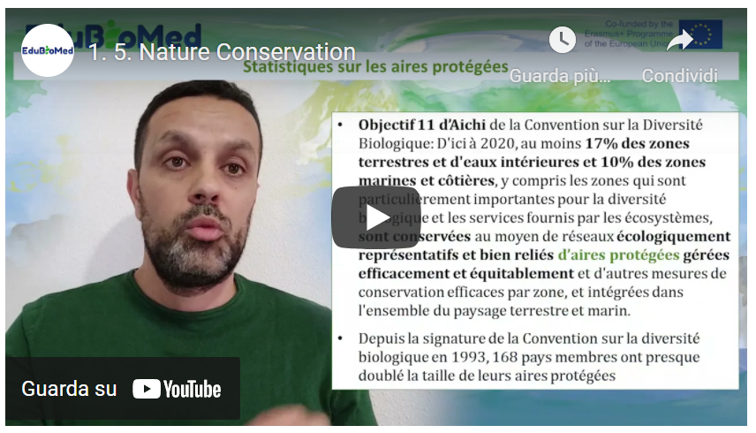
Link to video: https://youtu.be/NdoxUBL3Bb0

PPT presentation
Link to slides:
https://www.edubiomed.eu/wp-content/uploads/2021/07/PPT-Nature-conservation-and-protected-areas.pdf

Activity
Have a look at the World Database on Protected Areas https://www.iucn.org/theme/protected-areas/our-work/world-database-protected-areas and consult the Green List for Protected and Conserved Areas website https://iucngreenlist.org/ .

Transcript of the video
Hello, I am Maher Mahjoub, I am Programme Officer at the International Union for the Conservation of Nature. I am going to talk to you about the subject of protected areas. And to start with, what is a protected area?
The IUCN, the International Union for the Conservation of Nature defined a protected area in 2008 as follows. It is a geographically clearly defined area that is recognized, dedicated and managed by any means, effective, legal or otherwise, to ensure the long-term conservation of nature and its associated ecosystem services and cultural values. Protected areas may be established in terrestrial, coastal or marine environments. Protected areas contribute to the conservation of species. Either of an ecosystem or of a whole formed by natural and cultural components.
The importance of protected areas. Protected areas are an important pillar of biodiversity conservation strategies at the country level. They also contribute to the development of human and social activities. By ensuring the provision of many ecosystem services, be it locally, globally, through food, drinking water or medicines. Protected areas are also internationally recognized as an important natural tool in the fight against climate change. From a creation and management point of view, protected wings can be under the responsibility of States, NGOs, indigenous peoples or private entities.
The creation of protected areas began long ago. Among the first national parks created in the world was Yellowstone National Park in the United States, established in 1872. The Virunga National Park in the Democratic Republic of Congo, created in 1925, is also cited as an example.

The International Union for the Conservation of Nature - in addition to the definition - has established 7 categories for the management of protected areas. These management categories differ according to the management objectives assigned to each protected area. The 7 management categories are as follows. Integral nature reserve. Wilderness areas. National park, natural monument. Habitat or species man-agreement area. Protected terrestrial or marine landscapes and finally, protected resource management areas. You can see that as you go from the first category to the last, the degree, the level of protection established at the level of the protected area decreases. Going from integral protection to shared management in category 6.
Statistics on protected areas. The World Database on Protected Areas, which collects data from countries for the Global Report on the State and Status of the World's Protected Areas, indicates that as of November 2020 there are just over 260,000 protected areas in the world. Of course, these are protected areas in terrestrial, coastal and marine environments. 8% of this figure of protected areas have conducted an assessment of management effectiveness. In other words, just over 20,000, which is a very, very low figure.
The Aichi objective 11 of the Convention on Biological Diversity states that by 2020, at least 17% of terrestrial and inland water areas and 10% of marine and coastal areas, including areas of particular im-portance for biological diversity and ecosystem services, are conserved. On average of what? Through ecologically representative and well-connected networks - of what? - of protected areas. This means that the international community, through the Convention on Biological Diversity, recommends and calls on countries to double their efforts to reach 17% of protected areas in terrestrial areas and 10% of protected areas in coastal and marine areas. It should be recalled that since the signing of the Convention on Bio-logical Diversity in 1993, 160 member countries have almost doubled the surface area and size of their protected areas. Which is very, very good.
I had indicated the importance of effective management of protected areas because protected areas should not only be created. But also establish management plans and ensure that these management plans are executed and implemented. And for this purpose, the International Union for Conservation of Nature has developed in 2014 the 'green list' programme of protected areas. The objective of this pro-gramme is to help countries to reach international standards for the management and management effectiveness of protected areas. This standard has four evaluation components. An evaluation on the planning of the protected area. Another on effective management. A third component on equitable governance. A fourth component on successful conservation. For these four components, there are 17 criteria and 50 indicators to be assessed at site level, which may be relevant for the green list of protected areas. As of November 2020, 108 protected areas in the world have managed to get the IUCN Green List la-bel. Protected areas are a national and international heritage. And the international community must re-double its efforts to reach the commitments of 17% on land and 10% on the sea. Until the end of 2020, it should be remembered that the global biodiversity framework for the post-2020 period will indicate a more ambitious target of 30% terrestrial and 30% marine protected areas that must be achieved by the countries that are contracting parties to the Convention on Biological Diversity.
Thank you.

https://www.edubiomed.eu/?page_id=1620
https://youtu.be/ErKJv0FmgG4
https://www.youtube.com/watch?v=muWrmfXpivY
https://www.youtube.com/watch?v=ysa5OBhXz-Q&feature=youtu.be
https://www.youtube.com/watch?v=Mxp1nnrUG0Q&feature=youtu.be
https://www.wwf.ch/fr/vie-durable/calculateur-d-ecological-footprint
https://e360.yale.edu/features/in-defense-of-biodiversity-why-protecting-species-from-extinction-matters

