What exactly a Biosphere Reserve consists of?
The Edu-BioMed project’s course

[ENGLISH]

About Edu-BioMed
The project aims to strengthen, ameliorate and upgrade academic activity at four Moroccan and Lebanese Higher Education Institutions (HEIs) in the context of Mediterranean Biosphere Reserves (BRs), in collaboration and through networking with BRs’ stakeholders (citizens, visitors, managers and technicians), public administrations and EU Partners.

Partners:
- Universitat Autònoma de Barcelona, Spain (coordinator)
- Université d’Aix Marseille, France
- American University of Beirut, Lebanon
- Université Saint-Joseph, Lebanon
- Université Cadi Ayyad, Morocco
- Université Mohammed V de Rabat, Morocco
- MAB France, France
- Association for the Protection of Jabal Moussa (APJM), Lebanon
- UNIMED – Mediterranean Universities Union, Italy

More at
www.edubiomed.eu

The online version of the course is at:
https://www.edubiomed.eu/mooc/open-web-version-of-the-course/

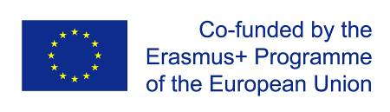 | The Edu-BioMed project has been funded with support from the European Union. This document reflects the view only of the author, and the Commission cannot be held responsible for any use which may be made of the information contained therein.
 | This work is licensed under a Creative Commons Attribution 4.0 International License

Table of Contents

Table of Contents 3
Welcome 5
Whom is the course for? 6
How to use the course 7
Presentation of the course 8
Inspiring talk: Biosphere Reserves as a lecture room 10
Module 1 - The role of the biosphere in an era of global change 12
M1 – Lesson #1 Global Change 13
M1 – Lesson #2 Climate Change 16
M1 – Lesson #3 The biosphere 19
M1 – Lesson #4 The biodiversity crisis 23
M1 – Lesson #5 Nature conservation and protected areas 27
Module 2 – What a Biosphere Reserve is (and is not!) 30
M2 - Lesson #1 The Man and Biosphere program (intro) 31
M2 - Lesson #2 The Biosphere Reserve concept 34
M2 – Lesson #3 How to become a Biosphere Reserve? 37
M2 – Lesson #4 The role of Scientific Committees in the management of a Biosphere Reserve 40
M2 – Lesson #5 The Mediterranean region 43
Module 3 – How Biosphere Reserves contribute to understanding and managing changes and interactions between social and ecological systems 46
M3 - Lesson #1 Biosphere Reserves as social-ecological systems 47
M3 – Lesson #2 Conflicts over the commons 52
M3 – Lesson #3 Patrimonialization of heritage 55
M3 – Lesson #4.1 Territorial governance in Biosphere Reserves 60
M3 – Lesson #4.2 Territorial governance in Biosphere Reserves. The case of Morocco 64
M3 – Lesson #5 Biosphere Reserves and Education 65
Module 4 – Case studies from the ground presented by Biosphere Reserve managers 66
M4 – Lesson #1 The role of women in Montseny Biosphere Reserve 67
M4 – Lesson #2 The Arganaraie Biosphere Reserve: a delicate balance between man and the Biosphere in Morocco 70
M4 – Lesson #3 Cevennes Case Study 73
M4 – Lesson #4 Jabal Moussa case study 75
M4 – Lesson #5 Thinking outside the borders: the Mediterranean Intercontinental Biosphere Reserve 78
Module 5 – Conceptual and methodological tools relevant in the field of conservation management 82
M5 – Lesson #1 Biodiversity knowledge, monitoring and representation 83
M5 – Lesson #2 Citizens science in Med BRs 87
M5 – Lesson #3 Stakeholder engagement 89
M5 – Lesson #4 Tools for decision making 91
M5 – Lesson #5 European Project Design and Mangement – Introduction to EU Programmes 94
M5 – Lesson #6 European Project Design and Management – Proposal preparation 97

Welcome
What exactly a Biosphere Reserve consists of?
The objective of the Edu-BioMed course is to answer to this key question from a Mediterranean perspective. The course is developed under the framework of the project, whose main objective is to promote education and applied research in Mediterranean Biosphere Reserves.
Throughout the course, participants will learn about the case of Biosphere Reserves, special protected areas promoted under the auspices of the Man and Biosphere Program of UNESCO. Teachers are professionals in the field of environmental protection and education: university professors and researchers, NGOs representatives and Biosphere Reserve managers.
The Edu-BioMed course in numbers:
- 5 modules
- 1 Inspiring Talk
- 28 lectures
- 14 organizations involved
- 22 trainers
- 1 MOOC

Whom is the course for?
The online course “What exactly a Biosphere Reserve consists of? from a Mediterranean perspective” produced within the Edu-BioMed project with the support of the Erasmus+ Capacity Building Programme of the European Union, aims to promote education and applied research in Mediterranean Biosphere Reserves and raise awareness on the management and relevance of the reserves.
The course content is composed of five modules, which explore different aspects related to Mediterranean Biosphere Reserves, exploring the role of the biosphere in an era of global change, and how Biosphere Reserves can serve to the understanding and managing of changes and interactions between social and ecological systems. Managers of the Reserves present case studies from the Med region as well as conceptual and methodological tools that are relevant in the field of conservation management.

Target Audience
The course is addressed to many different targets:
- Students developing skills on biodiversity, nature conservation, biosphere reserves and protected areas, territorial governance and more
- University educators (professors, lecturers) from several discipline, from environmental studies to Mediterranean geography, from sustainable tourism to natural sciences, etc.
- Researchers and professionals in the field of environmental protection
- Representatives and Biosphere Reserve managers, staff and practitioners
- Citizens, associations and the wider public with an interest in biodiversity and natural heritage protection
- Local communities living and working in the Biosphere Reserves
- Decision-makers at national and regional levels

How to use the course
The course is designed as a learning journey for students and adult learners, who can navigate through the 5 modules and the many lectures and resources available. Videos, readings and activities are proposed by the 22 trainers involved in the production and delivery of the contents.
The course can be accessed in both English and French.
The online course “What exactly a Biosphere Reserve consists of? from a Mediterranean perspective” produced within the Edu-BioMed project Course is one of the main outputs of the project. The content and online activities are available under an open license that enables anyone to reuse, adapt, store and share those resources.
The entire course and each one of the modules are available as standalone units of content, so anyone anywhere can repurpose them according to their own needs. To facilitate the use of the course contents, and to support the sustainability of the Edu-BioMed course over time, it has been developed in different formats.

Course Formats
PDF / WORD
The content of the course has been released as both PDF and Word files. The current document is the English version of the Edu-BioMed course.
HTML / Open Web
The open version is accessible through the Edu-BioMed project website: Open Web Version of the Course.

Terms of Use
The Edu-BioMed course contents are licensed under Creative Commons Attribution 4.0 International License.
This means that everyone is free to:
- Share: copy and redistribute the material in any medium or format
- Adapt: remix, transform, and build upon the material for any purpose, even commercially
You may do so for any purpose. However, you must give appropriate credit to the EduBioMed project, provide a link to the license, and indicate if changes were made. You may do so in any reasonable manner, but not in any way that suggests the licensor endorses you or your use. Moreover:
- You do not have to comply with the license for elements of the material in the public domain
- The licensor cannot revoke these freedoms as long as you follow the license terms
No warranties are given. The license may not give you all of the permissions necessary for your intended use. For example, other rights such as publicity, privacy, or moral rights may limit how you use the material.
Please contact us at info@edubiomed.eu if you have any questions about citation and attribution.

Presentation of the course
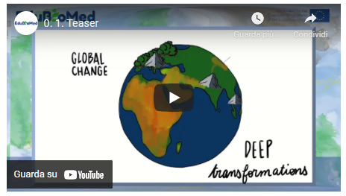
Link to video: https://youtu.be/Wr4ZEQyaymo

We are living in an era of global change. The Earth system is experimenting with deep transformations, on a planetary scale. The carbon, nitrogen and water cycles are altering; the climate is getting warmer; the population is growing; land cover is changing; the economy is globalizing; the urban is growing; the atmosphere, the soils, and the water bodies are getting polluted; the biodiversity is disappearing and getting poorer.

The biosphere is in crisis. And since we are part of it, we should start caring for it, but seriously.
During the last decades, nature conservation mechanisms, tools and practices have been put in place at various levels and scales. Governments, international organisms and civil society organizations have been working together, signing agreements and instituting environmental protected areas for the conservation of the biosphere and its bio-cultural diversity.
Throughout this course, we will learn about the case of Biosphere Reserves, special protected areas promoted under the auspices of the Man and Biosphere Program of UNESCO. According to UNESCO: “Biosphere reserves promote solutions reconciling the conservation of biodiversity with its sustainable use. They are learning areas for sustainable development under diverse ecological, social and economic contexts, touching the lives of more than 250 million people.”

But…what exactly a Biosphere Reserve consists of?
The objective of this course is to answer this question from a Mediterranean perspective and under the frame of Edu-BioMed, an international cooperation project co-funded by the Erasmus+ program of the European Commission, which main objective is to promote education and applied research in Mediterranean Biosphere Reserves. The project involves several organizations from Mediterranean countries, including universities and, of course, Biosphere Reserves management bodies.
You will have as teachers some professionals in the field of environmental protection and education: university professors and researchers, NGOs representatives and Biosphere Reserve managers.

The course is divided into five modules.
- In the first module, we will deepen our understanding of the role of the biosphere in an era of global change.
- In the second module, we will explain what a Biosphere Reserve is (and is not!)
- In the third module, we will see how Biosphere Reserves can serve to the understanding and managing of changes and interactions between social and ecological systems
- In the fourth module, Biosphere Reserve managers will take the stage and will bring case studies from the ground
- In the fifth module, we will provide with a few conceptual and methodological tools that are relevant in the field of conservation management

And now… it is time to learn from Biosphere Reserves!

Inspiring talk: Biosphere Reserves as a lecture room
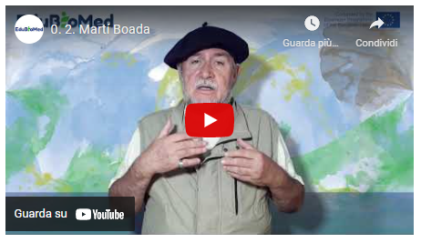
Link to the video: https://youtu.be/Wr4ZEQyaymo

Martí Boada – Universitat Autònoma de Barcelona
Geographer, naturalist and Doctor in Environmental Sciences, Martí Boada is specialized in global environmental change, biodiversity, and environmental education and communication. He is scientific advisor for UNESCO in the MaB program and member of the Education and Communication Commission of IUCN and of the United Nations Global Forum 500. He was awarded several international recognitions and prices. He is author or co-author of more than sixty books of scientific dissemination and about 140 publications of other kind.

Transcript of the video
I started working in environmental education in Montseny Biosphere Reserve right in the year it was declared as Reserve, in 1978, when we opened the first environmental education school in Spain (and Eu-rope).
It was clear then that one of the main functions of a Biosphere Reserve was this necessity to capacitate, to build capacity to understand the environment.
Actually, the Reserve, coherently with its principles, was a proof of the compatibility of conservation with local activity: the reality of natural history on one side, and of social history on the other.
We invented a methodology, because at that time it was a new concept, and we created the instruments for the understanding of how both the ecology and sociology of the territory was working.
Actually, a Biosphere Reserve is both a monitoring and experimentation area, but above all a university, a big lecture room, where we can learn the functioning of landscapes and society, and this is a very important requirement. To capacitate it would be needed to provide the learners - regardless of their education level: primary, secondary, higher - with instruments for landscape interpretation.
The experiences in a Biosphere Reserve relate to the capacity to comprehend these socio-ecological landscapes that are always hybrid: not an expression of nature from one side, and society on the other, but as a continuous interaction between them.
The importance in a Biosphere Reserve is to test valid and diaphanous methodologies for the interpretation of a landscape as a literary entity, as some authors say.
An oak, fir rather than beech forest expresses itself, calligraphically.
People who are in charge of communication, education, management in universities and institutions should be equipped with a toolbox - as in every other discipline where you equip with theoretical and methodological basis - that enables the understanding of this calligraphy, this grammar, this literature: this should be the first effort. And the Biosphere Reserve is the appropriate scenario.
The same functioning and management of a Biosphere Reserve should put the attention to these aspects and should not pose limits to the collaboration and partnership with academic institutions, right to build capacity and the understanding of the territory.
The collaboration agreements in the field of research - to perform Bachelor, Master, or PhD theses - is a very important component.
A Biosphere Reserve is a great scenario, a great classroom, and we should never lose sight of it.
In my professional journey in the field of environmental education - very much located in the Montseny Biosphere Reserve - I had the good fortune of meeting the mythical and great personality of Nelson Mandela in Pretoria, who told me: “do not ever forget that the main fight cause for the future of humanity is the environmental one”, that the environment is not about some concerns about pandas and four little flowers, rather a dimension beyond the knowledge of the environment, one of social compromise...
… that it is necessary to work from an interdisciplinary perspective on our relationship with the planet - related to economy, energy, society - and that it is needed to subvert the imperant model.
It is one of the things that changed my perspective as a naturalist, towards going beyond conservation-ism.
We - academics, researchers and professionals in the field of environmental studies - are in a context that we cannot deny, a context of crisis that transcends the local and has a planetary dimension. It is a civilization crisis. We are talking about a climate emergency, in the context of a pandemic, therefore, we cannot forget about the critical situation.
Without fatalism, without alarmism: professionals, cannot forget that our goal is to transform society especially its existential dimension.
The planet is not just a world of biological curiosities, but also the vital scenario for human beings. For its monitoring and experimental nature, the Biosphere Reserve constitutes a space for compromise. Citing the ecologist Bellamy: “we cannot play the violin when our forest is on fire”.
The Biosphere Reserve is without doubts a scenario where an orthodox-strict conservation coexists with the human activity: culture and nature in symbiosis.

Module 1 - The role of the biosphere in an era of global change

- LESSON #1 Global Change
Roser Maneja, UAB

- LESSON #2 Climate Change
Graham Mortyn, UAB

- LESSON #3 The biosphere
Magda Bou Dagher Kharrat, USJ

- LESSON #4 The biodiversity crisis
Catherine Numa, IUCN

- LESSON #5 Nature conservation and protected areas
- Maher Mahjoub, IUCN

M1 – Lesson #1 Global Change
Roser Maneja Zaragoza, Universitat Autònoma de Barcelona
Roser Maneja Zaragoza is the Project Coordinator of Edu-BioMed. PhD in Environmental Science (UAB, 2011), currently she is an Associated Professor in the Geography Department at the Autonomous University of Barcelona and Deputy Research Director at the Forest Science and Technology Centre of Catalonia. Her expertise ranges in the following fields: environmental education; communication and scientific dissemination; socioecological systems; urban biodiversity; forests; global change; health and environment and natural protected areas.

Description
We are living in an era of global change… What does this mean, or imply? Roser will introduce us to the topic from a socio-environmental perspective.

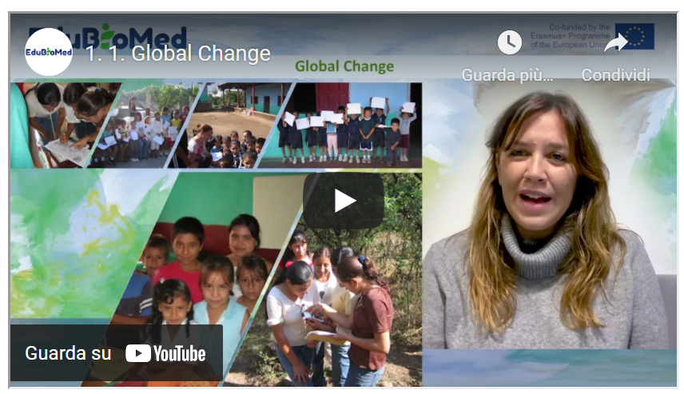
Link to the video: https://youtu.be/kJqA1Sal6bU

PPT presentation
Link to the slides:
https://www.edubiomed.eu/wp-content/uploads/2022/01/GLOBAL-CHANGE_MOOC_ROSER-MANEJA_FINAL-VERSION.pdf

Transcript of the video
Global change can be defined in a simple way as the set of socio-ecological alterations that take place in the Earth system. This set of alterations can be grouped into three main groups of impacts. The first, changes in land use and land cover. The second refers to the alteration of bio-geochemical cycles that take place in different parts and in different ecosystems of the planet. And finally, changes in biodiversity. This global change has a magnitude and speed of change hitherto unknown, so it refers to the history of mankind. It is also for the first time one of the planet's own species that is causing these changes, which although usually dry, although their expressions are at regional and local level, it is certain that their manifestations are on a global scale.
As can be seen in this slide, we can then define this global environmental change as the interaction between different socio-economic and biophysical driving forces. This global environmental change manifests itself at different times and on different spatial scales. That is why we speak of its local, regional and global dimensions. Moreover, all these changes are occurring on a temporal scale.
The history of the planet has had several cycles of change throughout the different historical stages, from the Neolithic revolution to the present day. We have suffered different oscillations of change, but it is from 1950 onwards that we can consider the year of inflection, from which all these changes are magnified and their rate of appearance is increasingly higher. Changes in landscapes, changes in the intensification of the nutrient cycle, changes in the introduction of invasive species, changes in the water cycle, in the atmospheric chemistry cycle, and also changes in the size of the world population. This year 1950 is known by the scientific community as the year B.P. before petroleum, before present, the year from which there is a massive introduction of fossil fuels that obviously change the behavior of our ecosystems.
They are different. The indicators and aspects that we can see are changing substantially on planet Earth. We talk about the ecological Footprint as an indicator that measures the number of hectares that each of the individuals living on the planet would need to satisfy our needs. As we can see, in this map, there are substantial differences between what we know as the global north and the global south, in which the differences in consumption to meet these needs is unfairly very different.
Also, as I have mentioned, changes in the world population, we can see that since this Neolithic transition, in which 3 million people were counted around the planet, we have increased to almost 8 billion people today and it is predicted that in the year 2100 this number will increase to 11 billion people in the world. There are three big drivers, the three big forces of change that we are facing today, that relate to population, to the increase of the world's population. Not only do we have a higher life expectancy, but also the per capita consumption of the inhabitants of the planet is increasing more and more.
We can then see in these graphs how this world population is increasing. And not only that, but more and more of the world's population is concentrating in urban areas.
Another of the indicators that we use to see these changes that have been occurring in a significant way since 1950 are the alterations of the cycles, in this case of the atmospheric cycles. And we can see in this graph how effectively the concentrations of carbon dioxide in the atmosphere are increasing more and more, even surpassing the limits that were already established as maximums. At that time, in addition to the increase in the average temperature of the planet, which is already almost at one point two degrees of increase in less than average.
As far as land use and land cover change is concerned, we can also see on this world map, how in certain areas of the planet, especially in these tropical and subtropical areas, deforestation rates are very latent, they are very important. Unlike what is happening in this global north, in which we can see that there is an increase of forest masses, especially in the Mediterranean area, where it can have very important effects on the water cycle, on biodiversity and also in the greater concurrence of large forest fires.
Here is a very illustrative image of what may be happening in different areas of the planet. This increase in forest mass in relation to the high rates of deforestation that are occurring in other areas of the planet.
Changes in biodiversity. Its main global causes are above all the destruction of habitats. Overexploitation of resources. Environmental pollution. Climate change and the introduction of invasive bio-invasive species may be deliberate or accidental in the face of this scenario of global change.
Faced with this scenario of ever more profound changes in our ecosystems, we firmly believe that we must change, that we must adopt a position of empowerment and not scare the population. But above all, we must be very aware of the panorama we have and be very aware that only through the empowerment of children's groups, of vulnerable groups, we can also change or try to change and reverse this situation. Also from knowledge, from training, from knowledge transfer. It is a good strategy to be able to know, to be able to appreciate the biodiversity and ecosystems that we have, to be able to face this ever-changing scenario, to be able to empower and not scare the population.
One of the proposals we have from the Edu-BioMed project is to integrate different forms of knowledge. On the one hand, tradition, empirical, traditional or popular knowledge, and on the other, scientific and academic knowledge. How to find these spaces of integration, of knowledge, of dialogue, of knowledge in relation to knowing our biodiversity? We have to consider a good tool. It is to consider our environment, our surroundings, as the best pedagogical tool.
And in this way, we can bring citizens closer, we can bring our students closer to the knowledge of their immediate environment in order to be able to value it, to be able to conserve it and to be able to understand much better what is happening on a more global scale.
In this sense, for example, young people and adolescents are a group that has traditionally been excluded from decision making, and a commitment is also to include these groups that have much to contribute.
And their knowledge is also important to also consider women and women from the global south and other areas of the planet with vulnerable situations. They are people that we must also include in this decision-making process and also in this process of including different forms of knowledge. From this traditional knowledge to more scientific knowledge.
These are some of the guidelines that we can contribute from this project, from Edu-BioMed, to make our ecosystems, to make our world a habitable world, a fairer world and a world where these changes that we are accelerating at an unprecedented rate, we can somehow incorporate them into the functioning of ecosystems. Thank you very much.

M1 – Lesson #2 Climate Change
Graham Mortyn, Universitat Autònoma de Barcelona
Graham Mortyn is researcher at the Institute of Environmental Science and Technology (ICTA) at the Autonomous University of Barcelona, where he is also affiliated to the Department of Geography. He earned BS and MS degrees in Earth Science and a PhD in Oceanography from Scripps Institution of Oceanography (University of California at San Diego, UCSD). Prior to academia he worked as a hydrogeologist. He was an Assistant Professor in California (California State University, Fresno, CSUF) before ICTA arrival in 2004.

Description
The capsule introduces to the topic of climate change. After a brief introduction to the most recent figures of global warming trends by the scientist Graham Mortyn, the learner will be invited to explore its causes and effects.

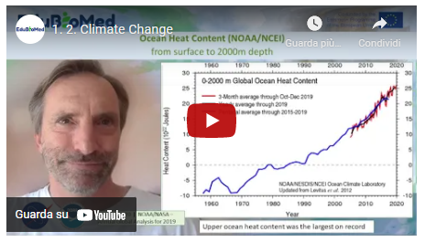
Link to the video: https://youtu.be/6DR33m1atPM

PPT Presentation
Link to the slides:
https://www.edubiomed.eu/wp-content/uploads/2021/07/PPT-Climate-Change.pdf

Activity
Learn about the causes and effects of climate change from NASA (https://climate.nasa.gov/) and IPCC (https://www.ipcc.ch/) websites.

Transcript of the video
Hello, my name is Graham Mortyn, professor at the Universitat Autònoma de Barcelona, at the Institute of Environmental Sciences and Technology, as well as at the Department of Geography.
So, I am going to try to describe global climate change in only 5-10 minutes. So, to do that, I'm going to rely on a few figures. And I understand that these my talk will be pasted into the PowerPoint where the figures exist later off line. So, I'm not actually showing you the figures right now.
So, to do this, I'm going to describe the NASA point of view of the global temperature at the end of the most recently completed year, which is the year 2019, of course. And this is something they do every year that we will in a few months to have that for the year 2020 present year. So basically, they show their annual mean for the year 2019 versus a global perspective of temperature difference and how that is different from place to place around the globe.
So, in other words, there are parts of the world that have warmed up more than other parts of the world. And so, in some sense, global warming is actually a bit of a misnomer because in some places it actually cooled. And in other places, it warmed by a lot. In other places it warmed by a little. In other places, it didn't warm or didn't cool, but it actually remained more or less the same.
And this is different from year to year based on dynamics and variability and so forth. But another thing they present, which I'll show in a later figure, is that how 2019 compared to other years and that decade versus other decades and so on. But the year 2019 was definitely accentuated in terms of warming in the high latitude northern hemisphere. And this is a process known as Arctic amplification, a part of the world highlighted in the northern hemisphere that has seen more warming than other parts of the world, not only for the year thousand and nineteen, but over several decades now really going back to the 1970s or so.
So overall in the year 2019 was zero point nine, eight degrees Celsius above the long-term average, which is taken from the year 1951 to 1980 as a form of baseline by which any year is sort of compared against as an example.
So not only the high latitude northern hemisphere, but in general, we see more warming over the landmasses and warming over the oceans, but not as much as on the landmasses. And in particular, Europe and Asia stood out with particular warming, although other continental landmasses as well.
And NASA reports that the year 2019 was the second warmest year of their long-term record. So, this second figure is showing how 2019 compared to other years, 2017-18 were relatively cool, although still very warm. Two thousand and 17 still stands out as the warmest year on record. And when you look at this graph showing a whole bunch of dots, you sort of get a sense not only of the multi decade sort of long-term increase in the global temperature, but also the entire annual variability in how, despite that long term trend of an increase, you do have a certain amount of noise in this record by virtue of things going on from one year to the next. And I'll highlight that in a subsequent figure. But another thing to point out from this figure, which I think is actually perhaps even more important, is taking the decade by decade comparison.
And so if you look at the year 2010 through ten thousand 2019 or prior decades, for example, 2000 and 2010 or 1990 to two thousand and so on, from that more collective time perspective, the annual global temperature increase and the amount of the warming is basically just going up from decade to decade, really going back to the 1970s or so.
And that is considered a time of sort of a regime shift when that global warming pattern in the media annual temperature record really started to go up and remain going up now for several decades, basically probably throughout the lifetimes of most people who are listening to this presentation. So that is a very significant observation about the global climate system.
Now to point out how inter annual variability can play a role. This third figure that I'm showing is the impact of El Nino Southern Oscillation on the NASA analysis. Now, I'm not going to take the precious time that I have and get into the details of what is El Nino Southern Oscillation, but take it at face value that it is a big temperature anomaly, among many other things, in the world's largest oceanic basin. And that is the Pacific. And because it's happening in the world's largest oceanic basin, it has impacts on the atmosphere. It has impacts on adjacent landmasses with tell a connection to other parts of the world. And so big El Nino events actually impact the global pattern.
And so, in the lower left of this diagram, you can see that the so contribution to specific years like 2015 and 16 were positive as it was for the year two thousand and nineteen. And those values are 0.03 for the year 2015, 0.11 degrees Celsius for the year 2016 and 0.07 degrees Celsius for the year 2019. So, by contrast, during La Nina conditions the opposite phase to El Nino. When you actually have a cooling anomaly in the Pacific Basin, that number becomes negative and 2017 and 18 were like that.
So, there are inter-annual changes that take place like El Nino, Southern Oscillation or El Nino and La Nina cycling that can give rise to one particular year’s variability. And another thing to point out on this record is volcanic eruptions as well, because sometimes from large emissions of volcanoes and their particles into the atmosphere and even as high up as the stratosphere, you can have short term cooling events. And so, Mount Pinatubo in the 1990s is probably the most recent large scale example of this on a global basis where that particular eruption is shown, as well as other volcanic eruptions, amount of going and LTE children in prior decades. But in the 1990s, for example, Mount Pinatubo had a very notable global cooling on a short-term basis of about a year or so after that eruption took place. So, despite the long-term warming trend, you do get inter-annual effects and features that can make any one year sort of stand out or be different on a short term basis.
So that's not to be taken lightly and not to be confused with the long-term trend. So now the last point, my fourth slide here is showing you the oceanic heat content from the National Oceanic and Atmospheric Administration. And last year at the end of 2019, it was the first year that they reported this, to my knowledge, down to a depth of two thousand meters. So, this is really significant because it implies that not only are the global oceans continuing to warm, as the graph suggests, but they are now reporting this warmth to deeper depths than prior times. So, this is implying that the warming is propagating from the top down in our global ocean system. And whether you look at the red curve here versus the black curve versus the blue curve, different ways of averaging time such that smaller amounts of time to larger amounts of time going from three months to five years, from red to blue to black with the black being annual record, you see a long term increase. And this increase in global ocean heat content is really disturbing in many respects because of things like hurricanes and storms and how the warming of the oceans is basically fuel for increasingly strong storms born from the oceans like hurricanes. As time goes on. So, this does not bode well for our planet. And it does not bode well for us as the human species that is increasingly inhabiting coastal cities, for example, that are prone to hurricanes and other such disasters. So that's a global climate change in a nutshell. And I hope that is useful and interesting for you. And I will now sign off. Thank you.

M1 – Lesson #3 The biosphere
Magda Bou Dagher Kharrat, University of Saint Joseph
Magda Bou Dagher Kharrat is a Professor at the University of Saint Joseph in Beirut (USJ) and Director of the Biodiversity and Functional Genomics Laboratory at the Faculty of Science of USJ. She holds an advanced degree from the University of Paris-Sud and a PhD on cedar genetics from the University Pierre et Marie Curie. She is President and co-founder of the NGO Jouzour Loubnan. She is a member of several international learned societies and research consortia and is the author of about 50 scientific papers. Her research work focuses on the genetic characterisation of the biodiversity of Lebanon and the Mediterranean region. The application of his research helps to define concrete and sustainable conservation policies.

Description
Prof. Magda Bou Dagher will explain what the biosphere consists of.

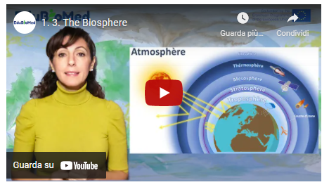
Link to video: https://youtu.be/muP3T_0oSbo

PPT Presentation
- Link to slides: https://www.edubiomed.eu/wp-content/uploads/2021/07/PPT-The-biosphere-1-9.pdf
- Link to slides: https://www.edubiomed.eu/wp-content/uploads/2021/07/PPT-The-biosphere-10-15.pdf
- Link to slides: https://www.edubiomed.eu/wp-content/uploads/2021/07/PPT-The-biosphere-16-19.pdf

Additional resources
- The Official Wizard Mind – Understanding the atmosphere.
- Journey to the centre of the Earth by Science Etonnante – The lithosphere.
- A Day on Earth, BBC.
- Interactions in an Ecosystem: How Wolves Change Rivers.
- Soil fauna: soil bioturbation.
- Calculate your ecological footprint - valid for Switzerland but will give you a rough idea of your ecological footprint.

Transcript of the video
The term biosphere is a contraction of the two Greek root words bios meaning "life" and sphaîra: sphere / or globe to refer to the earth globe.
It is therefore the set of living organisms on our planet and the space they occupy, in other words, any place on our planet Earth where there are living beings.
This biosphere consists of 3 parts:
- The atmosphere: the first 20 km of the atmosphere above our heads,
- The lithosphere: or the part of the earth's crust in and on which life exists.
- And the hydrosphere that encompasses all the waters of our planet whether fresh or salt, flowing or stagnant.
The atmosphere
The atmosphere is made up of several layers. We will focus here on the thin film of gas that surrounds the earth where the gases that form it are emanations from the earth itself. This layer is called TROPO-SPHERE, it is the seat of activity of living beings. It is thicker at the equator (13-16 km) than at the poles (7-8 km) and it is in this layer that meteorological phenomena, rain, thunder, lightning, storms and it is where airplanes travel.
The atmosphere is vital! No atmosphere, no greenhouse effect, no greenhouse effect, no life on earth. The term "greenhouse effect" has a negative connotation relative to the terrible global warming that our planet is currently experiencing. But be aware that if life is possible on Earth, it is thanks to this green-house effect that the temperature on its surface is neither too cold nor too hot. Without the atmosphere the temperature on earth would be -18°C. whereas thanks to this atmosphere the average temperature of the earth is around +15°C. The greenhouse effect is therefore vital but it is its accentuation that is harmful to us! To distinguish between these two notions, we will then speak of the "anthropogenic" greenhouse effect.

The lithosphere
The lithosphere is the rigid envelope of the Earth's surface that includes the crust and upper mantle, which make up the hard and rigid outer layer of the Earth.
The Earth's lithosphere is both continental and oceanic. The Earth's crust is divided into a number of tec-tonic plates, also called lithospheric plates.
Everything we know as living beings is on the lithosphere.
Not only on the surface but also IN the soil where millions of life forms evolve and make the soil fertile. Yes, the soil is alive.
The hydrosphere refers to all water on Earth, whether it is in liquid, solid or gaseous form; fresh, brackish or salty; flowing or stagnant.
Water provides shelter and food for a wide range of plant and animal organisms, enabling the establishment of complex and balanced food chains.
One should not conceive these 3 subdivisions The atmosphere, the lithosphere, and the hydrosphere as independent! Indeed, the biosphere is the seat of a constant interaction between the environment and the organisms that live there.
The biosphere's living conditions are maintained thanks to physico-chemical cycles (carbon, water, nitro-gen cycles, etc.) that allow elements to circulate between the environment and living beings.
The biosphere is the seat of a constant interaction between the physical environment and its abiotic (non-living) factors, whether climatic or non-climatic, and biotic factors (living beings) and their variability.
The environment influences living beings, their distribution, life cycle, reproduction, dormancy etc... and in turn these living beings shape the environment in which they live.
These interactions can be as basic as a food web. On this slide the food chain begins with primary producers such as the algae living in the pond which feeds the mosquitoes which in turn are eaten by the frogs .... The interdependence of several food chains forms a food web. The more complex the network, the more resilient the ecosystem is.
Food networks are not the only forms of interaction, here are some examples: competition, parasitism, predation, commensalism, mutualism or amensalism.... (TD related to these interactions)
The biosphere has been shaped by these interactions for MILLIONS of years! And the history of their presence on Earth and their evolution is very old. Dictated by all the geological and climatic events that our planet has known even before the appearance of mankind.
If you relate the history of life on earth to 1 hour of time, you will notice that the appearance of the hu-man species dates from the very last seconds compared to other forms of life whose presence is much older.
For more than 275,000 years since the appearance of our species, we were a species like any other we hunted and gathered for food. It is from the Neolithic period - around 12,000 - that human civilization be-came sedentary by domestication of plants and animals and since then our technology has not stopped evolving at times in such a dazzling way that for the first time in the history of the Earth a species is changing its face!

We have disturbed the biogeochemical cycles of our planet so much that we have decreed this new Anthropocene area!
It is a term of geological chronology proposed to characterize the time in Earth's history that began when human activities had a significant global impact on the Earth's ecosystem.
Biodiversity is weakened by human activities. It is declining almost everywhere in the world. Human population densities continue to increase. This translates into a continuous and rapid acceleration in the use of space and an increase in pressures on ecosystems and the species they contain. Pollution, the intro-duction of invasive species, overexploitation of natural resources, degradation, fragmentation and loss of habitats are all factors responsible for the erosion of biodiversity. Exacerbated by climate change, this anthropisation threatens to destroy the fragile balance of ecosystems and the biodiversity they contain.
The UNESCO program, Man and the Biosphere, launched in 1970, its objective is to preserve for present and future use, the diversity and integrity of animal and plant biotic communities within natural ecosystems, and to safeguard the genetic diversity of species on which their continued evolution depends.
Biosphere reserves are sites designated by national governments and recognized by UNESCO. They are learning sites for sustainable development.
Biosphere reserves allow ecological research and in particular basic studies in natural environments as well as in degraded environments. The purpose of these sites is to reconcile the conservation of natural and cultural diversity with economic and social development. They enable innovative approaches to sustainable development to be tested and developed from the local to the international level.
Biosphere reserves must fulfill three major functions:
1. Conservation function - contributing to the conservation of landscapes, ecosystems, species and genes.
2. Development function - to promote economic and human development that respects socio-cultural and environmental particularities.
3. Logistical function - to encourage research, monitoring, education and information exchange on local, national and global conservation and development issues.
Biosphere reserves are organized into three interconnected zones: the core area, buffer zone, and transition area, and only the core area must be protected by national legislation.

M1 – Lesson #4 The biodiversity crisis
Catherine Numa, IUCN Centre for Mediterranean Cooperation
Catherine Numa, PhD, is the coordinator of the Mediterranean Species Programme at the IUCN Centre for Mediterranean Cooperation. She coordinates two initiatives, the “Mediterranean Biodiversity Assessment” and the “Development of strategic conservation plans for threatened species”.

Description
In this capsule, Ms Catherine Numa (IUCN) explain us what biodiversity is, why it is important, how we are losing it, and what we can do for preserving it.

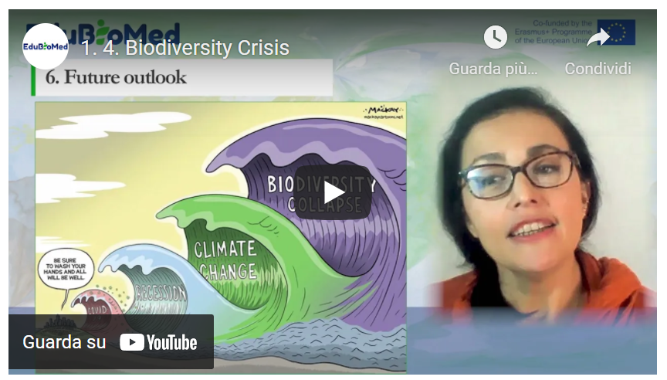
Link to video: https://youtu.be/15PrIy8etls

PPT presentation
Link to slides: https://www.edubiomed.eu/wp-content/uploads/2021/07/PPT_The-Status-of-Biodiversity.pdf

Further reading
In Defense of Biodiversity: Why Protecting Species from Extinction Matters, Carl Safina (2018)
Transcript of the video
In this chapter we will explore biodiversity and learn about its status nowadays. We will start by defining biodiversity, then learning about the number of existing species. We will explore the latest assessment of about the status and trends. The main threatened species, why it is important for us. And finally, what can be done to improve the situation.
So first, let's just clarify what we mean by biodiversity. Biodiversity refers to all variety of life that can be found on Earth. Plants, animals, fungi and microorganisms, as well as the communities that they form and the habitats where they live. It is the shortened form of two words "biological" and "diversity". In the article 2 of the Convention on Biological Diversity, a United Nations treaty, gives a formal definition of biodiversity that is often used.
Biological diversity is often understood at three levels. Species diversity refers to the variety of species (animals, plants, fungi and micro-organisms). Genetic diversity corresponds to the variety of genes contained in these organisms; ecosystem diversity refers to all the different habitats that exist, like forests, deserts, wetlands, coral reefs, etc.
Now let’s analyze how much biodiversity is in our planet. Researchers estimate that there are about 8.7 million species globally. However, we have barely scratched the surface! Science has only described 1.2 million species or so insofar. Some studies estimate that we have yet to discover around 86% of the species on Earth and 91% in the ocean. If you ever wanted to discover a new species, plan your next trip to tropical rainforests, or to the deep ocean, or actually don’t move because much of this undiscovered life is likely to be in these places or hidden in the soil.
But let’s focus on what we know.
1.2 million species. How are all these species doing? As per today only a few of these species have been assessed. There are several assessments at different levels: international, multi-country and national level, focusing on different species groups. For example, we have the IUCN red list of threatened species. The IUCN Red List index, the Living Planet Index or the IPBES Global Assessment Report.
The IUCN Red List is considered the most comprehensive international information source on the global extinction risk for species. It is a critical indicator of the health of the world’s biodiversity and it is used by most assessments worldwide.
And as per today, it has assessed 120,000 species, that is about 10% of the known species.
As per data from November 2020, from the total assessed species in the Red List, 32,000 species (that is almost a third of assessed species!), are threatened with extinction.
Based on data from the IUCN Red List of Threatened Species, the Red List index shows how likely a species –or group of species- could survive over time. A Red List Index value of 1.0 equates to all species qualified as Least Concern (which means, not expected to become Extinct in the near future). An index value of 0 however, equates to species having gone Extinct. Thus, a decline such as the corals’ line shows in this graph, indicates that species are being driven towards extinction at an accelerating rate. If the rate of biodiversity loss were reducing, the index would show an upward trend, but as we can see in this graph, none of these groups of species are in that scenario.

The Living Planet Index (LPI), which mainly focuses on populations trends of mammals, birds, fish, amphibians and reptiles, and is another tool to measure biodiversity. In its 2020 report, the LPI showed how these populations have declined 68%, since 1970.
And we can see in this graph how this trend is observed almost worldwide.
The IPBES Global Assessments are mostly based on IUCN Red List data. As you can see in this chart extracted from their 2020 global assessment report, it is possible to see how the global extinction risk in different species’ groups has alarming percentages, especially in amphibians and cycads.
The most threatened group, Cycads are plants that have been growing on our planet for over 250 million years. Who would have thought that plants that managed to survive ice ages, asteroids and being munched on by dinosaurs, are now threatened by habitat degradation and poaching… just to embellish our gardens.
According to IUCN Red List, the imperiled species are mainly threatened by habitat loss due to agriculture and aquaculture practices, …
…urban development, …
… deforestation...
… and invasive species and pests.
So, we have seen how species are declining at alarming rates, due to several factors.
So what? Species come and go... extinction is a natural process. Indeed – but not at this rate.
Studies have compared the current extinction rates with what would be expected from the fossil record and have concluded that the loss of species since 1970, is accelerating in a dramatic and serious way. Today, the loss of species now classed as 'critically endangered’ could propel the world into a sixth mass extinction
“So what? Too bad. Sorry! Why would we be interested in saving a creature such as… this one?” Some may still say. This is the naked mole-rat. He is the longest living rodent on Earth – up to 37 years, and it turns out that it has an exceptional resistance to cancer. Turns out that this animal’s immune system, the result of millions of years of genetic evolution, could maybe help us find a cure to cancer.
On Earth, each species has evolved over millions of years and has adapted to survive, its own way. Every time we lose one of them, due to human pressures, we lose a heritage of 4 billion years of nature’s evolutionary wisdom. The current situation can be compared to an immense library with millions of books. Each day, hundreds of books disappear, and we did not even have time to read the title of these books. This genetic loss, is irreversible, and it’s a huge loss of opportunity for humanity.
Besides the intrinsic value of nature, the reality is that biodiversity is also essential for human wellbeing. Morphine, corticoids, antibiotics… Up to 50% of the approved drugs are derived from plants. All food systems depend on biodiversity and a broad range of ecosystem services that support agricultural productivity. For example, bees with pollination, spiders and other insects for pest control. These are just examples. The list of benefits we get for free from nature are countless. The TEEB study is trying to estimate the economic value of biodiversity’s contribution to people. For example, it is estimated that for an annual investment of US$45 billion into protected areas alone, the delivery of ecosystem services worth some US$5 trillion a year could be secured.
Well, so what can we do? Since 1993, conservation efforts have saved up to 48 mammal and bird species from extinction. Without such interventions, extinction rates for mammals and birds over the past 27 years would be three to four times higher. But we need more efforts. The Global Biodiversity Outlook 5, published in September 2020, provides an interesting graph with various areas of action that, in combination, could bend the curve and halt this biodiversity decline. These actions are, from bottom to top: (1) Enhance conservation and restoration of ecosystems; (2) climate change mitigation; (3) reduce other drivers such as pollution, invasive alien species and overexploitation; (4) more sustainable production of goods and services, especially food; and (5) reduce consumption and waste. None of the areas of action alone, nor in partial combinations, can bend the curve of biodiversity loss. The effectiveness of each area of action is enhanced by the other areas, but they all require a collective effort.
In 2020, the world has faced a pandemic that, interestingly, is related to biodiversity. We know that there are many more waves to come. On our current trajectory, biodiversity, and the absolutely essential services it provides to humanity, is projected to decline, jeopardizing the delicate balance of our common home, the Earth. With the assessments and the data that we currently have, we cannot look the other way anymore. We’ve been warned. But the good news, is that we are still on time to bend the curve of this decline and its consequences.

M1 – Lesson #5 Nature conservation and protected areas
Maher Mahjoub, IUCN Centre for Mediterranean Cooperation
Maher Mahjoub is Regional Programme Coordinator, International Union for the Conservation of Nature (IUCN) Mediterranean Cooperation Centre, Málaga, Spain.

Description
In this capsule, Mr Maher Mahjoub (IUCN) explain what protected areas consists of, why they are important, how they are categorized and provide us with facts and figures on the current panorama from the nature conservation world.

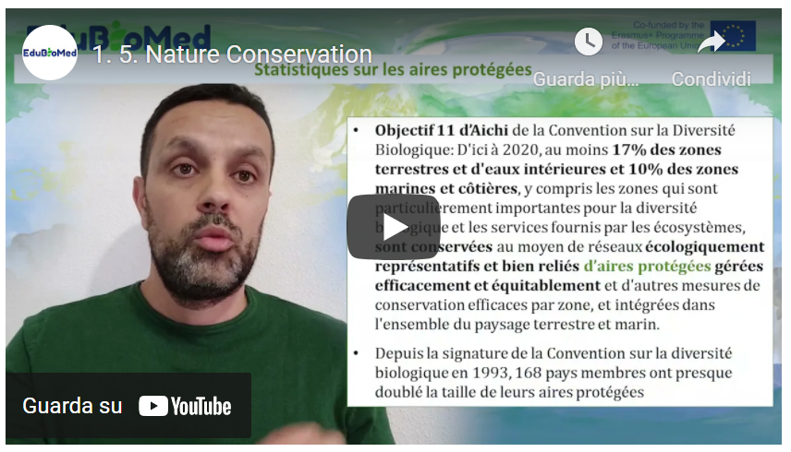
Link to video: https://youtu.be/NdoxUBL3Bb0

PPT presentation
Link to slides:
https://www.edubiomed.eu/wp-content/uploads/2021/07/PPT-Nature-conservation-and-protected-areas.pdf

Activity
Have a look at the World Database on Protected Areas https://www.iucn.org/theme/protected-areas/our-work/world-database-protected-areas and consult the Green List for Protected and Conserved Areas website https://iucngreenlist.org/ .

Transcript of the video
Hello, I am Maher Mahjoub, I am Programme Officer at the International Union for the Conservation of Nature. I am going to talk to you about the subject of protected areas. And to start with, what is a protected area?
The IUCN, the International Union for the Conservation of Nature defined a protected area in 2008 as follows. It is a geographically clearly defined area that is recognized, dedicated and managed by any means, effective, legal or otherwise, to ensure the long-term conservation of nature and its associated ecosystem services and cultural values. Protected areas may be established in terrestrial, coastal or marine environments. Protected areas contribute to the conservation of species. Either of an ecosystem or of a whole formed by natural and cultural components.
The importance of protected areas. Protected areas are an important pillar of biodiversity conservation strategies at the country level. They also contribute to the development of human and social activities. By ensuring the provision of many ecosystem services, be it locally, globally, through food, drinking water or medicines. Protected areas are also internationally recognized as an important natural tool in the fight against climate change. From a creation and management point of view, protected wings can be under the responsibility of States, NGOs, indigenous peoples or private entities.
The creation of protected areas began long ago. Among the first national parks created in the world was Yellowstone National Park in the United States, established in 1872. The Virunga National Park in the Democratic Republic of Congo, created in 1925, is also cited as an example.

The International Union for the Conservation of Nature - in addition to the definition - has established 7 categories for the management of protected areas. These management categories differ according to the management objectives assigned to each protected area. The 7 management categories are as follows. Integral nature reserve. Wilderness areas. National park, natural monument. Habitat or species man-agreement area. Protected terrestrial or marine landscapes and finally, protected resource management areas. You can see that as you go from the first category to the last, the degree, the level of protection established at the level of the protected area decreases. Going from integral protection to shared management in category 6.
Statistics on protected areas. The World Database on Protected Areas, which collects data from countries for the Global Report on the State and Status of the World's Protected Areas, indicates that as of November 2020 there are just over 260,000 protected areas in the world. Of course, these are protected areas in terrestrial, coastal and marine environments. 8% of this figure of protected areas have conducted an assessment of management effectiveness. In other words, just over 20,000, which is a very, very low figure.
The Aichi objective 11 of the Convention on Biological Diversity states that by 2020, at least 17% of terrestrial and inland water areas and 10% of marine and coastal areas, including areas of particular im-portance for biological diversity and ecosystem services, are conserved. On average of what? Through ecologically representative and well-connected networks - of what? - of protected areas. This means that the international community, through the Convention on Biological Diversity, recommends and calls on countries to double their efforts to reach 17% of protected areas in terrestrial areas and 10% of protected areas in coastal and marine areas. It should be recalled that since the signing of the Convention on Bio-logical Diversity in 1993, 160 member countries have almost doubled the surface area and size of their protected areas. Which is very, very good.
I had indicated the importance of effective management of protected areas because protected areas should not only be created. But also establish management plans and ensure that these management plans are executed and implemented. And for this purpose, the International Union for Conservation of Nature has developed in 2014 the 'green list' programme of protected areas. The objective of this pro-gramme is to help countries to reach international standards for the management and management effectiveness of protected areas. This standard has four evaluation components. An evaluation on the planning of the protected area. Another on effective management. A third component on equitable governance. A fourth component on successful conservation. For these four components, there are 17 criteria and 50 indicators to be assessed at site level, which may be relevant for the green list of protected areas. As of November 2020, 108 protected areas in the world have managed to get the IUCN Green List la-bel. Protected areas are a national and international heritage. And the international community must re-double its efforts to reach the commitments of 17% on land and 10% on the sea. Until the end of 2020, it should be remembered that the global biodiversity framework for the post-2020 period will indicate a more ambitious target of 30% terrestrial and 30% marine protected areas that must be achieved by the countries that are contracting parties to the Convention on Biological Diversity.
Thank you.

Module 2 – What a Biosphere Reserve is (and is not!)

- LESSON #1 The Man and Biosphere program (introduction)
Miguel Clusener Godt, UNESCO

- LESSON #2 The Biosphere Reserve concept
Catherine Cibien, MAB France

- LESSON #3 How to become a Biosphere Reserve
Catherine Cibien, MAB France

- LESSON #4 Role of Scientific Committees in the management of a Biosphere Reserve
Juana Barber Rosado, Universidad Politécnica de Madrid

- LESSON #5 The Mediterranean region
Pierre Doumet, Association Protection Jabal Moussa (APJM)

M2 - Lesson #1 The Man and Biosphere program (intro)
Miguel Clusener Godt, UNESCO
Miguel Clusener Godt is the Director of the Division of Ecological and Earth Sciences in UNESCO Headquarters in Paris, and he is the Secretary of the Programme on Man and the Biosphere (MAB), which manages the World Network of Biosphere Reserves.

Description
Miguel Clusener Godt presents an overview of the Programme and the World Network of Biosphere Reserves, including figures, curious facts and his views on both its track record and path ahead.

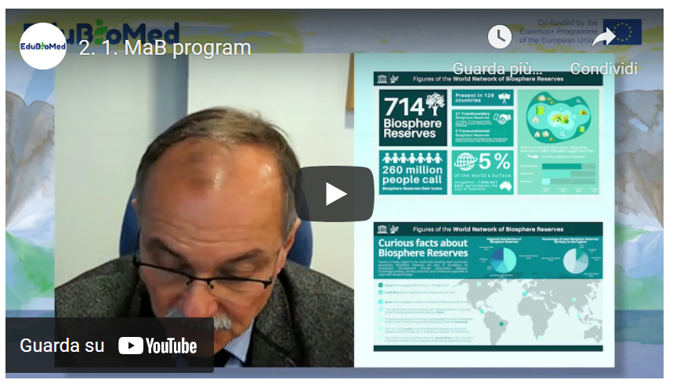
Link to video: https://youtu.be/3CMtpD9UBxE

Activity
Surf Man and the Biosphere (MAB) Programme ( https://en.unesco.org/mab/ ).

Transcript of the video
Hello, ladies and gentlemen, Friends of the Biosphere Reserve, my name is Miguel Clusener-Godt, the director of the Division of Ecological and Earth Sciences and also the secretary of the Man and the Biosphere Program. So, the Man and the Biosphere Program program started in 1971, so almost 50 years ago as a research program, but also as a program of integrating nature conservation and integrating sustainable development for human beings. So those days, it was extremely full participating already.
What became quite normal after the Rio conference in 1992 and also after the most recent events, also taking into account, for example, the results of the Paris agreement and working on climate change issues from the IPBES platform, working on biodiversity conservation. So, the backbone, of course, of the program are the Biosphere Reserves. And you will see on the slides what I am talking about. I will show you two slides. This one is some figures. I will start also showing you on the right side up of the slide what is the bias preserve the core area surrounding buffer zone and surrounding transition area. But today and I say today, it's 2020.
We are now having at the MAB International Co-ordinating Council, which every year designates new sites worldwide. So, we had this year some 25 new sites designated. And our total figure now is seven hundred fourteen Biosphere Reserves in one hundred twenty-nine countries, including 21 transboundary biosphere reserves and two transcontinental Biosphere Reserves. So, these are the raw figures, I would say, on the overall network. So, as you can see, they are spread all over the world. And of course, it's quite important. And this program is not another program just for natural parks or nature conservation. We have a total of more than 200 million people.
In these biosphere reserves. So, it's really a program for the people or people are part of nature and they are not opposed to nature, so they're incorporated in the nature protection, but also in the sustainable use of natural resources. Speaking about the size of biosphere reserves worldwide, imagine we will we pushed them all together, this will give us around five percent of the world's total surface.
So, all together is roughly some seven million square, seven million square kilometers. This would give us around the size of Australia. So, when you hear the figures, 260 million people the size of Australia, five percent of the terrestrial surface of the world, you may have heard that the conventional biological diversity CBD recently declared that the Decade for Biodiversity Conservation 2020-2030 and suggested 30 percent of the terrestrial area protected, 10 percent strictly protected. So, this is the target. I think it's a very good target and we are all called to participate in that. However, I must say that the program is, of course, participating in this for quite a long time now and that we have, as I already mentioned, five percent of the terrestrial size of the world protected and one point five percent strictly protected as national parks. So, we are still far away from that target, and I think it's quite important. When you see also on the right down side of the slide, the distribution of this surface in different zones.
So, you see a big transition area and slightly smaller buffer zone, even smaller core area. These, of course, the tendencies on the program, let's say, for the last 15 more or less before always, the core area was more dominating. So, this give you just a roughly a rough overview, what we are talking about and concerning also. Some curious facts would come to the second slide and to give you an overview, for example, where these areas are distributed, for example, you see that the regional distribution of biosphere reserve is mostly in the Europe and North American area. However, you see the total size of the biosphere reserves, the area that covers most is, of course, Latin America.
You see the pilot on the right side, just to give you some curious facts also, because we will we will often ask, what is the minimum size? What is the maximum size? Does this exist? So, first of all, I would say these biosphere reserves are represented in all ecosystems of the world. They are covering all parts, whether high mountains, savannas, islands, coastlines, peri urban areas. So, they are all present. And when you see, for example, point number one, the biggest size, this is Brazil, more than one point seven square kilometers. This is, of course, the midatlantic biosphere reserves that goes over three thousand five hundred kilometers.
But some other curious figures, Costa Rica, more than 50 percent of the national territory is a Biosphere reserve. So, a truly development plan for the country. Now we are coming to Spain.
Spain has the biggest number of biosphere reserves: 52. They are, of course, not so big, but they are spread all over the place as useful models for nature conservation and sustainable development. But also, some of the emblematic figure on board, for example, the Mount Everest in China is in the along the borders of Qomolangma biosphere reserve, and I'm coming more to the part of protecting the entire population of the highly endangered Sumatran Orangutan. And we are just talking about more than 6000 individuals, which is not very big. And living all together in the Gunung Leuser Biosphere Reserve of Indonesia. What does it mean? It means that if we don't have one day as far as we can, sure, we will not have these big ape species. And I think there we are touching already at the border of feasibility and the border of real need.
But also, who are managing these reserves? We hear a lot that national governments.
In Spain, for example, autonomous communities or mayors, but the Tsa Tue in Canada is the first Biosphere Reserve in the world managed by what they call first nation indigenous population. It's entirely managed by an indigenous group. And the last figure I just wanted to show you to give you an overview on the program is, of course, the poorest class diasporas in South Africa, which is the only place in the world where we have three recognized biodiversity hotspots coming together. So, again, something that is for nature protection, very important, but also existing in a highly populated area, because the whole cluster of biosphere reserves is really where a lot of people are living and where we, again, feel that we are really touching exactly the border between the people living in the area and the conservation of what could be done. Would like to give you some words why this is so important and why this has become even more important due to the covid-19 crisis.
Human population is going up. Nature. “Wild” nature, in inverted commas, is pushed. In his borders. And we are coming to a close, we are coming very close, closer than ever been and zoonosis I mean, pandemic coming out of situation, jumping over viruses, parasites to human beings is a lot fact due to these condensing and misusing of natural spaces. So, what we need and I think the Secretary-General of the U.N. mentioned it personally recently at the biodiversity meeting in New York. We need more of these areas with bigger areas. We should really go for the target. But for the sake just to be with the target, for the sake is, of course, that our entire planet managed in a sustainable way, that we get protected areas large enough to guarantee also for large most, for example, or for large animal populations, the required space to live well, also for us to produce what we need, agriculture, agroforestry, forest products. But we need also leasure we need also what in latin America is called ‘buen vivir’, good living for the world population.
And I think this is the challenge. I hope this MAB program, and I'm proud to be the secretary of this MAB Program can make a substantial contribution. As you heard from the first slide that I showed you, we have right now one hundred and twenty-nine countries on board. So globally speaking, still some 70 countries missing. I would hope they'll get them soon on board with a biosphere reserve proposal, at least one, so that we can really say we have the entire world community on board.
So, it was just a brief introduction for you, for your project, for your seminar, for your work in protecting biodiversity, but also in assuring at the same time the integration with sustainable development.
So, thank you very much for listening to me. Thank you very much for your interesting and UNESCO's Man and the Biosphere program. And looking forward to all your contributions in the future for this interesting program. Thank you very much.

M2 - Lesson #2 The Biosphere Reserve concept
Catherine Cibien, MAB France
Catherine Cibien is the Director of MAB France. MAB France animates and strengthens the national network of 14 Biosphere Reserves, puts it in touch with the French and international communities interested in this program: scientific community, educational and academic world, organizations for the management and conservation of biodiversity, sustainable development and of the ecological transition. She co-hosts the Master MAB (Man and Biosphere) at the University of Toulouse.

Description
Ms. Catherine Cibien explains what a Biosphere Reserve consists of.

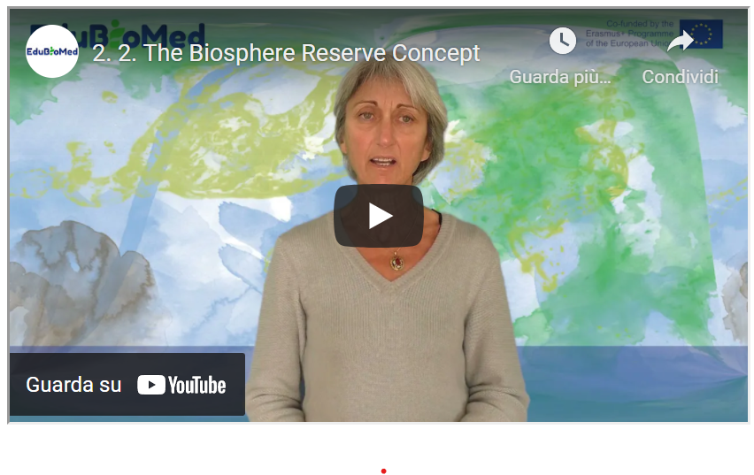
Link to the video: https://youtu.be/RK4FUadOsDc

PPT Presentation
Link to the slides: https://www.edubiomed.eu/wp-content/uploads/2021/09/PPT-Biosphere-Reserve.pdf

Suggested Reading
50 ans d’histoire du Programme MAB (l’Homme et la Biosphère) de l’UNESCO.
Transcript of the video
The UNESCO Biosphere Reserves are designed to experiment and implement sustainable development approaches in territories, and thus take up fundamental challenges currently facing humanity, both the rapid loss of biodiversity and the challenge of climate change.
They were set up under the auspices of a programme, MAB Man and Biosphere, launched in 1971. The MAB is looking for solutions to manage our resources more rationally. The RBs are sites for experimentation. They contribute to the UN 2030 agenda, to the implementation of sustainable development goals, It is a question of experimenting in BR, then inspiring beyond that, on practices, uses and management methods that have proven their effectiveness.
The first biosphere reserves date back to 1976. At that time, the criteria governing them had not yet been defined. They were built up little by little and were formalized in 1995 at a conference held in Seville, Spain. From this conference emerged the Seville Strategy and the Statutory Framework for the Global Network, which are still the framework documents for the BRs today.
The Seville Strategy defines the main objectives of the biosphere reserves and proposes recommendations to be implemented both at the international level, at the national level and at the level of each reserve, since in fact it is a question of acting at all levels of decision-making to guide policies and to put them in synergy. In the direction of sustainable development. The statutory framework of the World Network sets out the procedure and criteria for designating new biosphere reserves. This document explains what a biosphere reserve is and how it should function.
A biosphere reserve must fulfil 3 functions, 3 complementary, equally important and interconnected functions. The first concerns the conservation of natural diversity, of biodiversity while respecting cultural values, which means that biodiversity will not be conserved in the same way in Europe, Africa or Asia and that it will be adapted to the needs and cultures of the territory in which the biosphere reserve is set up. The second function of BRs is a sustainable development and land-use planning function. The 3rd function is called logistical support: this concerns research and scientific monitoring programmes to understand and monitor the territory, and education training raising awareness among inhabitants, stakeholders and visitors with a view to capacity building. which will help to achieve this delicate balance between conservation and sustainable development. 2 ideas to keep in mind: a balanced approach to conservation and development and the idea of better knowledge for better management.
Each biosphere reserve must be zoned with 3 types of zones. Core areas, areas protected under the law of the country in which one is located, where biodiversity is protected by legal means, in the long term. Buffer zones, to increase the effectiveness of core area conservation, around each core area: these are often public lands, areas where human activities are controlled in a reasonable manner. Around the core areas and their buffer zone is the transition/cooperation zone, where the towns and villages are located, where all human activities take place and where most of the development or support programme for human development will take place.
Each biosphere reserve must be large enough to be a real demonstrator of sustainable development approaches: the size will depend on the context: in the mountains, in a large homogeneous landscape or on an island, for example, the constraints and challenges will be very different in terms of development, biodiversity and management.
The Seville strategy and the statutory framework place particular emphasis on governance issues: each biosphere reserve must have an open governance system that will associate public interests, local communities and also private interests, both in the construction of the biosphere reserve project and in its implementation; in other words, there must be active local participation to establish and maintain a biosphere reserve because there must be a clear commitment to the project.
Each reserve must have a management policy or plan. That is to say, a document on which people have agreed and which concerns their territory for the years to come. This management policy must be supported by an authority and be endowed with human and financial resources so that it can be implemented.
Today there are 714 Biosphere Reserves in 129 countries. This large network shows that the biosphere reserve concept has the flexibility to adapt to a very large number of geographical, ecological, socio-economic and cultural situations. It has been set up in many regions of the world, and the World Network of Biosphere Reserves today constitutes a global cooperation mechanism and a large library of good practices and case studies in the field of sustainable development, and as such they can inspire the rest of society to face the current challenges we face.

M2 – Lesson #3 How to become a Biosphere Reserve?
Catherine Cibien, MAB France
Catherine Cibien is the Director of MAB France. MAB France animates and strengthens the national network of 14 Biosphere Reserves, puts it in touch with the French and international communities interested in this program: scientific community, educational and academic world, organizations for the management and conservation of biodiversity, sustainable development and of the ecological transition. She co-hosts the Master MAB (Man and Biosphere) at the University of Toulouse.

Description
Ms. Catherine Cibien explains the steps for a territory to become a Biosphere Reserve.

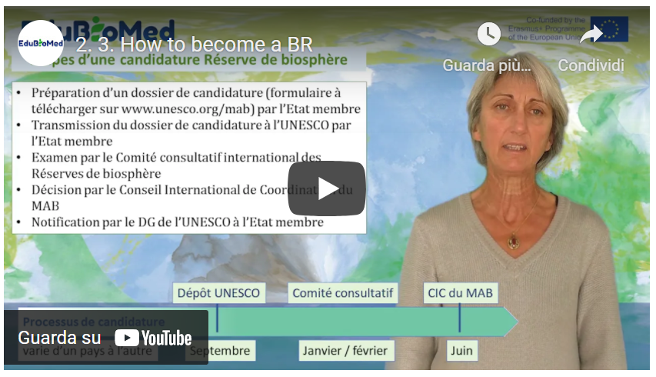
Link to the video: https://youtu.be/F7bpQErVVzg

PPT Presentation
Link to slides: https://www.edubiomed.eu/wp-content/uploads/2021/09/PPT-CAPSULE-2.3.pdf

Further Readings
- Technical guidelines for biosphere reserves
- Establish a Biosphere Reserve
- What is a Biosphere Reserve?
- The MAB Programme of the UNESCO

Transcript of the video
What steps must a region go through to be designated by UNESCO as a biosphere reserve and which bodies will be involved in order for a site to become part of the world network of biosphere reserves?
First of all, let us remember that UNESCO is a United Nations agency, where Member States are represented.
BRs are established under the auspices of UNESCO's Man and the Biosphere (MAB) programme. The secretariat of MAB is provided by UNESCO's Division of Ecological and Earth Sciences. The main international governing body of MAB is the International Coordinating Council, which is composed of representatives of 34 Member States. The representation of geopolitical regions is balanced. This body generally meets once a year and approves new biosphere reserve designations. It also approves periodic reviews of existing biosphere reserves, which take place every 10 years. The ICC appoints a Bureau, a lighter body. Another expert body, the International Advisory Committee, examines biosphere reserve files from a scientific and technical point of view. These experts, also from different regions of the world, are appointed by the Director-General of UNESCO.
Each biosphere reserve, in order to be recognized, is subject to a nomination process. The Member States submit the candidatures through diplomatic channels, through their Permanent Delegation to UNESCO. Let's recall the steps involved in applying for a site to become a UNESCO biosphere reserve. A file is to be filled in according to a form that everyone can find on the UNESCO website in French, English and Spanish and which can be downloaded in Word or PDF format. It aims to collect a set of information on the site and to ensure that it fulfils the 3 functions and the criteria required to become a BR, namely those described in the Statutory Framework of the World Network of BR of 1995.
The process prior to the application varies in its organization from country to country and can take several years. Once this candidature process is completed, the file is transmitted to UNESCO by the Member State. Each year, countries can submit files to UNESCO before the end of September. Each file will first be checked by the secretariat, which will make sure that all the documents are there, that nothing is missing. Then it will be examined by the technical body, the international advisory committee, this committee of experts who will check that the proposed site meets the criteria of the statutory framework. The advisory committee will make recommendations either to approve the biosphere reserve, or to refuse it, or to approve it on condition that additional documents or clarifications are provided by the member state, which has a few months to do so. The applications and clarifications made, or not, are then examined by the Bureau of the MAB Council, which proposes the sites for designation, proposals that are validated by the MAB International Coordinating Council, generally in plenary session. The MAB ICC usually meets in June/July, which means that it will have taken almost 10 months for the file to be processed within the framework of UNESCO.
So, let's go back to the process of submitting candidatures to UNESCO: how does the candidature process take place in the country, and who does what? It depends on the country and I will take two examples, France and Morocco.
In France, the French MAB committee has chosen to support applications from territories that wish to become a biosphere reserve. The initiative is therefore generally local, and may come from associations, researchers or elected representatives. The first step in the application process is a declaration of interest from the territory to the French MAB committee. It will be examined and encouraged if the proposed territory is likely to be able to meet the BR criteria. If this is the case, the deliberation of a local authority or administrative structure bearing the candidacy is requested, as well as membership of MAB France. A whole consultation process is then set up at local level. The application file is studied by MAB France, which will only forward it to UNESCO via the Permanent Delegation when it is deemed appropriate, in order to fulfil the statutory framework and functions expected of a BR.
The MAB France committee attaches great importance to the concertation stages prior to the establishment of the biosphere reserve and proposes that an information phase on the important project be carried out: a website, press articles, public meetings will help explain to the population what a biosphere reserve is, what it will be used for, what its outlines could be, and what role people can play in this process.
The second stage is that of appropriation: it is therefore a question of answering all the questions that arise so that the stakeholders understand the interest, what the biosphere reserve can bring them. Then, a process of co-construction of the project begins: what are the challenges facing the territory, how will the biosphere reserve enable them to be met, what are the priority subjects, who are the stakeholders concerned, all these points will be debated in the villages and towns and will enable the biosphere reserve project to be built. This project will take the form of a management document.
Morocco has another way of proceeding. In Morocco, in the 1980s, it was a question of involving the regions in the dynamics of sustainable local development and promoting them. The biosphere reserve will contribute to the fight against soil degradation, desertification, poverty and the loss of biodiversity. The choice made by the Moroccan state is to work on the scale of traditional production systems, such as the argan grove, for example, which concerns the distribution area of the argan tree, a tree to which very ancient uses are linked. The same applies to palm groves, which are places of great heritage interest. These places present a diversity and originality of land use. Biosphere reserves are established on the scale of regions that have a particular wealth or character. It is also a question of integrating networks of protected areas, a diversity of land use and sites of heritage interest into a vast territory in a sustainable development perspective. It is the Moroccan State, through the Department of Water, Forests and Agriculture, which initiates and presents the dossier to UNESCO. The work of collective appropriation takes place after the designation of the biosphere reserve.

M2 – Lesson #4 The role of Scientific Committees in the management of a Biosphere Reserve
Juana Barber Rosado, Universidad Politécnica de Madrid
Juana Barber Rosado is a forestry engineer from the Universidad Politécnica de Madrid and works in the administration of the Barcelona Provincial Government as Head of the Natural Parks Technical Office. Since 1992 she has been working for the Natural Park Service of Barcelona Provincial Council, first as an engineer in charge of building projects at the Central Services and, from the end of 1995, as head of the Building Unit at the Montseny Natural Park and Biosphere Reserve. From mid-2004 to early 2018 she was the director of the Montseny Natural Park and Biosphere Reserve and since 2018 she has been the head of the Parks Office but she still manages the Biosphere Reserve.

Description
The capsule provides an overview of the role of scientific committees within the MaB program and its synergies with the management bodies of a Biosphere Reserves.
Link to the video: https://youtu.be/4cY8ieJbE_Y
Activity
Reading about the International Advisory for Biosphere Reserves from the UNESCO and the related Statute.
Transcript of the video
If we consider the three objectives of a Biosphere Reserve: the conservation of natural and cultural heritage, the sustainable development of peoples who live in these territories and the logistic support.
The meaning of the latter is always difficult to understand, especially for us here in the Spanish Network [of BRs], maybe because of the literal translation from English of the term, but in exact terms, on what the logistic function draws the attention is on the fact that Biosphere Reserves are ‘laboratory spaces’ sites where sustainability models might be tested, models where sustainable development of peoples should be compatible with conservation that is, this third function [of a BR] comes in support to the first two objectives to be met.
It is in this third objective - the logistic support in laboratory spaces - where [scientific] research has a very relevant role. Given the importance of the role - [scientific] research cannot be performed by whom is managing the territory. Management is hard, sometimes: the day-by-day is very complicated, so people who are in charge of managing the territory cannot be the same who conduct scientific activity
Is here where the union between management and the academic entourage becomes crucial and this is what should be stressed: it is very important for a Biosphere Reserve manager -to make the right decisions- to know what is exactly going on in their territory, on a scientific base the Scientific committees play such a role there in Countries where Biosphere Reserves exist.
For example in the case of Spain, a Scientific Committee exists within the Spanish Network of Biosphere Reserves, and it is multidisciplinary, as it can only be because in a Biosphere Reserve, with the previously mentioned objectives, the range of issues you have to deal with is very vast: not only we are speaking about biodiversity protection; not only we are speaking about local development in its broad meaning -related to a rural environment: so to agricultural, forestry issues, but we are talking of many other things: of employment, of social issues, of everything that happens in that territory. Therefore, the existence of a Scientific Committee multidisciplinary that works together with managerial actors is a successful model towards which we should aim everywhere there are Biosphere Reserves.
I’d like to bring the example of what has been done in the case of the Spanish Network of Biosphere Reserves and its indicators system. A system of indicators was built in collaboration between managers and academics, so to understand if the Biosphere Reserves were complying with their objectives in the accomplishment of the Seville strategy and the Lima Action Plan. Why?
Because UNESCO is periodically evaluating [the BR] every 10 years. But obviously, if after 10 years of work, they tell you that you are not doing a good job, that would be discouraging but if you perform monitoring along these 10 years by yourself - in collaboration with a Scientific Committee- you can more easily evaluate independently where you should intervene, where you should put more resources, or what direction you should take.
So, I believe this is important and it has been an effective approach in Spain and was satisfactory in terms of the periodical evaluation.
Finally, this Scientific Committee is obliged to provide a return back to society, in the territory that is the object of study. It is very important that we start to work on what is called ‘citizen science’. That is because people should gain awareness of their territory, for this territory be a successful Biosphere Reserve and to get awareness, it is important to know what is happening. And who else but the Scientific Committee is best suited to return the results of their analysis back to society? I strongly believe it is very important to have a Scientific Committee in any Biosphere Reserve.

M2 – Lesson #5 The Mediterranean region
Pierre Doumet, Association Protection Jabal Moussa
Pierre Doumet is the Director of the Association Protection Jabal Moussa (APJM) – MBA and a Chemical Engineering degree. He is a founding member and currently the president of APJM. Although a volunteer position, Pierre dedicates more time and effort in managing APJM than he does on managing three other companies which he directs. Renowned for his pioneer work in the private sector, Pierre brought the professionalism and focus of the private sector to the not-for-profit domain of APJM. Under his management, Jabal Moussa, designated a Biosphere Reserve in 2009, became one of the most important ecotourism destinations in Lebanon, receiving an exponentially growing number of visitors every year.

Description
Pierre will tell us stories and tales about Mare Nostrum…!

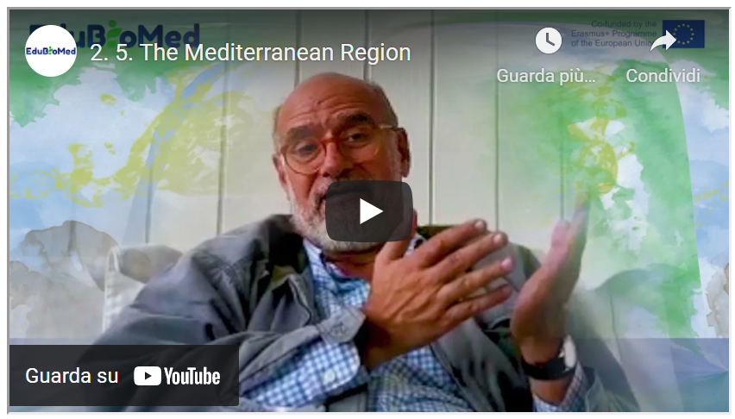
Link to the video: https://youtu.be/VuLw9No3A0Y

PPT presentation
Link to the slides: https://www.edubiomed.eu/wp-content/uploads/2021/09/PPT-presentation-2.5.pdf

Activity
Watch “A Walk with the Expert” ( https://youtu.be/64-at1ZeJ9U ) and “Who Were the Phoenicians?” (https://youtu.be/-X4WtUwaPsA ).

Transcript of the video
Hello, my name is Pierre Doumet and I'm a Mediterranean. Actually, I believe that my ancestors originated from one of the three city states on the far eastern shore of the Mediterranean. Tyre, Sidon or Byblos.
Those guys were traders and they traded all over the Mediterranean and they set up counters everywhere, but they weren't just that. It is said that they invented the simplified alphabet that allowed them to trade more effectively.
And if you look at some of the mythology, it's pretty interesting, for example, to focus on the two children of King Agenor of Tyre and his wife, Telephassa. Their kids were Cadmus and Europa. Cadmus was the first hero in Greek mythology, and he was the founder of the Greek city of Thebes.
He introduced the Phoenician alphabet to the Greek.
And what was he doing so far away from his homeland in Tyre? What was he doing in Thebes? What he was looking for his sister. His sister was called Europa, Europe from where Europe's name originated and his sister was seduced by no less than Zeus himself, transformed into a very tame white bull who took her away. So, everybody was looking for her. But actually, where they were where they had eloped was to the island of Crete. And there they had a child called King Minos and the Minoan civilization started right there.
So, between Cadmus, funder of Thebes and the foundation of the Minoans civilization and the name Europe are coming from a princess of Tyre. What we can see here is that the Mediterranean is a is a place where many civilizations have just been together, worked together or originated one from the other. And this is my purpose today to call for a little bit of this incredible richness of our cultural heritage. So, let's talk a bit about the next phase, … I'd like to show the island of Sicily about 500 years before Christ.
You can see the map right there.
And on that map, you have an island divided between colonies from Phoenicians, Carthaginians, Greek and Ionians. So there, too, you have this incredible mix of civilizations. Let's go further. Let's go into about 100 hundred years after Christ.
We have the Roman Empire. We focus on the Mediterranean and the sea. The Mediterranean Sea is called by the mighty imperial or Mare Internum, or Mare Nostrum which is a great name. And we should all call the Mediterranean Mare Nostrum: Our Sea. My goal is to see this, that there is an incredible wealth, of cultural wealth in the Mediterranean and here we're talking. Not just of archaeology and history, of course, we should be focusing on all the other cultures of wealth like wine, olives and food, song, dance, theatre... all the rest.
As a matter of fact, you hear a lot about the division of north and South North rich – South poor. Of course, I'm not concerned from the far eastern part of the region. But I would have to say that in the Mediterranean, we are all rich.
All of us are so rich with heritage and culture. And one more thing: nature. Nature, I don't know if we all are aware of that. And we are the third richest hotspot for plants in the world in the Mediterranean, 25000 species and one of the most important areas on earth for endemic plants and mammals: there are almost 300 species of mammals in the hotspot in the Mediterranean hotspot, 38 of which are terrestrial endemics birds, 534 species, 63 of which are endemic reptiles, amphibians, it goes on and on. So, let me say again, north and south, east and west, the Mediterranean is so incredibly rich, but unfortunately, it is on the verge of risking to become very poor because it might use it might be losing a lot of its cultural wealth, and more importantly, its natural wealth. There's a lot of species being extinct in the Mediterranean.
There's a lot of loss of habitat. And so, what can be done about that?
This is my purpose basically today is to discuss a little bit the Man and the Biosphere Program of UNESCO. Before I do that, I want to discuss another UNESCO program that's maybe even better known than the Man in Biosphere program is the World Heritage Sites Program. Now, that is where we take a very important site and the fence around it , or we put a wall around it and shut it down, and then we let people come and visit one by one and some nice concept and we preserve the site.
But does it really involve the people around? Does it bring them into the concept?
And here the Man and the Biosphere concept, which is about 50 years old, but I would say is more relevant even today than when it was invented. The man and biosphere put man humans in the middle of the conservation concept. It's a concept where we say we have to preserve nature and culture.
We have to do a lot of research to discover the incredibly rich richness and wealth that we have.
But we have to involve local human beings into activities that are remunerative, that are socially, economically useful to them, that can increase their standard of living. And of course, these have to be sustained over time. So, we call it sustainable development. Might be a word that's been overused, but that is the purpose to have the human being at the heart of conservation. So instead of having a protected area where we put like a box or a belt all over the place and we don't let people in and that's how we protect it, that's not the way we do know. What we have to do is a protecting area, an area that protects nature, protects the birds and the bees and the plants and the forest and the human beings, both the human beings living inside the area. And then they have a vested interest in continuing to protect. And those who visit all of these are inside of a protected area. And that's the Man and the Biosphere concept that I'm talking about. And that concept, I am working with an association called the Association for the Protection of Jabal Moussa, which is one of two very active biosphere reserves in Lebanon. And this is what we try to do.
Now, my purpose today was to discuss the Mediterranean. And so, I'll show you one more chart.
And that chart shows you something called the MedMAB, the Mediterranean Biosphere Reserves. And those biosphere reserves are linked into a cluster that's relatively recent. Previously, we had the AfriMAB , the ArabMAB , the EuroMAB and the IberoMAB and the Asian and Pacific MAB. Now, those are clusters that are started long years, many years ago, and that are forming this MedMAB and showing you is something that we started on an informal basis that we are trying to establish. And that would bring together the incredible cultural and natural wealth of the area into an organization or a sub organization or to at least a link between biosphere reserves that have a lot in common, culturally and naturally, as we already discussed, that hopefully as if you have a future in terms of both conservation and development.
Thank you very much for your attention. We will later talk about in a next video about what has been achieved or was being achieved or what is being tried to achieve in Lebanon in the local biosphere reserve. Thanks.

Module 3 – How Biosphere Reserves contribute to understanding and managing changes and interactions between social and ecological systems

- LESSON #1 Biosphere Reserves as social-ecological systems
Esteve Corbera Elizalde, UAB

- LESSON #2 Conflicts over the commons
Pablo Dominguez, UAB

- LESSON #3 Patrimonialization of heritage
Said Boujrouf, Cadi Ayyad University

- LESSON #4.1 Territorial governance in Biosphere Reserves
Catherine Cibien, MAB France

- LESSON #4.2 Territorial governance in Biosphere Reserves, The case of Morocco
Lahoucine Amzil, University Mohammed V

- LESSON #5 Biosphere Reserves and Education
Angela Barthes, University of Aix Marseille

M3 - Lesson #1 Biosphere Reserves as social-ecological systems
Esteve Corbera Elizalde, Universitat Autònoma de Barcelona
He is a Research Professor at the Institute of Environmental Science and Technology, Universitat Autonoma de Barcelona (ICTA-UAB), where he co-chairs the Laboratory for the Analysis of Social-Ecological Systmes in a Globalised world. He is an environmental social scientist who studies human nature relationships, and the impact of social, policy and environmental change of resource governance. He holds a PhD in Development Studies, an MSc in Natural Resource Management and Development (University of East Anglia), a PhD in environmental management (University of Barcelona), and a BSc in Environmental Sciences (UAB).

Description
Biosphere Reserves (BRs) can be interpreted as a socio-ecological system (SES): an ecological unit embedded with its socio-cultural part. In this capsule, Dr Esteve Corbera will explain us what are the features that characterize a SES, and how the theoretical framework applies to BRs.

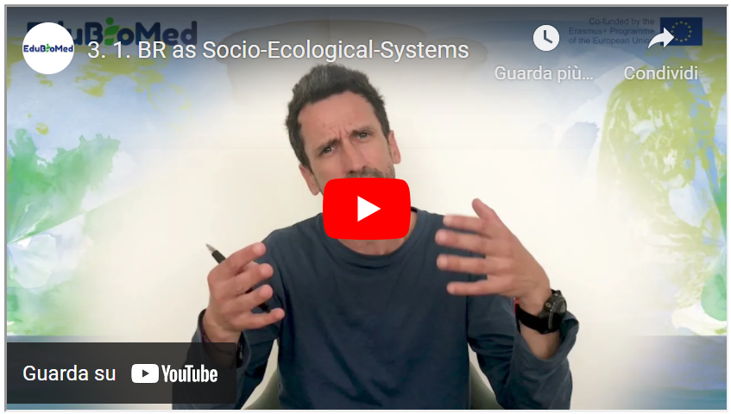
Link to video: https://youtu.be/ZUGpFAPuVDk
Suggested Reading
Adaptive governance of social-ecological systems, Folke et al. (2005).
Transcript of the video
Good morning. So, what is a Social-ecological system (SES)? A SES is a biophysical unit together with its people and social groups and, of course, its cultural practices. So, a Social-ecological system has within it this idea of an embeddedness. So, we're talking about the merging of the physical, the ecological components of the world with the social components of the world and the cultural component as well.
There is another important property in Social-ecological systems, which is interconnection. These components that I just mentioned, the social and the ecological, the cultural and social are interconnected with each other. And because of such interconnection a Social-ecological system is a complex reality because these components interact with each other continuously. This takes me to the second property of Social-ecological systems. They are not monolithic. They change over time. They change over time because the ecology changes, but also because society changes and both can change at the same time. They are in transition. Social-ecological systems change over time. Some scholars have identified six principles of Social-ecological systems or six characteristics.
The first one is that Social-ecological systems, as I said before, they are relational, relational means that these components are interconnected, but also the different components within the components are also interconnected. Think about ecosystems, for example, how trees are connected to the soil, how soil is connected to microbiota and how trees are also connected to birds, to mammals and so on and so forth. There are networks of connection, and if we think for a minute about social systems alone, the same applies, right? So, you have people connecting with other people. You have people connecting with different types of actors, governments, NGOs, companies, companies connecting to all companies. Right.
And all of these social actors at the same time are connecting to the ecology that I was mentioning before. Maybe there is a company that exploits trees. And if this exploitation is unsustainable, it might have a negative impact, for example, on mammals or birds and so on. So that's the first characteristic. It's a Social-ecological system. It's relational and it's network based.
The second one is that it's open, it's open and permeable. Right. A Social-ecological system usually, as I will mention later, is defined by boundaries. But these boundaries are permeable. Why? Well, think again about these components within the components. New actors may appear in our Social-ecological systems. Migrants, for example, who come to live in a given territory. Birds that migrate, they are sometimes in the system at some point of the year and some of the times of the year they have migrated elsewhere. Social-ecological systems are context dependent. The ecology, the geology, the physical properties of the unit obviously depend on where this system is located is not the same as Social-ecological systems in the mountains of Morocco than one Social-ecological system in the mountains of Spain, the characteristics of the soil may differ. The type of trees may differ. The type of social actors may differ.
A fourth characteristic is that Social-ecological systems are adaptive. Right? So, the environment changes. For example, as a result of climate change. And then there are there are species within the ecosystem that adapt to these new temperature conditions or to these new rainfall conditions. And the same happens with the social components of our Social-ecological system. We humans have adapted for millennia to changing environmental conditions, but also to changing policies, to changing governments, to changes in the social fabric. Right. So, we adapt to new market opportunities. We adapt to new cultural regulations or cultural rules. So that's a fourth important characteristic. Social-ecological systems are adaptive.
Finally, they can be, as I said before, dynamic but importantly non-linear. There might be changes in the system which are abrupt that may occur in a very short period of time. And that then may involve that some of these components that I was talking about, the ecology or maybe some social actors may not be able to adapt to such non-linear changes. Think, for example, about recurrent drought. What would be the effects of recurrent draws on the trees or the ecology of that given system? Maybe the drought is so severe and so recurrent that there are some species that simply disappear. Right. So, we are not saying that the Social-ecological system would disappear, but some elements of it would disappear and would be probably substituted by others. And the same applies if you think about the social system were, for example, changing market conditions. If there are changes in the pattern of demand over certain natural resources, for example, there might be some social actors in disadvantage. They might not be able to adapt to these new markets, to these new patterns of demand, and would simply have to reinvent themselves.
And the final characteristic is that within all these relations that exist across components and within the components of each component, the ecosystem, the geology of these given unit, the social system, there are complex processes of causality. So, if, for instance, we observe changes in the in the ecology of a given Social-ecological system, it's very likely that there is no one single cause of such change. There might be different elements or different processes influencing or determining such change. We talk about complex causality within Social-ecological systems.
And again, if I have to give an example, for example, I will go back to trees and imagine a situation where trees in a given Social-ecological system are increasingly being locked. OK, so deforestation is proceeding apace. What are the causes of such deforestation? There might be proximate causes by local actors. We live in the system that are exploiting the trees, but there might be distant causes as well, which is, for example, a growing demand of such type of trees in international markets. And it's about this growing demand that local actors are responding to. So here, if we want to regulate the logging of trees in this given socio ecological system, we obviously need to work with local actors. But we also need to think about, for example, sustainability standards in the international market. And this is, of course, a complex thing to do. And this is why we talk about complexity and complex causality in Social-ecological systems.
If the capsule results too long, we can think of splitting it into two capsules in this point.
So, after this kind of long introduction, probably you've been all thinking, OK, so are biosphere reserves are socio ecological systems? And I hope that all the points I've made resonated to you in one way or another as users of biosphere reserves, as inhabitants of biosphere reserves, as managers of biosphere reserves. I'm sure that you've been thinking that most of the issues I referred to are issues that can also be reflected in the realities of biosphere reserves around the world. Biosphere reserves are indeed a Social-ecological system because they have these defined unit. They have these defined territorial boundaries. These territorial boundaries define what is the ecological system or systems that are included in the biosphere reserve. What type of forest, what type of grasslands? What type of agricultural landscapes? What type of soils? Right. Let's not forget about the then the non-living part of the environment. It's also very important because without it we wouldn't have the ecosystems that we then see and observe.
And then of course, we have the people who live in the biosphere reserves in the outskirts of the biosphere reserve. We will talk about permeability afterwards. And also, of course, the actors who live within it or even the actors who don't live within it, but that have an important role in determining regulations. What can be done and what cannot be done within the Biosphere Reserve. In terms of, for example, natural resource management or agricultural practices and this is very important in biosphere reserves. Biosphere reserves are per se an institution. They determine certain ways of managing the environment that at the same time determine those complex relations that I was talking about before. Right. So, the regulations that the biosphere reserve imposes on the people who live and who make use of the resources within the reserve have consequences on which relationships are established and what can or cannot be done with resources.
Of course, I mentioned before that Social-ecological systems are dynamic, they can change. So, regulations in biosphere reserves could also change. Could adapt to changes in the environment. In the living and non-living environment, but they could also change as a result to changes in society, to changes in culture. What if local actors, local people who live in the reserve have an idea about a new crop to be grown and they are thinking about deforesting. Should they deforest? Or not? The rules may say they cannot deforest. But can these rules be changed? What would determine change? Is it legitimate to ask for changes in the institutions that govern biosphere reserves so that local actors can make a different use of their resources? This is a question that deserves to be asked not only in biosphere reserves, but in any other kind of conservation institution or conservation practice, because societies are dynamic and so is the environment. Often regulations about conservation are focused on resources as they were when the Biosphere Reserve was established maybe 20 years ago. Are those resources is still there? Are they, for example, a as a result of climate change diminishing in quantity, in quality? Does it still make sense to protect those resources? Or maybe they're going be lost anyway as a result of, you know, these global phenomena known as climate change. These are these are questions that socio ecological systems and particularly biosphere reserves should be asking all the time.
Whatever happens within a biosphere reserve, as I mentioned before, needs to be analyzed very. I would say with care, right? What I mean is not if I talked before about complex causality. This is something to take into account when we think about patterns of resource use and conservation within biosphere reserves. Who is to blame for certain practices that may go against the interest of the managers of their reserve? Maybe there is no one single actor to blame or the actor to be blamed is no local actor, but an actor sitting very, very far away of the Biosphere Reserve.
I would like to finish reflecting also on these two other ideas that I mentioned before, one is this idea of relationality. So, thinking about the fact that all actors within the Biosphere Reserve are somewhat connected to each other and that at that same time these actors are connected to resources through different practices, through different cultural understandings of nature, and that all of these different connections are to be taken into account when we think about how to manage a biosphere reserve or what we want to make out of their resources within our biosphere reserve.
And finally, I will end up with this idea of adaptiveness. Biosphere reserves, the ecosystems within it will adapt to changing global environmental conditions. And reserve managers need to be aware of that. They need to be constantly monitoring the state of the state of the environment. Not necessarily to enforce further regulations to avoid changes, but to accommodate changes so it works for the benefit of the actors who live out of these resources.
And finally, in the same way that managers can adapt their expectation about resource use also local actors may need to adapt to changing priorities within the Biosphere reserve and of course, to the changing needs of the broader society where these biosphere reserves are located. And here what I have in mind is how Biosphere reserves for example may adapt to changes in demand of local tourism, for example. With the global COVID pandemic we are seeing for example –at least in Spain but I presume this is the same in other parts of Northern Africa and Morocco as well- where we have increasing number of national tourisms within protected areas. And this type of tourism may have some needs and some priorities which are different than for example international tourism. How then these biosphere reserves can adapt to such changing priorities and these changing needs? It's a question worth asking in the time of COVID.
Well, I hope my reflections were useful, they were maybe too abstract, so what I would recommend you to do is to is that you think about these issues through the lens of your own biosphere reserve, the biosphere reserve you like walking in the biosphere reserve where you live in, or the biosphere reserve that you manage. Thank you very much.

M3 – Lesson #2 Conflicts over the commons
Pablo Dominguez, Universitat Autònoma de Barcelona
Pablo Domínguez, PhD, is an Eco-Anthropologist of the commons, especially centered on pastoral commons of the Mediterranean mountains. He mostly focuses on the ecological and socio-cultural holistic understanding of their functioning. Pablo is Senior Researcher at CNRS (France); Laboratoire Géographie de l’Environnement (GEODE), CNRS / Université de Toulouse 2; Associate Research Fellow at LASEG & AHCISP, UAB (Barcelona); Associate Research Fellow at LPED (Marseille) and LMI MediTer (Marrakech), IRD / Aix-Marseille Université.

Description
In this capsule, Pablo will tell us how Mediterranean Biosphere Reserves can contain traditional cultural practices for the sustainable management of the territories called as ‘commons’ – and how these are threatened in the past, and nowadays.

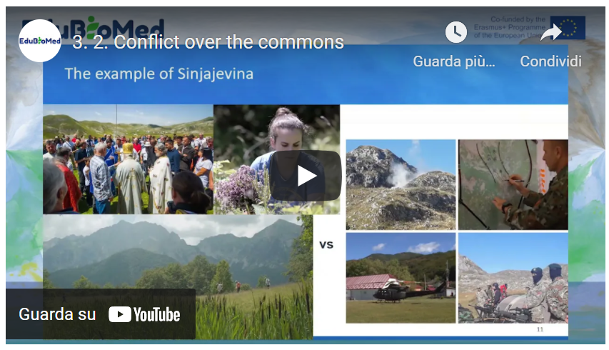
Link to video: https://youtu.be/FhN98nwGAQE

Activity
Learn more about the Sinjajevina case.
Transcript of the video
Hello, my name is Pablo Dominguez, anthropologist of the French National Council for Scientific Research (CNRS). And today, 18th of November 2020, I'm going to give a talk about pastoral community conserved areas in the mountains of the Mediterranean and the case of Sinjaejevina. Mediterranean mountain pastoral commons at the same time a natural and cultural subject, their ever-evolving pasturelands conserved by local populations through dynamic adaptive community governance systems. Mountain populations governing the commons have generally a strong bond with tradition, which is most usually linked to the conservation of the ecosystems and natural resources, as their survival most often directly depends upon them and which they are deeply culturally connected with. In strict economic terms, these comments generally involve assemblies of pastoralists that impose the limitation of access to pastoral space during spring to allow the vegetation to rest at a particularly sensitive period when exponential plant growth, flowering and green production are happening and ensuring so the pastures recycling and sustained use year after year at the same time as maximizing their production while minimizing social conflicts between users due to the high participation of right holders in the management of these ecosystems. Commons are spread practically in all the mountains of the Mediterranean, and we can assume that there are hundreds of thousands of commons in this region and that they could cover more than half a million square kilometers, giving them therefore a huge spatial weight concerning the management of key and very sensitive mountain landscapes that are mostly ignored partially by science and especially by decision makers. Ecologically speaking, community based management results most often in maintaining a denser and better preserve plant cover and free open access lands, biodiversity is often also more important in this commons or has a particularly one authored a small scale and an epic scale of commons. At the same time, they also favor pools for seed conservation diffusion so unrepentant against that ocean availability of water, carbon sinks against climate change, and a great diversity of landscapes, among others.

As a result, even though they are still poorly integrated in international policies and state legal systems, the concept of the Commons is now included in the political decisions and initiatives of some of the most important organizations at the global scale, such as the Convention for Biological Diversity, International Union for the Conservation of Nature, the United Nations Development Program and the United Nations Environmental Program. But it is impossible to know the exact special range of these systems as much as their precise environmental, social, cultural and economic impact, unless a major comparative research on this system is launched at a Mediterranean scale. A large funding is needed for a comparative study of mountain pastoral commons across the Mediterranean, determine exactly their value in terms of biodiversity conservation, ecosystem services, fighting global warming, sustainable development and so forth, with the aim of establishing an audit plan for the support at the regional scale of the whole basin.

At the same time when there is data on social ecological interests, the rural commons in the Mediterranean, actions must be urgently launched in their favor because these systems are eroding very quickly while they will be practically unrecoverable if we do not get to them on time and thus losing forever a living heritage several times millenary that once touched upon practically all Mediterranean landscapes. They are part of our history, our identity, our biodiversity, our past and present ecosystems that we cannot allow ourselves to lose. In fact, this interesting systems, socially and ecologically speaking, are practically all threatened. This is the case since the dawn of time. We're all Moroccan, Spanish, Italian, Montenegrin common studied by myself and colleagues. Moreover, the enclosure of the commons in the Mediterranean mountains seems systematic and not only a question of the past, but very actual.

Let's take the concrete example of Sinjajevina, a cluster of pastoral commons in Montenegro that we have also started to study in depth. The biggest mountain pass through the Balkans, the second in Europe, and a vital ecosystem against climate change that particularly favors biodiversity conservation. In 2019 last year, the government of Montenegro, supported by NATO, decided to inaugurate the military training ground in Sinjajevina within the Tara River Basin Biosphere Reserve next to two UNESCO World Heritage sites, a protected Natura 2000 area where the protection of birds habitats and a regional park for the protection of nature and culture that was supposed to be inaugurated in 2020 - but we're still waiting - unconcerned about the damage this would represent to its people, their traditional uses, and to these social, ecological invaluable systems built by humans and nature through millennia. Is especially astonishing when taking into account the artillery testing ground has been inaugurated without any publicly available environmental impact assessment, health evaluation, economic impact study nor any substantial negotiation with the affected pastoral communities on Montenegro is in accession talks of the EU, where things are usually done all the other way around. The inauguration of this military ground stands as an example of the types of threats many commons in the Mediterranean basin are facing still today in a generalized context where these systems and their customary laws are not acknowledged by the states, which most often consider the lands and resources within this commons as public property and not the local communities’ who are there using them and that have generally enjoyed them for centuries, since the widespread degradation of rural commons in other Mediterranean countries. At the same time, their importance for global and regional ecological sustainability. It is obvious, urgent to address them and to work to protect them and promote them, meaning that Sinjajevina case is important for itself, but also much more as an indicator of a greater degradation phenomenon and lack of recognition to these systems at the Mediterranean and in fact, also at a global scale. Thank you very much for any questions, any reactions. You may just feel free to contact me on the email address you see in the first slide of the of the of the show. Thank you very much.

M3 – Lesson #3 Patrimonialization of heritage
Said Boujrouf, Cadi Ayyad University
Saïd Boujrouf, professor of geography and director of the Laboratory for Studies on Resources, Mobility and Attractiveness (LERMA) at Cadi Ayyad University in Marrakech-Morocco. Interested in territorial planning, territorial development, patrimonialization and touristic valorization. His researches also concerned governance and innovation in Moroccan context.

Description
How can heritage be enhanced for sustainable territorial development? Second, are biosphere reserves a tool for heritage development? Thirdly, could patrimonialization contribute to the preservation and resilience of biosphere reserves? Professor Boujrouf will address this question using the case of the Arganaraie Biosphere Reserve in Morocco.
Link to video: https://youtu.be/UtwkXCkKL8s
Activity
Read about the Réserve de Biosphère des Arganeraies.
Read about the scientific field trip of UCA teachers and students.
Watch the video about the scientific field trip of UCA teachers and students.
Further Readings
Benhsain, Wafaa & Boujrouf, Said. (2020). Territoire labellisé, enjeux et contraintes pour un développement et une attractivité touristique, cas du Patrimoine mondial de l’UNESCO.
Dubeuf, Jean-Paul & Boujrouf, Said & Romagny, B & Alifriqui, Mohamed. (2021). Les visions et référentiels des politiques de développement territorial dans l’arganeraie : retour sur 10 ans d’initiatives et de projets -2019.
Tebaa, Ouidad & Boujrouf, Said. (2019). Patrimonialization and the Geopark Label: for Which Development Model in the South? The Case of Morocco. 10.1002/9781119681489.ch4.
Abdollah, Ahmed & Bouaabid, Hanane & Michon, Genevieve & Boujrouf, Said. (2016). Chapitre 16. Tourisme et valorisation des spécificités locales. 10.4000/books.ird éditions.26009.
Auclair, Laurent & Kejjaji, Sana & Michon, Geneviève & Boujrouf, Said & Skounti, Ahmed. (2016). Chapitre 9. Quels processus de patrimonialisation pour la préservation des sites rupestres ?. 10.4000/books.ird éditions.25949.
Boujrouf, Said & Mostafa, Hassani & Dubeuf, Jean-Paul. (2015). La participation des politiques publiques à l’émergence et à la gouvernance des dispositifs de valorisation des produits de terroir : Une analyse croisée des politiques de valorisation des produits de terroir au Maroc et en Corse.
Boujrouf, Said. (2014). Ressources patrimoniales et développement des territoires touristiques dans le Haut Atlas et les régions sud du Maroc. Revue de géographie alpine. 10.4000/rga.2259.

Transcript of the video
Hello Saïd Boujrouf, professor at Cadi Ayyad University and member of the EduBioMed programme. Today, I would like to talk to you about the enhancement of the cultural and natural heritage of biosphere reserves in the case of the Arganeraie Biosphere Reserve in Morocco.
This vignette is part of the MOOC entitled: "Biosphere reserves as living laboratories for sustainability education, applied research and local development". Our initial questions are threefold. Firstly, how can heritage be enhanced for sustainable territorial development? Second, are biosphere reserves a tool for heritage enhancement? Third, could heritage development contribute to the preservation and resilience of biosphere reserves? So, to answer these questions, we have set two main objectives; Starting from the fact that Unesco when it defined biosphere reserves as learning places for sustainable development, among others. For this reason, we are looking for a general objective that can be manifested in the following questions: How can biosphere reserves serve to understand and manage changes in the interactions between social and ecological systems? And how can the enhancement of the biosphere reserve and its heritage contribute to a strong awareness among stakeholders and learners of the role of this reserve in territorial and sustainable development? Thus, biosphere reserves are an open-air laboratory. It helps us to observe, learn, understand and act on sustainable development issues. And of course, we are going to see all this from the case of the Argan Biosphere Reserve (ABR) located in central western Morocco.
So, the ABR is the first biosphere reserve recognised in Morocco by UNESCO in 1998. It was declared as an area that could be preserved and be a conservation area. But, at the same time of human, social and sustainable development. Because it is inhabited by the local population who have the right to exploit the natural resources found in these areas. This reserve covers an area of approximately 2,500,000 hectares. It concerns 8 provinces and prefectures, located in the centre-west of Morocco. It covers a vast intra-mountainous plain, bordered by the High Atlas and Anti-Atlas mountains and the Atlantic Ocean in its western part. Thus, it reaches an altitude of 2,500 metres and is part of the Saharan Mediterranean transition zone established around a forest species endemic to Morocco called Argania Spinosa, the main characteristic of the Moroccan sector with a vegetation of Mediterranean forests, woods and scrub. This biosphere reserve extends from the Essaouira region in the north to the Sidi Ifni region, Guelmim in the south and as far as Tafraoute in the east and the Tata region. This large area of the RBA recognises the singularity of the production system and the potential of biodiversity combined with a specific cultural identity. This is a situation for which sustainable projects are needed.
The main objectives of the creation of the biosphere reserve are as follows: Firstly, the preservation of biological resources, landscape and cultural values. Secondly, to maintain the balance and the ecosystems. And finally, the promotion of environmental education and the contribution to local and regional development in this area of Morocco.
The enhancement of this heritage, which is natural, human, diverse, rich and specific, requires sustainable territorial development in order to make the RBA sustainable. To this end, in order to enhance this heritage, the efforts of the various actors and stakeholders must be combined to ensure an enhancement that brings several elements and several important results for the sustainability and the social, human and sustainable development of the reserve and the local population. Firstly, the well-being of the population within the framework of an inclusive human and social development. Secondly, a sustainable development of biodiversity in a sense that integrates the economic aspects related to the life of the local population. Thirdly, a construction of the heritage resource on the basis of the specificity linked to the endemism of the argan tree and to the local human treasures, the result of the know-how and life skills of the populations. Fourthly, a better contribution of the biosphere reserve's ecosystem services, as it provides services related to water, wood, agricultural products and crafts with the population. Other services are added that are linked to its resilience, such as the fight against erosion and desertification. Thus, the RBA is a space of conciliation between man and nature. A space that offers its natural capital for the promotion of sustainable solutions, especially the resilient tree that is the argan tree. Therefore, enhancing the heritage for a sustainable territorial development of the biosphere reserve requires combining the efforts of the different actors and stakeholders to ensure an enhancement that brings in the 5th point, the labelling and certification.
This fifth point should be connected and complementary, ensuring geographical origin, food quality, fair trade and ecotourism, etc. Thus, for the role of labelling in the heritage of the RBA, we can see that the relationship between enhancement and the recognition of the biosphere reserve as a world heritage site emerges as a strong issue and produces economic spin-offs and a real race for 'labelling'. In fact, labelling is becoming a means of justifying the discourse and practices of environmental protection. But also, to reinforce the territorial anchoring and the reconstruction of the resources which become of course patrimonial. In this respect, several labels and certifications are emerging, based on the concepts of ecotourism, ecolabelling, and agricultural and craft certification.
There are at least a dozen labels and certifications that take into account the specificities of the RBA, its heritage and its natural and human capital. So, the role of labelling in the heritage of the Argan Biosphere Reserve is important, but we must pay close attention to the developments that are beginning to take place in the field and that we have noticed in a certain number of field surveys, especially in the city of Agadir. Although general or specific labelling contributes to the construction of a territory brand and a local identity, we must be careful about the trivialisation that could affect the specification system and risk eroding its constructs. For example, the idea that labels for local products protect local knowledge and specificities needs to be demonstrated; especially, on the one hand, with the few deviations that are beginning to be noticed in the different places and territories of the biosphere reserve. On the other hand, noticed in the urban space and noticed, essentially, in the markets.
Another important aspect, which makes the valorisation and patrimonialisation help the sustainable development of these specific territories, is the recent recognition of the International Day of the Argan Tree by the United Nations.
This is another way of raising awareness, education and heritage of the RBA, which promoted an international day of the argan tree, on May 10 of each year. The year 2021 was the first day to celebrate this tree which is the argan tree, presents not only natural endemism, but also a whole human, cultural and identity heritage behind; Thus, how this resilient tree that can cope with difficulties and climate change, but also fight against desertification, degradation of the environments of this vast territory. Thus, this International Argan Day is another way of raising awareness, educating and making the biosphere reserve a heritage site.
Promoting heritage for sustainable territorial development of the biosphere reserve also involves promoting tourism, which is an important aspect of heritage development. In the context of the RBA, this tourism development is carried out in connection with a tourist hub, the city of Agadir. At the beginning, tourism in the RBA seeks to diversify the offer of the tourist city of Agadir with approximately one million tourists in 2015, of which more than 95% of tourists are mainly targeting the seaside. Tourism in the hinterland of Agadir is small, accompanied mainly by small rural accommodation structures with an essentially itinerant tourism.
At the same time, eco-tourism is beginning to mobilise the heritage resources linked to the biosphere reserve and which involves crafts, cultural art, gastronomy, identity and local products, etc., with a real start to raising awareness of the sustainable development of the biosphere reserve, with a concretisation of the biosphere reserve concept by means of labelling, certification and conciliation between the needs of the population and the need to conserve the natural capital. A diversity, therefore, of local, regional, national and international stakeholders who come to carry out preservation projects, but also human development projects in these territories of the RBA. These territories are fragile, specific and are the breeding ground for a new territorial construction that seeks to establish a local ecotourism adapted to the environment of the biosphere reserve. But the stakeholder system still needs a specific governance adapted to this biosphere reserve situation. It needs connectivity, communication, building bridges of negotiation, coordination between the different stakeholders, sharing and ways of sharing. As well as, ways of sharing the heritage resources of this territory equitably. This means being able to move towards a territory project and not project territories, which we are currently seeing develop. Of course, this territory of the reserve or these territories of the RBA, seen from the tourism side, is made up of several territories.
Firstly, Agadir, Ida Ou Tanane and lnzegane Ait Melloul, the Chtouka Ait Baha, Taroudante, Tata and Tiznit with the construction either in the sense of preservation and ecotourism; or in the diversification of the offer of the city of Agadir. There are at least 7 major tourist routes; the honey route, the Igoudars route, the route linking the Atlantic to the Anti-Atlas, the orange routes, the Mesguinas route, the Atlantic coastline route and which touches on the Souss-Massa National Park (PNSM), as the last product or the last space for practising ecotourism. There are initiatives, for example, that of the Rural Tourism Development Network (RDTR), which builds tourist circuits around the problem of the biosphere reserve by linking the heritage sites with the diversified landscape linked to the relief and the argan forest. As well as, the sites of the production of local products by criss-crossing the plain areas, the mountain areas, the Piedmont, the mountains of the High Atlas and the mountains of the Anti-Atlas going as far as the Saharan border open to the regions of Guelmim and Tata. If we take a map of tourism in the RBA region, we find that there is a well-developed tourism which is essentially established in the city in the urban area, while on the other hand there is still a timid tourism, linked to rural and ecotourism, in these diversified regions, with territories which can be complementary in the tourist offer, but there is still a lot of work to be done in this direction.
Lastly, to enhance the value of the heritage for sustainable territorial development and to ensure that the patrimonialization that is underway will contribute to the sustainability of the biosphere reserve. To do this, we see that we should move up a gear and set up a system of payment for ecosystem services (PES). We know that Morocco has launched a project with the UNDP called "Circular Economy Approaches for the Conservation of Agro-Biodiversity in the Souss-Massa Region", in the Arganeraie Biosphere Reserve, which is the result of this cooperation between Morocco and the UNDP. However, in order to achieve this goal, which is payment for ecosystem services, it is necessary to use this innovative instrument for the preservation of "nature" capital, which should be integrated into public and private accounting in our country.
Valorisation involves the labelling and marketing of two local products, namely argan oil and honey, which will help to mobilise natural and human capital in a market context. Will we be able, through these choices and orientations, to ultimately face the weakness of the resilience and fragility of the environment of the RBA and the needs of the local population, for the development of their goods and their well-being? Can we, in this way, achieve territorial and sustainable development? And also as a hope, to honour Morocco's commitments to UNESCO, to the local population and to everyone who loves nature and would like to preserve its territories of sustainability and endemism, and even of cultural specificities and identities such as the Arganeraie Biosphere Reserve.

M3 – Lesson #4.1 Territorial governance in Biosphere Reserves
Catherine Cibien, MAB France
Catherine Cibien is the Director of MAB France. MAB France animates and strengthens the national network of 14 Biosphere Reserves, puts it in touch with the French and international communities interested in this program: scientific community, educational and academic world, organizations for the management and conservation of biodiversity, sustainable development and of the ecological transition. She co-hosts the Master MAB (Man and Biosphere) at the University of Toulouse.

Description
In this capsule, Catherine will provide an overview of the overarching arrangements that constitute the governance of a Biosphere Reserve.

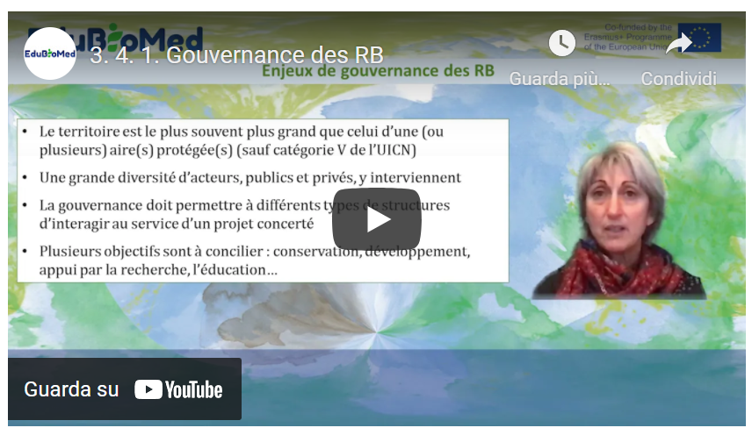
Link to video: https://youtu.be/U1-LKBbn9O8

PPT presentation
Link to the slides: https://www.edubiomed.eu/wp-content/uploads/2021/09/PPT-4.1-Module-3.pdf

Further Readings
Stratégie de Séville et cadre statutaire du réseau mondial. UNESCO 1996.
A New Roadmap for the Man and the Biosphere (MAB) Programme and its World Network of Biosphere Reserves 2015-2025. UNESCO 2016.

Transcript of the video
The governance of biosphere reserves was clarified at the Seville conference in 1995, particularly through the texts that are still relevant for the implementation of biosphere reserves. Biosphere reserves are not protected areas, but are more than protected areas. They integrate them, but with the vision of integrating conservation into the sustainable development of populations. The statutory framework governing biosphere reserves, which dates back to the Seville conference, sets out the provisions relating to governance in Article 4, and specifies that measures must be taken to involve and associate a set of stakeholders who are representative of the territory in which the biosphere reserve is located. The public authorities, administrations, and therefore elected representatives, local communities and also private interests: companies, associations, associations with an interest in the environment, cultural associations, etc. Both public and private interests will be associated at the time of the creation of the biosphere reserve and throughout its life and the implementation of its management.
It is therefore necessary to provide, in addition to this broad and open governance which may take the form of a management committee, resource use management mechanisms for the buffer zone where not everything is allowed and the buffer zone.
Activities must be controlled in one way or another, and therefore must have management mechanisms in place. But the whole biosphere reserve, and therefore all three areas that make it up, must have a management plan or policy. Of course, this management policy must be put in order and periodically renewed. Usually every ten years, and it will therefore need an authority or a mechanism to implement this management policy.
Also recall that the biosphere reserve must develop research programmes and environmental monitoring programmes, education, training and awareness-raising programmes. It should also be recalled that the core areas of biosphere reserves are protected areas established by law and their objective is long-term conservation. The biosphere reserve is more than a protected area, but it contains protected areas.
Then, it should be noted that the territory itself can sometimes be a protected area which will be category 5 or 6 in the IUCN categories. May contain several protected areas, sometimes several different types of protected areas, for example in France, a nature reserve and a biotope protection decree, and a piece of land that will be under land protection that will belong, for example, to the Conservatoire du Littoral (Coastal Protection Agency).

A biosphere reserve is a territory where a wide variety of stakeholders, both public and private, are involved. We must always keep in mind that several objectives have to be reconciled and therefore different types of public and private structures will be called upon to interact, but they will interact within the framework of a concerted project. The objective of this governance and the establishment and animation of this concerted project. As several types of statues are present in biosphere reserves. It will be necessary to make them consistent. In other words, the work of the biosphere reserve and this governance will serve to coordinate, animate, implement and mobilize different types of stakeholders and, of course, sometimes to deal with complex situations. They are obviously not absent.
Conflicts between interest groups who may have a different vision of the future of the territory and who will need to be brought into dialogue, to discuss conflicts over land use, over the use of resources, sometimes from different points of view within the local population, but sometimes between the local population and governments further away from the field. Conflicts also arise between production and the economy and conservation. These are all conflicts that the biosphere reserve will have to manage and will be keen to manage.
It is obvious that information and communication are important in all this. Transparency regarding the decisions taken and the associated stakeholders, local participation is very much encouraged in biosphere reserves and different types of animation techniques are required. Therefore, all these points relating to communication, dissemination and mediation are absolutely fundamental.
The way in which biosphere reserves are organized varies a lot from one case to another and on a global scale. There are obviously different types of models that implement governance.
In some countries, there is a model called authorities, according to work done by the German Commission for UNESCO, which notes that in some cases, the state is in charge of the management of biosphere reserves, sometimes only the core areas. And in these cases, it is obvious that the State is poorly equipped and has little or no competence for local development, and therefore has a weakness. From this point of view. Often, it is the oldest biosphere reserves which were based on this type of governance model. There are also much more flexible models that the German Commission for UNESCO has called the NGO Model Coordination Model. It is a model that is more based on cooperation, a coordination function, but often limited means of management and implementation, means of intervention, land management or land use. On the other hand, these structures make it possible to fluidify dialogue at the territorial level, to make it possible and they are present in different countries. And then, of course, there are many mixed models. In France, there are many different types of arrangements, but most of them are mixed models or rather coordinated models, but nevertheless with a mix. Among the mixed models we have two biosphere reserves which are supported by national parks. The national parks in France have been adapted following a relatively recent law dating from 2006 which provides for a core area of the park which is regulated, but which is integrated into a zone of free adhesion of local authorities and whose objective will be a sustainable development project around the core of the park in a notion of ecological solidarity, solidarity between the core and the zone of adhesion, therefore a balance between conservation and development and a balance which aims to be reinforced by solidarity mechanisms. The two biosphere reserves based on this system have the same governance as the national park, with a board of directors comprising a majority of local authorities, representatives of local communities, but also the administration, representatives of the main activities of the territory, foresters, farmers, representatives of farmers, and representatives of the private sector.
And who can of course sit in thematic and specialized committees, but also have the right to take decisions at the time of the board of directors. This board is also supported by an economic, social and cultural council and a scientific committee.
Among the biosphere reserves that operate according to the co-coordination model, there are different supporting structures that can be alone or in connection with other communities. And in these cases, when there are several types of structures that support a single biosphere reserve, the biosphere reserve serves as a cooperation mechanism between different entities on the scale of a territory that has ecological, social or cultural coherence. And there, there are different possibilities: a watershed management institution as in the Dordogne, mixed syndicates, mixed syndicates of regional nature parks alone or with other mixed syndicates, or other types of community codes such as conurbation communities when a town is part of the biosphere reserve territory. Or a marine nature park, as is the case in the biosphere reserve in Brittany. Thus, there is a wide variety of arrangements that enable the biosphere reserve to adapt as well as possible to the implementation of these three functions of conservation, development support and logistical support on the scale of a territory that is an entity in ecological, social and generally cultural terms.

M3 – Lesson #4.2 Territorial governance in Biosphere Reserves. The case of Morocco
Lahoucine Amzil, University Mohammed V
Full professor of Geography / Co-Coordinator of Master program on tourism, sustainable development and land management. University Mohammed V, Rabat – Member of several national and international research groups aligned with the scope of Edu-BioMed project – Research team on the Region and Regionalization (E3R) – Centre for Research and Geographical Studies (CERGEO) – LITOPAD/UM5R team – LMI-MediTer/IRD. He is conducting a research project named: “Man and mobility: new identities, new territorialities” in the Arganeraie Biosphere of Southern Morocco M&B.
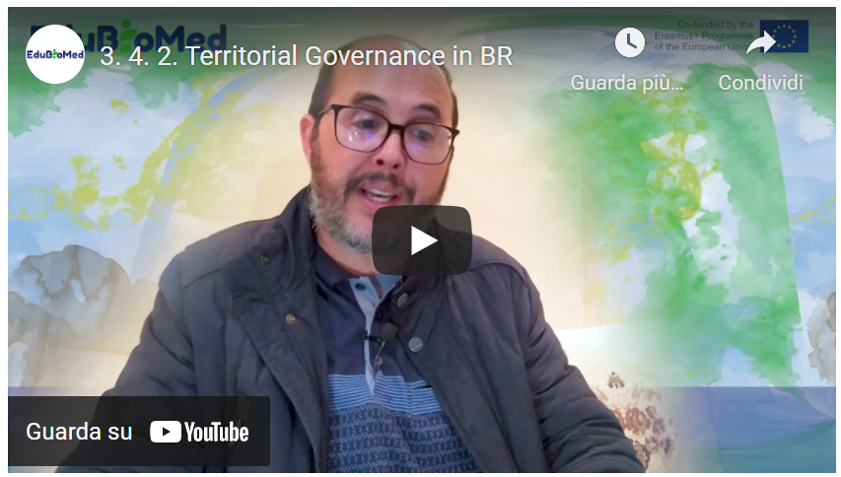
Link to video: https://youtu.be/zvBj1FwnN80

M3 – Lesson #5 Biosphere Reserves and Education
Angela Barthes, University of Aix-Marseille
French Full professor, Department of Education in Social Sciences, Humanities and Management (AMU-ADEF). Projects: Intercultural Education for Environment and Sustainable Development (EIEDD) ANR/FRQC; Rise H2020 “Geoparks: Heritage, Education and Sustainable Development”. Teaching: IUT environment – Geography – Sciences of education. Research topics: Education, Knowledges and territorial development, Sustainable development education, citizenship education, territories education, heritage education, local development, rural development and education.

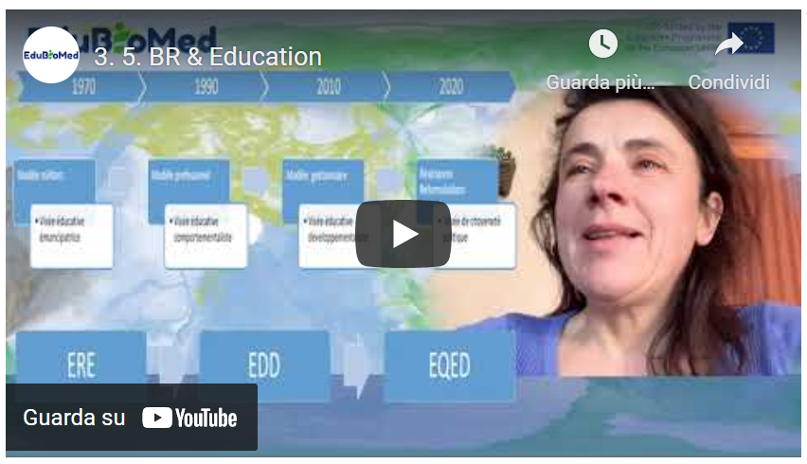
Link to video: https://youtu.be/VCxY4dIfUFk

Module 4 – Case studies from the ground presented by Biosphere Reserve managers

- LESSON #1 The role of women in Montseny Biosphere Reserve
Juana Barber Rosado, Montseny Biosphere Reserve

- LESSON #2 The Arganaraie Biosphere Reserve: a delicate balance between man and the biosphere in Morocco
Abdelaziz Afker, RBA

- LESSON #3 Cevennes Case Study
Stéphane Garnier, MAB France

- LESSON #4 Jabal Moussa case study
Pierre Doumet, Association Protection Jabal Moussa (APJM)

- LESSON #5 Thinking outside the borders: the Mediterranean Intercontinental Biosphere Reserve
Mchich Derrak and Águeda Villa Díaz, RBIM

M4 – Lesson #1 The role of women in Montseny Biosphere Reserve
Juana Barber Rosado, Universidad Politécnica de Madrid
Juana Barber Rosado is a forestry engineer from the Universidad Politécnica de Madrid and works in the administration of the Barcelona Provincial Government as Head of the Natural Parks Technical Office. Since 1992 she has been working for the Natural Park Service of Barcelona Provincial Council, first as an engineer in charge of building projects at the Central Services and, from the end of 1995, as head of the Building Unit at the Montseny Natural Park and Biosphere Reserve. From mid-2004 to early 2018 she was the director of the Montseny Natural Park and Biosphere Reserve and since 2018 she has been the head of the Parks Office but she still manages the Biosphere Reserve.

Description
A case study from Montseny Biosphere Reserve (Spain). Its manager Juana Barber Rosado tells about the story of how the women of Montseny got to develop a Gender Equality Plan and a women assembly after a series of workshops.

Link to video: https://youtu.be/xMSJLvEAHIU

Activity
Explore the web of Montseny Biosphere Reserve and read about its Gender Equality Plan. You can use DeepL translator since the web is in Spanish.

Transcript of the video
The management of a territory that is called Biosphere Reserve relies on an Action Plan that the same territory presents to UNESCO during the application process. This very Action Plan should base on the Seville Strategy, in the Lima Action Plan, in the UN’s Sustainable Development Goals and in the 2030 Agenda.
In this regard, in the case of Montseny Biosphere Reserve, these days [September 2020] we are between the end of an Action Plan and the adoption of the following one.
Until now, the way we implemented the Plan was through working groups, specifically four groups that would lead the daily management of the Reserve. The first working group is for the issue of ecolabeling and the related patrimonialization of the rural heritage. Another working group of mobility and public transport, which is a very relevant topic in Montseny BR, since it is close to the place [Barcelona] where approximately 70% of Catalonia’s population lives and therefore receives many visitors. Another working group works on energy efficiency. In the case of Montseny, given the abundance of forests, biomass is a central topic. And another working group that is dealing with water management. As we like to say in Montseny BR, water is the element on which we orbit. The conservation of natural heritage passes by a good water management.
Besides these four basic working groups, opportunities come up. In this sense, and looking at the 5th Sustainable Development Goal - gender equality - in 2017 we organized some meetings to discuss the role of women in the rural world. These meetings were held in Montseny BR and people from other Biosphere Reserves came to share their experiences.
The idea that we managers had at that time was to discuss a topic that we believed important, without expectations. And the meetings were successful, mainly thanks to the engagement of attendants, who put emotions and feelings in what was happening and it created in Montseny -as I like to say- a small revolution.
And when the meetings concluded, many people, both men and women came to me saying that it had to continue, that we had to keep working the topic of gender equality, so we kept working, and last year [2019] we approved the Gender Equality Plan of Montseny Biosphere Reserve.
A plan that deals with equal gender opportunities, in a world -the rural- where inequality is even larger than in the urban world, it counts of a series of objectives (available in our website), and what is important to say is that it has been a Plan born from the same citizens of Montseny Biosphere Reserve that enabled the organization of a series of workshops on women empowerment, the creation of a women assembly, and above all... That people got to meet. Rural and mountain areas - as it’s the case of Montseny BR- they are isolated areas. So people were not knowing each other’s’ before. They did not have a relationship. Thanks to all these workshops, all the meetings and the Gender Equality Plan, a small revolution happened, as we like to say. Small business and enterprises led by women are starting, especially in the agricultural and forestry sectors.
I believe it is very important also because that it is not accomplishing just the 5th SDG, but also other ones, especially the #17, the one on Partnership. Well, this is the small experience of Montseny BR, and do not hesitate in contacting us for anything.

M4 – Lesson #2 The Arganaraie Biosphere Reserve: a delicate balance between man and the Biosphere in Morocco
Abdelaziz Afker, Arganaraie Biosphere Reserve
Abdelaziz Afker is the focal point of the Arganaraie Biosphere Reserve at the Regional Directorate of Water and Forests (Agency of the Ministry of Agriculture, Maritime Fisheries, Rural Development and Water and Forests of the Kingdom of Morocco) in Agadir. Diploma in Water and Forestry Engineering (1988 Salé Morocco) Master’s Degree in Human Resources Management and Organizations (Nancy 2009) and Professional Coaching Certificate (Casablanca 2013). Involved in all initiatives supporting sustainable management of biodiversity (projects and programs) and also in the animation and support of local groups in the process of revitalization of territories.

Description
Mr Afker tells us about the complexities of the Arganeraie Biosphere Reserve (RBA) socio-ecological landscape, in Morocco, a territory covering 2,5 millions hectares. What are the main factors hindering rather than supporting a sustainable coexistence between human development and nature conservation practices?

Link to video: https://youtu.be/DzEr-5y4T2o

Transcript of the video
Good morning, it is a great pleasure for me to talk about the Arganeraie Biosphere Reserve (RBA). It is a reserve that was created in 1998. It is the first one in Morocco. It covers a territory that extends over 2.5 million hectares and is home to about 3 million inhabitants and which is experiencing a dynamic that is very, very complex and contrasted as well. Why is it so? Because if we take the Reserve, it is a set of territories. We will find each territory has its own characteristics, its dominant functions, we will also find characteristics related to culture, linked to the most dominant production system. If we take the mountain, it's not like the plain, the High Atlas is not like the Anti-Atlas. The coastal part is not like the continental part, even the mountain, the piedmont is where we see more presence of the population, uses and pressure on the resource.
And also, it is a territory rich by its culture, where we will find the identity culture characterizing the Anti-Atlas, but also that of the High Atlas. It is a crossroads from the climatic point of view of oceanic influences, Saharan influences, but also the dominance of influences characterizing the Mediterranean ecosystems found in northern Morocco. A part of these Mediterranean ecosystems is present at altitude and follows the stages constituted by the Arganaraie. The Arganaraie extends from the ocean to an altitude of 1500 . Beyond 1500, we will find the Red Juniper, Oak-Green, the Oxycedra and all the accompanying species of the ecosystems based on Oak-Green and Juniper. But the Arganeraie also consists of many, many associations, it offers many biotopes with Mediterranean species, then with species that we will find in the Canary Islands, especially the three species of euphorbia most known here, but we will find the presence of Saharan species like the acacia. And this is what gives a little more richness in terms of biodiversity to the territories, the Arganeraie and the biotope offer a lot of habitat for a remarkable and interesting fauna, I would say with an important status, very important in terms of numbers. But in terms of the importance of status, I'm going to talk here about the Cuvier gazelle, which has made a significant return, but also the mouflon and a number of species of raptors that have made a comeback.
We are going to talk about the relationship of these biotopes with the dynamics of the territory in terms of use, in terms of population mobility. Over time, we have points of attraction, that is, metropolises, cities that offer more jobs, if not where we have encouraged the development of good agriculture, which needs manpower, especially on the plain, and this has created mobility over time. We have a strong exodus from mountain areas to the plain or to the cities. And all this creates a lot of disturbances in relation to the biotopes. There are areas that receive this mobility, but also, on the other side, we are going to see a return of biotope balances, ecosystems in the mountains that have been more or less overexploited. And all of this is known by everyone in the world.
But overall, we must always keep an eye on these balances or between conservation and development. And that was the initial objective among others in the creation of the RBA: to maintain practices, to maintain production systems that operate on the same space throughout the year, but in such a good balance and a balance where the population ensures the sustainability of this resource and does not go beyond the possibilities of productivity.
And here, over time, we see changes, whether at the level of society or community organization. Well, we've given way to individualistic action, if I dare say so. But also, it is everywhere in the world. Also because we are part of it and we are impacted by the influences that let us go towards a consumer society. So now is the time to change scale. We want to look for return quickly and seek a profit quickly, whereas in these territories where the central point we have to manage is to look at the resilience of these territories. We are in territories with low resilience, ecosystems that need to be made resilient. Why? Because in a territory that is mostly arid and semi-arid, this means that degradation is occurring more rapidly than the return to equilibrium in terms of ecosystem composition and development. And that degradation occurs rapidly if the uses are not adapted to the resource and the loss in relation to the long-term gains is considerable.
Today, the challenge is to bring all actors and users, from afar, to understand that resilience is important to take into consideration in planning whose action or even in the completely normal or simple behaviour, but also to take the RBA as a way of doing, to look at the territory with the presence of all its facets. Whether natural or physical, biotic, abiotic in a general way, but also to review all the gearing of actions that are done on this territory and federate them, put them on a mechanism that ensures a certain balance between the conservation of the natural heritage in general, but also of these ecosystems, these biotopes that the argan tree offers and also be part of a sustainable development where we can not only seek the maximum, the maximum profit, but to ensure a threshold, sustainably.
Why? Because the loss in relation to natural capital is not something that can be easily recovered. And there, the role of the youth of young people, but also of research for me, are considerable. In this sense, it's because tomorrow is for the youth. They must be aware of their way of doing things and their relationship with the territory, but also with scientific research. It is there to bring scientific solutions and technical solutions to help managers, actors and users to better appreciate first of all the territory, but also to better adapt the action to what this territory can give. Because the will is there, everyone is aware, everyone is committed to the principle in the concept of the Biosphere Reserve. But the translation of the practice of this concept and its scale, it is still a big construction site.
Will the conciliation be able to be conceived in relation to the whole extent of the reserve? Or, in my opinion, we must move towards a territorial unit that is as small as possible, as I said, as small as possible in relation to the scale of the RBA, which is 2.5 million hectares, where we are going to say good, that is where the territorial unit is, where we will really seek conciliation between conservation and development, but also to put in a very precise, very clear manner the role and contribution of scientific research.

M4 – Lesson #3 Cevennes Case Study
Stéphane Garnier, MAB France
Stéphan Garnier, local development officer at the Cévennes National Park, is the coordinator of the Cévennes Biosphere Reserve.

Description
Stéphan will tell us about Cevennes Biosphere Reserves.

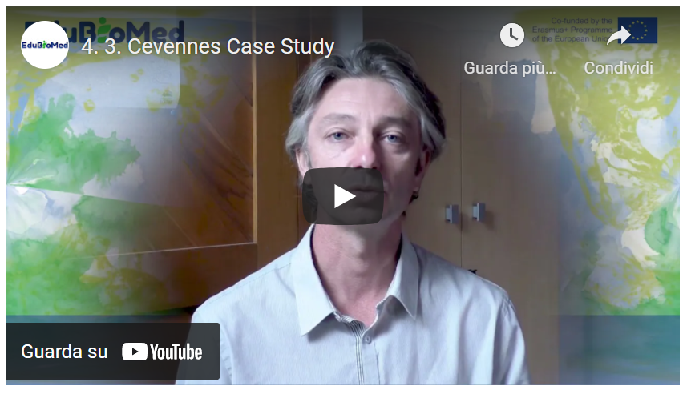
Link to video: https://youtu.be/PTiiWVFLWd0

Additional Resources
Animer une Réserve de biosphère… d’une génération à l’autre.
Park national des Cévennes.

Transcript of the video
The Cévennes Biosphere Reserve has the particularity of being supported by the Cévennes National Park and has existed since 1985.
And indeed, the local authorities have an essential role in the implementation of the management plan which makes the Cévennes a real territorial project that has been co-constructed with all the stakeholders and where the national park is the manager, in which it has an important mission of implementation, but where the majority of the actions that are planned in this real territorial project are made by the public authority. And that's why. Moreover, it is on the basis of this project that the communities decided to join the biosphere reserve by adopting the territory project, and our role as manager of the biosphere reserve is to help the communities implement this project of territory. So, it's really a matter of providing support and advice, of agreeing contracts on very specific subjects, since the member communities have committed themselves to ten very, very specific points which correspond to the different axes of the territorial project. And then, beyond that, we count every three years or so. Other actions more specific to the municipality, which we want to carry out together and which contribute to the territorial project. Concretely, we could talk about the commitment, the modernisation of public lighting. For example, we have decided to apply for the label of international dark-sky reserve so that it will be the driving force for the territory. It engages more players than it is motivating and our action consisted in showing elected officials all the dimensions related to public lighting, i.e. both the energy side, but also the light pollution side and the impact on biodiversity. And for that, we set up training courses for elected officials, training courses for municipal agents and we released funds, notably European, throughout the Occitan region to encourage the modernisation of public lighting around very precise technical specifications that had been shared with the main technical operators of public lighting on our territory.
Another theme that we are working on with the local authorities is the management of public spaces, what we call the differentiated management of public spaces, that is to say bringing more biodiversity into public spaces, that is to say avoiding always chopping down. Also choose species that are resistant and do not require a lot of water.
It also means thinking differently about the management of cemeteries. It also means thinking differently about tree pruning. Put more plants back in the city, especially in relation to the living environment and the effects of global warming, and find and equip communities and train them, especially agents in alternative techniques to all the pesticides that are no longer used at all on our territory. And then, another action as well, which is very mobilizing for the communities. But beyond the inhabitants, it is what we call the class of communal biodiversity. It is a methodology and a national policy in France that is widely relayed in the Cévennes Biosphere Reserve by supporting the municipalities that are project owners and that, for two to three years, will mobilise all the stakeholders in their area to significantly increase their knowledge of communal biodiversity. Moreover, everything that is a field inventory is associated with moments of awareness raising and protocol learning. It is very participative and it is really a work on the sensitivity and sharing of this taste for nature and the discovery of new species. But it is also very concrete since it allows precise mapping of biodiversity to be drawn up, debates or technical committees to be held on the issues specific to the commune and on the actions that can be carried out to make it more attractive for this more welcoming biodiversity, to be more exact, and since there is a real action plan that is implemented, it can be implemented by the community in its management, but also by the citizens. Of course, schools are highly mobilised to contribute to knowledge, awareness and sharing.

M4 – Lesson #4 Jabal Moussa case study
Pierre Doumet, Association Protection Jabal Moussa
Pierre Doumet is the Director of the Association Protection Jabal Moussa (APJM) – MBA and a Chemical Engineering degree. He is a founding member and currently the president of APJM. Although a volunteer position, Pierre dedicates more time and effort in managing APJM than he does on managing three other companies which he directs. Renowned for his pioneer work in the private sector, Pierre brought the professionalism and focus of the private sector to the not-for-profit domain of APJM. Under his management, Jabal Moussa, designated a Biosphere Reserve in 2009, became one of the most important ecotourism destinations in Lebanon, receiving an exponentially growing number of visitors every year.

Description
Pierre will tell us about Jabal Moussa Biosphere Reserve.

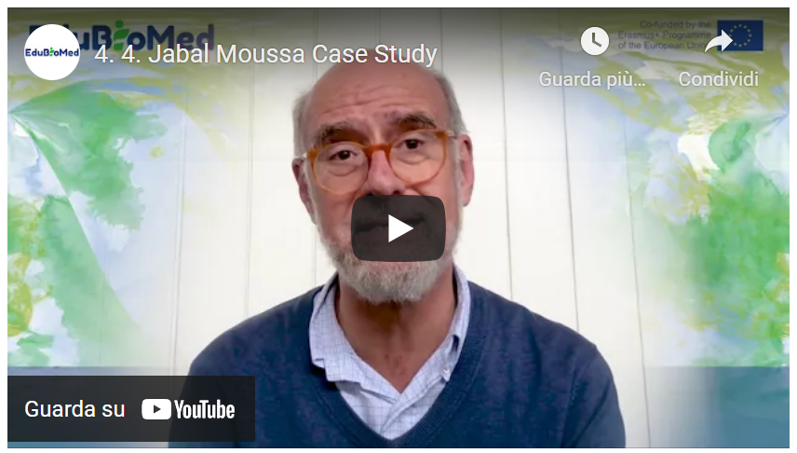
Link to video: https://youtu.be/7CYzZzeAXh0

Activity
Watch The Epic of Gilgamesh, Lecture by Andrew George. Surf the websites of the Jabal Moussa Reserve (https://www.jabalmoussa.org/) and the Shouf Biosphere Reserve (http://www.shoufcedar.org/).

Transcript of the video
In a previous video we discussed the world network of Biosphere Reserves, as well as the Mediterranean Network of Biosphere Reserves, of which Jabal Moussa is a very proud co-founder. And today we will discuss the Lebanese biosphere reserves of which one is currently inactive. It's called Jabal Rehaan and two are very active: Shouf Biosphere Reserve, four hundred and forty square kilometers , 22 villages, over 100’000 visitors a year; and Jabal Moussa Biosphere Reserve: sixty-five square kilometers , seven villages and over thirty-five thousand visitors a year. What is particularly interesting to note and emphasize is the mythological dimension of both these Lebanese Reserves, not just historical or cultural, but mythological. So Shouf is associated with the Epic of Gilgamesh out of Mesopotamia. It is said that King Gilgamesh and his alter ego Enkidu, came to Mount Lebanon from Mesopotamia to fell the large cedars there and bring them home. But there was a giant, the fierce giant called Humbaba who was there watching the forest. Unfortunately, or fortunately, depends how you see it - Humbaba gets tricked by Gilgamesh and Enkidu, and they are able to fell the large cedars and just before they take them home Enkidu talks Gilgamesh into killing the giant Humbaba. Now, that was an unnecessary act because they could they took the cedars and they could have gone home, but unfortunately, they do slay giant Humbaba.
So, what you have here is the mother of all protection, since this is a four-thousand-year-old story, presumably, and you also have the mother of all non-sustainable behavior since they go out and kill the giant, whatever you do remember, do not slay Hubaba. So that's the Shouf story... Now I will discuss Jabal Moussa. Jabal Moussa is bordering Adonis valley is associated with the myth of God Adonis out of Phoenician and Greek mythology, itself related with the ancient Egyptian myth of Isis and Osiris. Adonis is an exceptionally handsome young man, loved by many goddesses in the Olympus, in particular by Astarte, goddess of love and fertility, and Persephone, the goddess of the underworld. These two are fighting for his favours, but basically, he's favoring both a little bit equally. Part here, part there, until he decides that he's madly in love with Astarte and he starts being with her more than Persephone. So, she gets mad. And one day as he's hunting in the Adonis valley bearing his name by the river, he gets attacked and mauled by a mysterious wild boar, presumably sent by Persephone. And his blood flows in the river and he dies right there.
Well, Astarte is able to convince Zeus to let him come back to life three days every year. That's the legend and the mythology. And so, from Byblos, there was a yearly procession of the king and princes going up the river to the Astarte Temple. And they used to have there in Afaka or Afka three days of revelry and feasting for the return of Adonis. This is all, of course, mythology. But the places continue to exist today. And one of the great joys of a biosphere reserve such as ours is to contribute to the protection and knowledge of such extraordinary sites. There are three pillars in any Man and Biosphere program, and we have the same. These three are, number one, conservation of nature and culture.
We have seven hundred and twenty-six species of plants of which six are endemic to the sole Jabal Moussa.
A wonderful deciduous forest that is presumably a remnant from the Ice Age, a global important bird area. Many wonderful things that are worth conserving. What does research do? That's the second pillar. One is conservation. Two is research. Research allows us to find out about more and more things that are worth conserving. For example, local universities have found that we have all kinds of interesting mammals like hyenas and wolves that can be seen in plain daylight. And that is quite extraordinary. 50 kilometers from the capital, Beirut. Foreign University, for example, in the case of Helsinki University, they found insects, new insects or insects new to science that they actually called Jabal Mussa. Archaeology. There is a recent documentary that explains this, that we can that you can watch, that we'd like you to watch. Basically, what we have is remnants, archaeological remnants from the Kananae and Bronze Age, which is 2500 years before Christ, going all through Roman and Bizantine up to the Ottoman period. So, this is through research. We unearth these extraordinary things that we can then conserve and show people. Third pillar is the social economic aspect of sustainable development to encourage local people to protect their heritage. This is really very important because that's the philosophy of the man and biosphere concept, human beings at the heart of conservation. So here again, we have three pillars, important pillars of our socio-economic action. One is ecotourism. We have local guards and guides, all of them local. We have guest houses where people have lunch when they come. The 35000 people that came so far, a large number wants to take something to stay at guesthouses or bed and breakfast. And then we have also the traditional food products and handicrafts. So, these ecotourists, they want to take something home. And so, we have a central kitchen where the local ladies are able to make some wonderful products that people then at the entrances can take home. In particular, we have honey and oregano that are the most cherished products at this stage. A third activity we have that's been quite successful is our native tree nurseries, where we plant up to 40000 seedlings every year coming from our wonderful seeds in our forest and we propagate those. So, we are replanting large parts of Lebanon with these local native seedlings as opposed to importing stuff from outside. So, these activities are bringing something socioeconomically to the homes of the mountain of the biosphere reserve, and that makes the whole difference. Now, you can imagine that there are many constituents in the Man and Biosphere Reserve. We have the landscapes that are part of it. We have the forest, the birds, the bees, the mammals and of course, the people, as we just discussed with their invariably rich culture and traditions, how to balance the often-conflicting interests of all these constituents. That is a difficult balancing act. What we try is to respond to grassroots concerns by all constituents, of course, particularly the people, by giving them work, tested universal answers with support from international knowledge providers and donors. We call this the helicopter approach to biosphere reserve management hovering between intensely local grassroots issues and internationally tried and tested responses.
Does it work? So far, so good. Thank you for your attention.

M4 – Lesson #5 Thinking outside the borders: the Mediterranean Intercontinental Biosphere Reserve
Mchich Derrak, RBIM
Mchich Derrak is a Moroccan forestry engineer who has been working since 2003 at the Regional Directorate of Water and Forests and the Fight Against Desertification of the Rif (Agency of the Ministry of Agriculture, Maritime Fisheries, Rural Development and Water and Forests of the Kingdom of Morocco) in Tetouan. In 2011, he obtained his Master’s degree in Science in Integrated Planning for Rural Development and Environmental Management from the Mediterranean Agronomic Institute of Zaragoza, Spain. In 2017, he obtained his PhD in Ecology jointly from the University of Tetouan and the University of Alicante in Spain. He has participated in several projects on natural resource management in general and on participatory forest restoration in particular.

Águeda Villa Díaz, RBIM
Águeda Villa Díaz has a degree in Geography and History (University of Seville) and a PhD in History and Humanistic Studies: Europe, America, Arts and Languages (University Pablo de Olavide). She develops her professional activity in projects and technical studies of planning, natural heritage and culture, sustainable development and landscape. Since 2000 she has been working as an external technical advisor for the Committee of Biosphere Reserves of Andalusia. As a teacher, she is an associate professor at the Universidad Pablo de Olavide and participates in masters and courses on heritage, land management, sustainability and landscape.

Description
This capsule presents the case of the Mediterranean Intercontinental Biosphere Reserve (RBIM), a territory that goes beyond the national borders since it is ‘shared’ between Southern Spain and Northern Morocco. Two Biosphere Reserve managers, from the two different shores of the Western Mediterranean, will tell us how the RBIM is a virtuous case of international collaboration in the frame of the MaB program.

Link to video: https://youtu.be/4GjGr7tuuqU

Activity
Reading and analysis of the last part (pages 38-80) of the RBIM Activity Report 2006-2011. [SP] [FR]
Transcript of the video
Part 1
The Mediterranean Intercontinental Biosphere Reserve (RBIM) is established on a double basis: first, on the recognition that there was a very much valuable socio-ecosystem that was shared between Andalusia (Spain) and Northern Morocco, that is between Europe and Africa and on the other side, the conviction that to establish a transboundary Reserve would have been a key instrument for the development of a cooperation.

How to do it? From one side, through two Memoranda. One that the Andalusian Regional Government (JA) holds since the year 2000 with the Reign of Morocco to do environmental cooperation; the other, more specific, ratified in 2003 between the Andalusian Environmental Office (CMA) and the Water and Forestry Office of the Moroccan Ministry of Environment (HCEF). Those are the two instruments that facilitate the establishment of the Reserve with a certain Institutional guarantee

From another side, an Interreg program that mobilized the funding for the drafting of the needed documents. This Reserve is presented, and it was approved in 2006. At that moment, the International Co-ordinating Council (of MAB) congratulated the initiative, finding it pretty ambitious. What stands out is that the initiative has many possibilities, despite its complexity, it has a very elaborated documentation already drafted, which achieved two very important things as to establish the main work strategies, the common values that have been worked together between Spain and Morocco; and to pave the way for future work when the proposal was accepted, the three bodies (JA, CMA, HCEF) started working together.

We can speak about the results of the 10-year evaluation (by UNESCO). They have been quite acceptable, and we received a particular remark on the level of maturity that the Reserve gained. Maturity that comes from the fact that the three institutions (JA, CMA, HCEF) have been willing to continue working together , not only voluntarily, but also generating an institutional instrument that allows it to be: the Memoranda. Since 2006 two more Memorandum has been ratified. One in 2011, and another in 2016. Those documents contemplate those instruments that are basic for the functioning of a Reserve: a mixed Committee, that is the transboundary management organism; the participatory organism, that is yet to be formed; and the Action Plan. An Action Plan that was conceived in a flexible way , so to make it adaptable and modifiable according to the circumstances and evaluations (from UNESCO), like projects or even the work strategies.

Part 2
The territory of the RBIM, both in its Moroccan and Spanish parts, is subject to soil erosion, forest fires, forest cover degradation, the advance of desertification or other effects related to climate change. In order to face these problems, several actions have been implemented within the framework of cooperation projects between the Moroccan and Spanish partners of the RBIM.

These actions focus on three main areas: conservation actions, development actions and logistical support actions. In terms of conservation actions and particularly the exchange of knowledge and experience in the field of forest fire prevention and control. The restoration of forests and some emblematic species such as cork oak, cedar and fir in Morocco or nif and fir in Spain. The strengthening of the urban waste sanitation network and the study of bird migration through Gibraltar.

As far as development actions are concerned, they have mainly focused on the promotion of sustainable tourism, revaluation of the products of the territory, such as meat, cheese, aromatic and medicinal plants.

The implementation of an integrated management in the rural environment and the strengthening of signage and supports in the protected area

Finally, in terms of logistical support actions, and particularly the carrying out of scientific studies developed in cooperation between the Spanish partners, the organisation of workshops on various topics such as integrated management of the RBIM, the fight against forest fires, ecotourism, management of the RBIM protected areas, etc.

Training for the benefit of academics, members, cooperatives, administrative technicians and engineers, nature guides.

The development of environmental education activities.

Other actions, such as the elaboration of information and communication media on the RBIM, such as leaflets, books, brochures, catalogues and finally the elaboration and strengthening of signage. Therefore, these actions have been implemented. But other projects are still open and deserve more work in order to progress in economic, environmental and social sustainability.

In this sense, a sustainable development strategy specific to the City is being drawn up. Another project is planned for the year 2021, which is the concretisation of governance within the RBIM. Concretely, through the operationalisation of a Participation Body that brings together different social actors involved and interested in the future, and finally the strengthening of shared management through institutional collaboration ensured and supervised by the RBIM Joint Committee.

Module 5 – Conceptual and methodological tools relevant in the field of conservation management

- LESSON #1 Biodiversity knowledge, monitoring and representation
Magda Bou Dagher Kharrat, University Saint-Joseph

- LESSON #2 Citizens science in Med BRs
Salma Talhouk, American University of Beirut

- LESSON #3 Stakeholder engagement
Catherine Cibien, MAB France

- LESSON #4 Tools for decision making
Gonzalo Gamboa, Universitat Autònoma de Barcelona

- LESSON #5 European Project Design and Mangement, Introduction to EU Programmes
Raniero Chelli, UNIMED

- LESSON #6 European Project Design and Mangement Proposal preparation
Raniero Chelli, UNIMED

M5 – Lesson #1 Biodiversity knowledge, monitoring and representation
Magda Bou Dagher Kharrat, University of Saint Joseph
Magda Bou Dagher Kharrat is a Professor at the University of Saint Joseph in Beirut (USJ) and Director of the Biodiversity and Functional Genomics Laboratory at the Faculty of Sciences of USJ. She holds an HDR from the University of Paris-Sud and a PhD on cedar genetics from the University Pierre et Marie Curie. She is President and co-founder of the NGO Jouzour Loubnan. She is a member of several international learned societies and research consortia and is the author of about 50 scientific papers. Her research work focuses on the genetic characterisation of the biodiversity of Lebanon and the Mediterranean region. The application of her research helps to define concrete and sustainable conservation policies.

Description
How to map, monitor and represent biodiversity? Prof Magda Bou Dagher introduces some tools to better know the diversity of life around us!

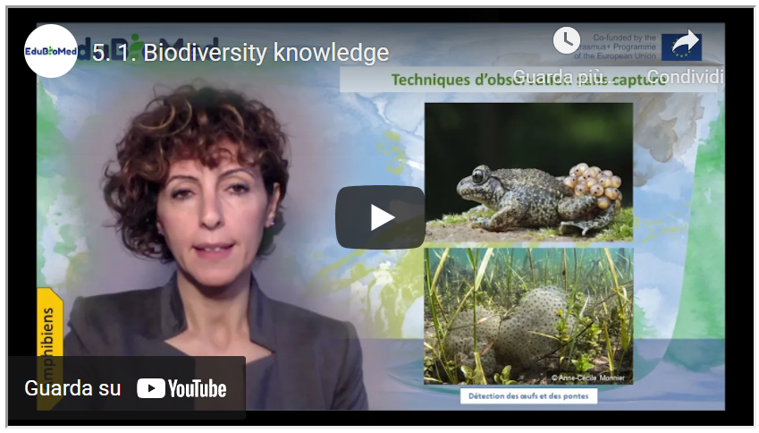
Link to video: https://youtu.be/XDQfLJsLio8

Activities
Additional resources to go further:
- Watch the video “Big Cats Wild for Calvin Klein Cologne?“
- Catalog of entomological sampling methods (Chap. 2, part. II), P. Bonneil, L.M. Nageleisen, Christophe Bouget
- Evaluation of the microfauna biodiversity of a watercourse, Biodiversity in Lebanon
- Watch the video on stream invertebrates “A visual guide to Riverfly monitoring”

Transcript of the video
To study biodiversity, we must consider its different levels:
- Species-level = species diversity
- Ecosystem level = landscape diversity
- Intraspecific level = genetic diversity

When asked to characterize biodiversity, we generally limit ourselves to species diversity. However, it is recommended to consider the other two levels. In this MOOC, we will address only the species level. For species diversity, it is necessary to consider animal, plant, and fungal species and microorganisms and other forms of life called “protists.” These inventories are not just a list of species but rather contribute to an understanding of the functioning of the ecosystem. Thus, these studies will clarify the potentialities of the site to be studied, its weaknesses, the issues, and the constraints to be tackled.

Ideally, the entire ecosystem should be systematically inventoried. As part of the "One cubic foot" project, a photographer systematically photographed every living organism he found in this volume; he carried out this exercise on land and in the sea. The results would not be precisely the same if he had examined the integrality of the site. This approach is not feasible on a large scale since it is time and resources consuming.
For this reason, we carry out a sampling in a representative area of our site, and we will then extrapolate the results to a larger area.

This representative area can be a “Quadrat,” which is a rectangular surface whose size depends on the nature of the ecosystem:
• 1x1 in a bog
• 5 x5 in a meadow
• 100 x 100 m in a forest.
Several quadrats are defined when the site is heterogeneous. The location of the quadrats must be studied scrupulously to represent all types of habitats. One could also draw transects and assess the biodiversity along these transects. The choice of the transect location must also cover the maximum number of habitats in the site to be studied. The quadrat technique is used in terrestrial, aquatic, or underwater environments. It is adopted for fixed or low-mobility species.

To inventory species and draw up an inventory of biodiversity, it is necessary to tackle all groups of organisms and find the optimal means of effort and resources to be spent to list the site’s biodiversity. Naturalists competed in imagination and creativity to adapt sampling techniques appropriate to their group of interest.
Mammals inventory: they should be observed with the naked eye or binoculars. There are other means of observation for fearful or stealthy animals. It will be necessary to install camera traps. Alongside these traps, researchers tend to set traps or decoys. For example, to attract big cats, perfumes like Chanel Number 5 or Obsession by CK have proven their effectiveness in attracting big cats. Other means also exist, such as non-invasive traps, which allow animals to be trapped temporarily to study them before releasing them.

I cite other techniques such as ultrasonic detection for bats.

Traces left by animals can also constitute indirect evidence of their passage: droppings, hair, paw prints, etc.
Animal droppings, for example, have proven to be a great source of information; sometimes, scat shape could be sufficient to identify the animal that dropped it: rabbit droppings are ball-shaped, while wombats ones are cubic ….
Apart from the shape that can tell us about the animal’s identity, droppings contain much more information. Animals' diets can be revealed through the analysis of their scats. The technique of DNA metabarcoding, which simultaneously sequences several DNA fragments and compares them to a database, allows us to know what the animal has consumed, such as leaves or roots or other parts of plants that are not detectable like seeds visual analysis.
For birds, ornithologists have their tools. There is, of course, observation using binoculars, but the most popular technique today relies on the bird-song recording. And in this regard, today's technologies have revolutionized this field since they allow uninitiated amateurs to identify the birds encountered from their song. Indeed, it is possible to record the sound of a bird and use specific applications available on smartphones, for example, compare the soundtrack to the database and identify the bird. Techniques for tracking traces such as feathers or nests or eggs… Examination of droppings is also possible. This is especially interesting in owls, where whole rodent skeletons can be found in the scats. Japanese mist net for catching birds is used when seeing the bird is necessary for studies and for ringing them. Ringing makes it possible to monitor a large number of birds individually and to collect a lot of information (sex, age, biometrics, etc.). This collected data improves the bird’s life, behavior, and survival rates. GPS tags are used for migrating birds. This allows you to know the dates and routes of migration and the location of rest areas.

To study reptiles, herpetologists have techniques and tools specific to them: long cuffs, thick gloves... because the bites of some reptiles can be dangerous. Since reptiles are cold-blooded animals, they often seek warmth. Traps such as tunnels or artificial shelters that trap heat catch reptiles and identify them. Identifying reptile exuviae can also reveal the identity of the reptile. Examination of the DNA extracted from it allows precise identification of the species. Observation of amphibians can be done with or without capture. This observation can be done during the day or night, a privileged time for certain species to move. Singing detection: Singing (croaking) can reveal the identity of frogs.

We choose listening points to cover potential areas of species presence. The songs are diurnal and nocturnal. Visual detection in water or on the ground: The use of a high-power lamp makes it possible to detect amphibians present in the breeding sites at night. We gently walk around the perimeter of the aquatic sites, observing the borders and water areas. Searching for eggs and clutches (some species have very typical egg-laying techniques) can also reveal the species present.

To capture amphibians, the use of artificial caches is employed. This propensity to use shelters can be taken advantage of by placing plates (wood, sheets, squares of carpet) near the egg-laying sites. These techniques make it possible to assess the biodiversity of aquatic environments, but what has revolutionized the field of study of aquatic biodiversity is the discovery of eDNA or environmental DNA. The DNA can be recovered after water filtration extracted from an aquatic environment. The analysis of this DNA reveals the identity of the lake inhabitants who, by their mere presence, leave cells, excretions, etc. Arthropods: This group forms more than 52% of our planet's biodiversity. There is enormous variability in the life forms of this group. The techniques for studying insects are just as diverse. Active methods require dislodging insects from their environment using threshing, mowing, or debarking techniques. Then a visual identification specimen by specimen is carried out. In the aquatic environment, cloudy-water nets are used, such as the Suber net, to recover animals dislodged from their habitats. Some of these animals are indicators of water quality.

As for the passive techniques, they are also very numerous:
Light traps consist of placing a light source rich in UV or a lighted white sheet in the middle of the biotope whose insects you are trying to study. This phenomenon of attracting insects to lights is well known to entomologists worldwide. We can even observe it with our insects in town around public lighting or a lamp on our terraces in summer evenings.
The Barber Trap, invented in 1931 by the American entomologist Herbert Spencer Barber, makes it possible to capture organisms moving on the surface of the ground. It consists of the insertion in the ground of a container filled with a liquid (vinegar or alcohol) in which the insects drown by falling into it.
René Malaise a Swedish entomologist invented the device that bears his name. It is a tent with a white roof which makes it possible to converge the insects which enter it, in particular Diptera and Hymenoptera, towards a bottle filled with alcohol which will keep them for later studies.

To study the arthropods of the soil, it is the Berlèse device that will have to be used. A fraction of the soil (litter plus the height of a shovel) is taken and then placed in a device lit brightly from above (wide-mesh sieve above a funnel), causing the arthropods to escape from below into the pot collector containing a preservative liquid (alcohol). “Splatometer” is an unusual technique that relies on the evaluation of the diversity and abundance of insects killed on the windshields and license plates of cars during their movement at high speed. To study the diversity of plants, the procedure is relatively simple since the plants are generally fixed to the ground. On the other hand, to assess all the plant diversity of a place, it will be necessary to pass several times and in different seasons to observe the different parts of the perennial plants and to be able to observe the seasonal plants. Plant pollen can also be a plant identification tool. Placing a device such as the Cyclone sampler in an environment that sucks up airborne particles reveals the presence of plant or fungal species that have released these spore or pollen particles. It is by analyzing the DNA of these particles that we will identify the species. Mushrooms are present all year round but visible above ground only at certain times of the year when humidity and heat conditions are adequate. The study of the carpophore (visible part of the mushroom) allows their identification. Note that the genetic study from soil extracts is possible all year round.

The LIFEPLAN project aims to establish the current state of biodiversity across the globe, and to use our insights for generating accurate predictions of its future state under future scenarios. Biological diversity will be explored through a worldwide sampling program, and develop the bioinformatic and statistical approaches needed to make the most out of these data. LIFEPLAN is led by the University of Helsinki, it brings together more than 100 study points around the world

M5 – Lesson #2 Citizens science in Med BRs
Salma Talhouk, American University of Beirut
Salma Talhouk is Professor of Landscape Horticulture, at the Faculty of Agricultural and Food Sciences (FAFS), Department of Landscape Design and Ecosystem Management (LDEM) of the American University of Beirut.
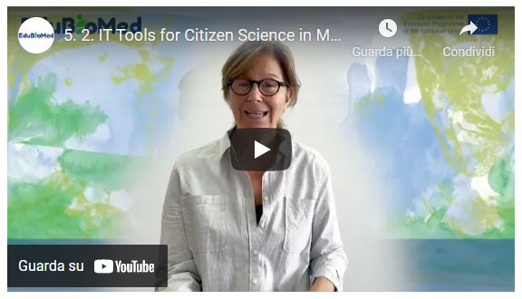
Link to video: https://www.youtube.com/watch?v=6t7hJSlRfxA
Transcript of the video
So how often do you spend time in nature, maybe once or twice a year, or maybe you go regularly? Either way, you go to nature, probably because it makes you feel better. But how do you know if nature is feeling better every time you visit them? How would you know if nature is healthy? This is what Biosphere Reserve managers and scientists do. They are in charge of nature's health. They monitor biodiversity. They monitor organisms on a regular basis because they need to gauge how people impact nature. Biosphere reserves managers, they work with scientists to learn how organisms and ecosystems are changing in response to people's visits and their activities. This monitoring is crucial to help them detect early warning signs of any damage that we may be causing to nature. But to do this, both managers and scientists need to collect a lot of data through our very large fields and many organisms and over very long periods of time. You can hide them and be involved in the scientific research that takes place in biosphere reserves without being a scientist as a citizen. You can actually participate in scientific research that takes place in biosphere reserves. You can, as a non-expert, become a citizen scientists. By doing this, you can help scientists and managers uncover changing partners in nature.

So, what do citizen scientists do in biosphere reserves? Citizen scientists, they learn from researchers and managers, they engage in data collection, and they are involved in scientific research only when many citizens work together with scientists and managers. Then it becomes possible to collect big data across time and over large areas. The data collected by citizen scientists will drive change because it is useful and it is impactful. So, the citizen scientist who engages with scientists and managers will help them acquire knowledge through research and will help transform this knowledge into action, and it will guide management and planning. When you want to be a citizen scientist, you can choose the research that interests you that you find important. Some people may be curious about scientific research. Others may be interested in a specific organism, even if you don't have specific preferences. The key is that when you are a citizen scientist, you will also advance your scientific literacy and you will contribute to research and have a direct impact on nature. In short, as a citizen scientists, you get to make a difference in nature and the communities living in biosphere reserves, while also you are growing, learning and acquiring knowledge from the scientific perspective. Your contribution as a citizen scientists will help the scientists plan larger projects and more impactful research projects because they know that there are many people working with them, and so they can plan a collection of a large number of samples over a long period of time. If you don't contribute, if you don't have them, they will not be able to do this because large projects are very costly.

There are many success stories of citizen science around the world. One of them is citizen engagement in bird watching. On October 9th. Citizen scientists around the world do bird watching. Specifically, they collect, identify, locate and upload as many bird species as possible using the eBird phone application, which has been developed specifically to allow citizen scientists to contribute bird watching data. In 2020, despite the COVID 19 outbreak, more than 32000 participants submitted 18400 checklists, with 7128 species. There are many phone applications that have been developed to engage citizens and citizen scientists in monitoring and data collection of organisms and natural elements. Our team has developed a phone application that allows citizen scientists to participate in research conducted and Mediterranean by its users. The application, called Edu-BioMed, allows scientists and managers to share projects conducted in biosphere reserves, and it is a useful tool that facilitates the participation of citizens in the search. As a citizen scientist, you can browse and choose a project that interests you and list the skill that you have, or that you would like to learn. The Edu-BioMed phone application will link you with ongoing projects that match your choices. Your contribution can range from uploading your photo or contributing to other data collection apps. Now, as you visit biosphere reserves, you can help scientists and managers conserve nature and promote sustainable development in the biosphere reserves. Sign up on Edu-BioMed phone application, visit the Mediterranean biosphere around you and see how you can make a change. Your contribution is necessary. In summary, the Edu-BioMed phone application targets citizens who are interested in participating in biosphere reserves related research projects. Through this app, you can familiarize yourself with Mediterranean biospheres and encourage friends and families to engage in citizen science, becoming citizen science today and help scientists and managers conserve nature!

M5 – Lesson #3 Stakeholder engagement
Catherine Cibien, MAB France
Catherine Cibien is the Director of MAB France. MAB France animates and strengthens the national network of 14 Biosphere Reserves, puts it in touch with the French and international communities interested in this program: scientific community, educational and academic world, organizations for the management and conservation of biodiversity, sustainable development and of the ecological transition. She co-hosts the Master MAB (Man and Biosphere) at the University of Toulouse.
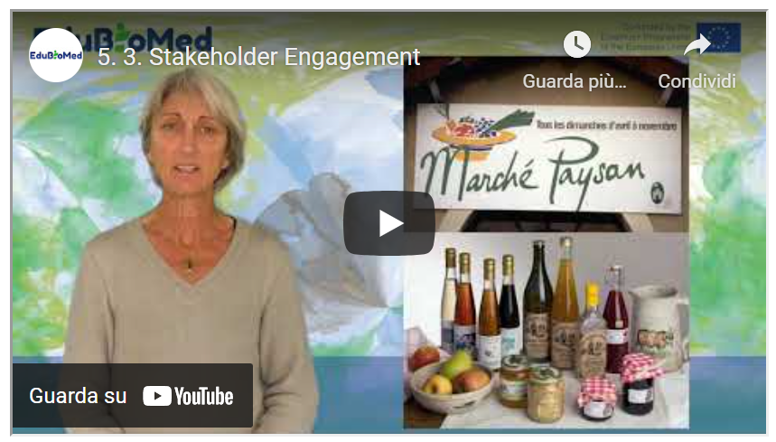
Link to video: https://youtu.be/ZR22YSq45bY

PPT presentation
Link to slides: https://www.edubiomed.eu/wp-content/uploads/2021/09/PPT-5.3.pdf

Transcript of the video
In Biosphere Reserves (BRs), the involvement of "stakeholders" is fundamental, and concerns different types of stakeholders, for whom the stakes of participation differ. It takes place in a particular way at certain key moments in the life of the BR.
A key moment for participation, creation, periodic review and implementation of the biosphere reserve's management policy. At these stages, the inhabitants, their representatives, the private and associative sectors and institutions will have to analyze the issues facing the biosphere reserve and agree on the policy and projects to be carried out in the coming years, in the fields of conservation, support for the development of human activities, research and studies, and education - training - awareness raising.
It is therefore necessary to plan cycles of meetings that will first inform, identify and understand in a transparent manner the challenges of the moment. Then, there will come a phase of co-construction of the BR project that the official bodies will have to validate and carry out.
Various participatory facilitation techniques can be mobilized: public meetings, various participatory workshops (world café, forum theatre, or the famous THM that Obama used on a large scale for his health reform), the reports of which should be put online, made public and relayed in the local media. Outside of these highlights, local participation is also encouraged on a daily basis, through the working methods and governance of the Biosphere Reserve, which includes representatives from the public and private sectors.
They are based on the reflections of committees or working groups and projects, which involve stakeholders, on agriculture for example, or forestry, or education. Representatives of professions, associations are invited to participate. The social and ecological transition of a territory can only take place if the inhabitants and actors take ownership of it and make it, are themselves bearers of transformation.
Some Biosphere Reserves have established mechanisms to recognize their commitments. Depending on the country, they call themselves ambassadors or eco-stakeholders of BR. In France, eco-actors sign a charter with BR, committing themselves to a process of environmental and social progress for their own activity. Some BR have established brands for products and services that meet high environmental and social standards. Those who benefit from these brands have their quality efforts recognized by the BR.
In France, trophies are awarded every year for original initiatives by local players. All these schemes are complementary and it is not uncommon for companies with branded products to also be eco-actors or ambassadors of their BR. They enable the creation of networks and partnerships at the service of the region.
Participation efforts can also be aimed at a specific social group.
Thus the mobilization of young people aged 18 - 35 is on the agenda in the BRs. Youth forums, or youth councils, are organized, in participatory formats, to train them in territorial dialogue, in the management issues raised by the territory where they live or study, and to invite them to take part in discussions concerning its future, in an informed and constructive way.
Helping the younger generation to be more proactive, to initiate the reforms necessary to achieve the SDGs before 2030 is an important issue for many countries.

M5 – Lesson #4 Tools for decision making
Gonzalo Gamboa, Universitat Autònoma de Barcelona
Gonzalo Gamboa is a social ecological economist. He holds a PhD in Environmental Sciences (UAB, 2008) and has extensive experience in combining participatory methods with quantitative analytical tools, such as multicriteria evaluation and multi-scale integrated assessment of societal metabolism. Gonzalo has applied this approach to a wide range of fields: windfarms location, coastal management, water management and territorial planning. Also, he has focused his research in how to define adequate indicators to characterize and assess the performance of socio-metabolic systems across scales, making explicit the contrasting visions and values in society.
Description
Biosphere Reserves as complex socio-ecological systems are difficult to understand and manage. When it comes to make public decisions, the social multi-criteria evaluation is an adequate tool to employ.

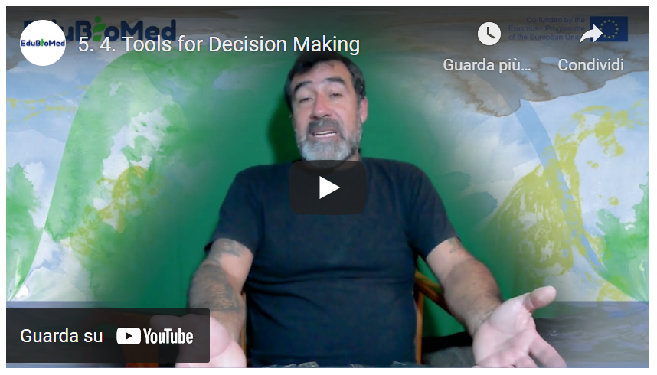
Link to video: https://youtu.be/Gb0mkN4ns00

PPT presentation
Link to the slides: https://www.edubiomed.eu/wp-content/uploads/2021/09/5.4-slides.pdf

Activity
Have a look at the Handbook on Participatory Action Research, Planning, and Evaluation​ (2021), and read “Social multi-criteria evaluation: Methodological foundations and operational consequences” by Giuseppe Munda (2004), from the European Journal of Operational Research.
Transcript of the video
Hello! In the following, I will present some tools for public decision making. In this case, we will focus on the social multi-criteria evaluation. In the real life, we face many situations where conflicts and conflicts of interests converge. In these situations, where different knowledges and values encounter, the social multi-criteria evaluation is an adequate tool for public decision making. We face complex socio-ecological systems, and we could differentiate between two types of complexities.
The ontological complexity, that has as consequence the social incommensurability, that is, that in society a set of contradictory and legitimate values exists, and based in different perceptions of the situation we have. And this ontological complexity calls for public participation. Then we have the epistemological complexity, that relates with technical incommensurability, that is, it is impossible to put express all the (e)valuations under the same measuring unit. So we can say that these two types of complexity are participative and multidisciplinary. The social multi-criteria evaluation frames into three phases: approaching, representing and evaluating. In the first part, the approaching, we have the first step, which is the identification of social actors. Then, we would define the problem we have in front of us, for which we must decide. As methods, we have different ones: historical-institutional analysis, interviews, focus group, that we will review later. Then representation would come: that implies to generate a multi-criteria structure with alternatives to tackle the problem we are facing, and different valuation criteria to evaluate these alternatives. Again, in this step we could make use of participative tools such as in-depth interviews, focus groups, workshops
Finally, we evaluate the different alternatives, basing in different criteria; which requires a multi/inter-disciplinary work; we compare the different alternatives and analyse and discuss results. Once again participation comes into play. This is a non-linear, cyclical process since we go back to the beginning in the sense that we go back reinterpreting the problem and re-define them, if necessary, and go back into the various steps until when someone must decide. Some tools? To identify social actors, we have the historical-institutional analysis that is basically based in document review so to generate a timeline so to identify in which moments which actors are present in the situation we are analysing.
To define the problems, we have dynamics like the participatory mapping or the problem tree, that generate a vision of what are the roots and consequences of what problem. Then we represent. We need to create a multi-criteria structure... Again, the problem tree is a good tool because in identifying the causes of the problems we can define some alternatives to solve it. And then we have for instance the narrative analysis, that is a methodology where we conduct a text analysis of interviews, newspapers, opinion articles, so to identify narratives and from that to define evaluation criteria for the evaluation, we must evaluate the criteria, compare the alternatives and dynamize the discussion.
In this case, we use the multicriteria evaluation where –in this case, for example- it is presented an impact matrix with different alternatives that are evaluated under different criteria. The interesting part is that each of the criteria maintains its measuring units and not everything should be reduced to a single measuring unit. Here we can see, for example, as only by colouring with different colours the different cells of the impact matrix we can have an idea of what is the best alternative – or the less bad- in order to solve a determined problem. We can also use algorithms, that tells us the order of alternatives according to the input parameters. Always keeping in mind that these algorithms should be a tool that help us in making a decision, and they are not the ones who take the decision. We should made responsible for the decision on the basis of the information we collected. Then, these impact matrix with a lot of information should serve as basis to go back discussing the problem and, if it’s the case – take a decision, or go back defining the problem and seek for alternatives. Here I present you a manual with many participatory dynamics for identifying actors, determining the problems, and a series of participatory dynamics that allow us to face these situation of high complexity.
As conclusion, in general, the social-multi-criteria evaluation is a framework for the public decision making, mainly – I would say - at a project level, that allows us to include different visions of the problem that we are dealing with. It combines public participation with multi/inter-disciplinarity work. When we invite to participate social actors in these kinds of processes, we need to take into consideration and be very cautious with the fact that the expectative of participants and of whom dynamize the process can be very different. Transparency is required, and be very clear on what are the premises, the time span, and all the factors that are taken into account for both the development of alternatives and the definition of evaluation criteria. We need to comply with the acquired compromises, for example with giving back information to participants. And there are key issues as: who decides who participate, how they participate, and what is the knowledge that is relevant in the process? For the same reason, ethics and transparency are very important in the participative processes. We need to have clear who and why someone participate.
Another thing: the participation is necessary, but not always sufficient...
...for this reason... It is promoted the shift from the quality of the product to the quality of the social process, in which everyone has the right in participating, and in which we can facilitate the participation of all sort of actors, with more or less resources or more or less possibilities for expressing their opinion in these processes.
The quality of the process requires engagement, multidisciplinary work, and transparency. The software we are utilizing should provide results that are consistent with the information at hand. And more important: the ethics and responsibility of the process... how do we incorporate the vision of who cannot participate, or of whom do not have the tools to participate. And, to assume the responsibility in the moment in which we make a decision based on the information at hand.
That it’s. Thank you very much.

M5 – Lesson #5 European Project Design and Mangement – Introduction to EU Programmes
Raniero Chelli, UNIMED
Raniero Chelli. Active since 1985 in European projects (mainly in RTD, training and international cooperation), as a Commission Official (ESPRIT Programme 85-88), Project Manager, Project Design specialist, Evaluator and reviewer, Quality assurance manager, National Delegate in IST management Committees and as a trainer on EU programmes and funding. He is currently the Coordinator of EU projects at UNIMED, to facilitate access to EU funding by identifying appropriate calls for proposals, helping them in setting up successful proposals and consortia, and where applicable, supporting the management of selected projects with a particular emphasis on Quality Assurance. Over the years, he has managed more than 10 significant projects funded by the European Commission through R&D Framework Programmes, TEMPUS, Erasmus+ and Euromed Heritage and he has consequently acquired an outstanding experience in managing large and complex international publicly funded projects, especially as regards the planning the activities of a highly diversified consortia, conflicts resolution and administrative matters.
Description
The title of this lecture is the introduction to European Union programs. But actually, what we’re going to look at is the European programs providing funding for countries which do not belong to the European Union.
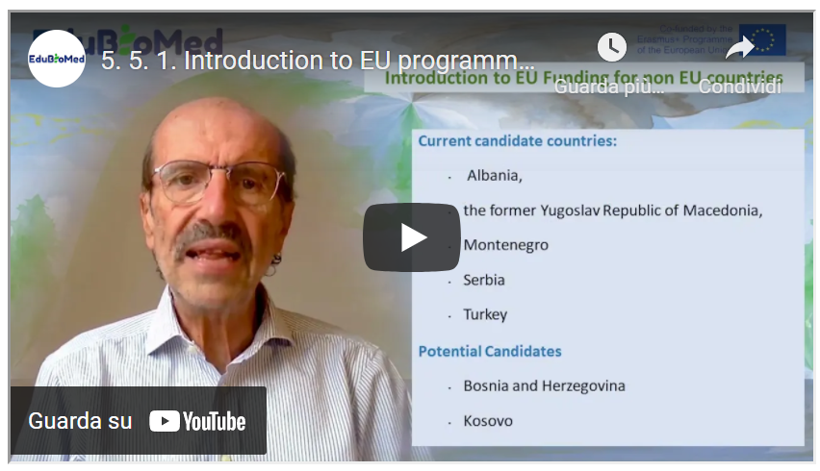
Link to video: https://youtu.be/tM2Hwtjp6ao

PPT presentation
Link to the slides: https://www.edubiomed.eu/wp-content/uploads/2022/01/Lecture-5.5.1-Introduction-to-EU-programmes-.pdf

Transcript of the video
The title of this lecture is the introduction to European Union programs. But actually, what we're going to look at is those European programs which provide funding for countries which do not belong to the European Union. As you probably know, the European Union is constituted by today 27 member states, which you have the list here. And the United Kingdom used to be a member, but they decided to leave this year. It is important to know which countries belong to the European Union because most programs are reserved for European Union countries. However, there are other countries which are in the in the status of candidate countries, and you have the list here. These countries have a special treatment because they are following a process of joining the European Union so they can be part of some programs. And then for each program, you can have some exceptions. For instance, Horizon 2020 is the largest European research and development and innovation program provides funding for projects which are in the area of research, development and innovation. It will finish this year, but they are already preparing the next generation, which is called Horizon Europe. You can have here the link to the Horizon 2020 website. And the easiest thing, however, is to google H2020 and you will find the website. The interesting thing about Horizon 2020 is that there are some countries which I called associated countries.
For instance, Tunisia, which is the only African country which is an associate of Country. What does it mean? It means that Tunisian organisations, whatever type research companies, universities, they can participate in the program as though they were at European Union countries. But in addition to that, many eligible countries do not belong to the European Union. In many cases, proposals of Horizon 2020 allow non European Union organizations to participate. There are some specific goals which explicitly call for the participation of non European Union countries. But the general rule is that whatever, wherever you are in principle, if there is a good reason for participating in the program, then you are allowed to do so. The program is very, very articulated, very complicated. It has a number of different programs, but by and large, in virtually, let's say, the greatest part of the program. Organizations from countries like yours can participate in the project. Get funding from the project, of course, in partnership with European Union organizations. There are some exceptions like China, Brazil, India, but this is not the theme of this course. No. The other big program is Erasmus Plus, as you probably know, is a program which addresses basically the word of education, training and in particular of higher education. It also addresses of basically concerned youth and sports. It is structure within the Central Agency, which is in Brussels and national agencies. Here again, I advise you to visit the website of the Erasmus plus. But the most important strand sub program of Erasmus plus is the one which is called cooperation for HEIs in all EU countries.
This is the program, for instance, where the Edu-BioMed project has been funded, and it is explicitly meant for cooperation between universities in countries which do not belong to the European Union and countries which belong to the European Union, as it is in partnership with some European countries and some non-European countries. You have another, a similar program, which is called capacity building in field of youth, as the name says, does not address as university addresses associations organization to deal with young people. And through this link, you can get a list of the eligible countries for the capacity building for higher education. The third big strand, which is explicitly meant for non-European Union countries, is the central cooperation: Europe Aid. It is the Directorate-General for External Cooperation, also called the cooperation for development and the extent of cooperation is strengthened into three areas. The Pre-Accession Countries IPA, this is the countries which was shown before Albania, Kosovo, etc. the nine country, ENI, European Neighbors initiative. And these are the countries that we should belong to those countries which are neighbors to the European Union, through land or even through sea. So, all countries which belong to the southern Mediterranean area belong to the ENI. And then the third one is the DCI, the Developing Countries Initiatives. You have many calls for proposals. I recommended that you go and look through this link to some External Cooperation call for proposal to see what they are about. So as a quick recap of what we have seen up to now, you have the H2020, which allows the participation of European countries, you have the Erasmus+, which has one stranded capacity building for higher education, which is explicitly meant for non-European Union countries. And you have Europe Aid, which is everything concerning extending cooperation. Thank you very much.

M5 – Lesson #6 European Project Design and Management – Proposal preparation
Raniero Chelli, UNIMED
Raniero Chelli. Active since 1985 in European projects (mainly in RTD, training and international cooperation), as a Commission Official (ESPRIT Programme 85-88), Project Manager, Project Design specialist, Evaluator and reviewer, Quality assurance manager, National Delegate in IST management Committees and as a trainer on EU programmes and funding. He is currently the Coordinator of EU projects at UNIMED, to facilitate access to EU funding by identifying appropriate calls for proposals, helping them in setting up successful proposals and consortia, and where applicable, supporting the management of selected projects with a particular emphasis on Quality Assurance. Over the years, he has managed more than 10 significant projects funded by the European Commission through R&D Framework Programmes, TEMPUS, Erasmus+ and Euromed Heritage and he has consequently acquired an outstanding experience in managing large and complex international publicly funded projects, especially as regards the planning the activities of a highly diversified consortia, conflicts resolution and administrative matters.
Description
In this lecture, we’re going to look at the main steps that they need to take in proposal preparation. Once you have identified the suitable call for proposals and you want to submit your proposal in order to get your project funded, you have to write the proposal. So basically, what I’m going to give you is the process that you have to follow in order to prepare a good proposal.
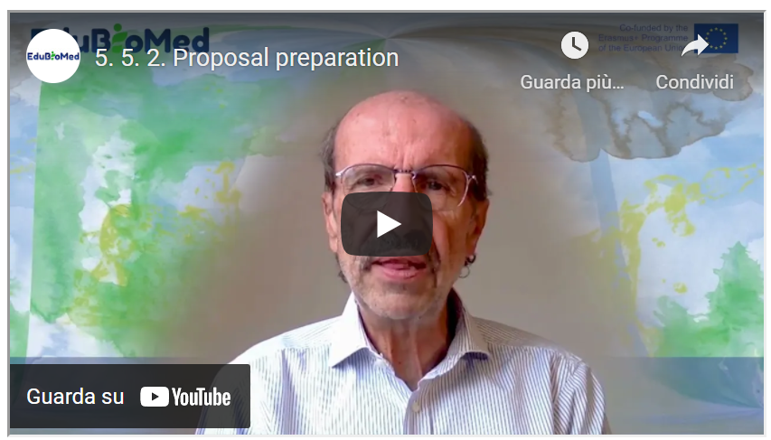
Link to video: https://youtu.be/AdXGGWqh_Tk
Transcript of the video
In this lecture, we're going to look at the main steps that they need to take in proposal preparation. Once you have identified the suitable call for proposals and you want to submit your proposal in order to get your project funded, you have to write the proposal. So basically, what I'm going to give you is the process that you have to follow in order to prepare a good proposal. Of course, you have to start by identifying a project idea. Why am I saying that? Because many times you find a call for proposals and you want to submit the project so you react to the call for proposal, this is not a good idea.
You should start by a strong project idea around which you are going to build a partnership and write the proposal. Then the second important thing is that you have to download the documents related to the call and analyzing that. We have a terms of reference, we have an application form, you sometimes have another document, which is the logical framework, you have another document, which is the budget. You have to download the documents and analyze them to understand in the first place what are the rules for that particular course for proposals. If you are eligible, and things like that. So, you had to analyze on the basis of what you have read, if it is a good idea to take part in that particular call for proposals.
As I said before, you should check whether you are an eligible organization, in an eligible country, whether what you want to do fits into the requirements of the call for proposals. If the budget which is allowed by the call is coherent with what you want to do. You normally have, for instance, in the Horizon2020, you have an indication like this project should cost three million euros. if you had in mind a project for five hundred thousand euros, this is not for you. You should look for some something else and things like that. Once you have decided that you have a good idea to participate in the call for proposals, then you have to prepare a proposal summary: a short document which carries the basic concept, the basic project idea, which you would need to start the Partner search. Partner research is an articulated activity. It is very, very fundamental for the success of your application process.
Having a good partnership or strong partnership allows you to have a good hope that your proposal will be selected. There are many, many channels for partner search. Many programs provide you with facilities for partner search, and then you have networks, like UNIMED, which are there to support you in finding good partners. Once you have put together a suitable partnership, what do you want to do is to share with your partners the work of writing the proposal. So, you should allocate the responsibilities in the writing of the proposal issued a sign writing tasks to all of your partner. Of course, you need that agreement, and once you have done that, you can start working in parallel and waiting for the partners to send a contribution. In some cases - this is very, very critical - You need formal documents, documents signed by, for instance, the legal representatives of the parties.
So, because this procedure is a bureaucratic one, it can take a long time. You should if in the contract proposal, you find out that these documents are needed, you should start as soon as possible. Collecting this document, send in these documents to the parties and asking them to return the document signed in time for submitting the proposal.
Now, the biggest part, of course, is the writing of the proposal, and we will see in the next lecture some parts of this in collaboration with the partners. You have to finalize the full documentation set, which means you put together all the bits and pieces and then you give them a final check, sometimes in some cases you still need to do the packaging if the donor requires that you submit also paper copies. In most of the cases, now the submission happens via the internet to be on the web, so you don't need to do the packaging, but in some cases, this is needed. The submission, as I said, in 95 percent of cases is electronic, but this means that you must check the procedure well in advance. Sometimes you need a particular identification code for the organization. For instance, Horizon 2020 is called the PIC to be obtained from the European Commission. In the case of Europe Aid, that you need what is called the PADOR. And then again, you have to ask for the PADOR, you have to submit so you must start in advance and so that you make sure that when you do the final submission, all what is needed, everything is in place.

https://www.edubiomed.eu/?page_id=1620
https://youtu.be/ErKJv0FmgG4
https://www.youtube.com/watch?v=muWrmfXpivY
https://www.youtube.com/watch?v=ysa5OBhXz-Q&feature=youtu.be
https://www.youtube.com/watch?v=Mxp1nnrUG0Q&feature=youtu.be
https://www.wwf.ch/fr/vie-durable/calculateur-d-ecological-footprint
https://e360.yale.edu/features/in-defense-of-biodiversity-why-protecting-species-from-extinction-matters
https://www.mab-france.org/workspace/uploads/mab/documents/histoire-du-mab.pdf
https://unesdoc.unesco.org/ark:/48223/pf0000375692
https://www.mab-france.org/fr/les-reserves-de-biosphere/etablir-une-reserve-de-biosphere/
https://www.mab-france.org/fr/les-reserves-de-biosphere/vous-avez-dit-reserve-de-biosphere/
https://www.mab-france.org/fr/le-mab-unesco/le-programme-mab-de-lunesco/
http://www.unesco.org/new/en/natural-sciences/environment/ecological-sciences/biosphere-reserves/advisory-committee/
http://www.unesco.org/new/fileadmin/MULTIMEDIA/HQ/SC/pdf/sc_mab_IACBR_Sept2011_ENG.pdf
https://www.edubiomed.eu/wp-content/uploads/2021/09/READING_Adaptive_Governance_of_Social_Ecological.pdf
https://www.landrightsnow.org/get-involved/save-sinjajevina-now/
http://andzoa.ma/fr/andzoa/zone-dintervention/zone-de-larganier/reserve-de-biosphere-des-arganeraies/
http://lerma-flsh.uca.ma/sortie-de-terrain-rba-de-lequipe-du-lerma-uca/
http://lerma-flsh.uca.ma/sortie-de-terrain-rba-de-lequipe-du-lerma-uca/
http://belsp.uqtr.ca/id/eprint/797/1/MAB-UNESCO_1996_Strat%C3%A9gie%20de%20S%C3%A9ville_Cadre%20statutaire_A.pdf
http://www.termeszetvedelem.hu/_user/browser/File/UNESCO/MAB-UNESCO%20dokumentumok/New%20Strategy%20and%20Lima%20Action%20PLan.pdf
https://parcs.diba.cat/es/web/reserva-de-la-biosfera-del-montseny
https://parcs.diba.cat/es/web/reserva-de-la-biosfera-del-montseny/pla-igualtat-genere
https://www.deepl.com/translator
https://www.mab-france.org/en/new-and-publication/animer-une-reserve-de-biosphere-dune-generation-a-lautre/
http://www.cevennes-parcnational.fr/fr
https://www.youtube.com/watch?v=Rd7MrGy_tEg
https://www.edubiomed.eu/wp-content/uploads/2021/09/memoria-rbim-espa%C3%B1ol.pdf
https://www.edubiomed.eu/wp-content/uploads/2021/09/memoria-RBIM-franc%C3%A9s.pdf
https://www.nationalgeographic.com/animals/article/100624-big-cats-cologne-vin-video
https://www.edubiomed.eu/wp-content/uploads/2022/02/pub00030221.pdf
http://biodiversite-liban.blogs.usj.edu.lb/2012/03/03/la-biodiversite-du-liban-nahr-ibrahim/
https://www.youtube.com/watch?v=2lSh9UfwdZM
https://www.participatoryactionresearch.net/
https://www.edubiomed.eu/wp-content/uploads/2021/09/munda_2004.pdf

